Select voice font settings for speech

emgrol

# Technology preview for Build 2022

This year at Microsoft Build 2022, we are excited to announce the evolution of Power Virtual Agents.

The new intelligent bot authoring experience unifies the sophistication of Azure Bot Framework Composer pro-code capabilities with the simplicity of the Power Virtual Agents low-code platform, making it even easier for professional developers and subject matter experts to build collaboratively in one Microsoft bot building studio.

This evolution brings new features including:

* Updates to authoring experience
  + [Multimedia cards​](advanced-cards.md)
  + [YAML code editor](authoring-create-edit-topics.md#edit-topics-with-the-code-editor)
  + [Bot response variations](authoring-create-edit-topics.md#message-variations)
  + [Quick replies](authoring-create-edit-topics.md#quick-replies)
* Unlock the power of voice
  + [Speech authoring](advanced-custom-speech-ssml.md)
  + [Voice font selection](advanced-speech-settings.md)
  + [Telephony channel](publication-connect-bot-to-telephony.md)
* Power FX and variable management
  + [Enhanced variable management](authoring-variables.md)
  + [Power FX support](advanced-power-fx.md)

For a guided tutorial on how to use these new features, please refer to the [Build 2022 quickstart](build-2022-quickstart.md).

To get answers and tips directly from other users in the technology preview, visit the [community forums](https://aka.ms/PVABuild22Forum).

This technology preview doesn’t yet support some of the existing features you’re used to in Power Virtual Agents, such as, custom entities, agent transfers, and bot authoring in Teams. For the full list, see [Limitations of technology preview](build-2022-limitations.md).

## For desktop Composer users

There are a number of differences and similarities in how bots are designed in Bot Framework Composer and in the Power Virtual Agents technology preview. The following table lists some key concepts in Composer and describes where to find information about similar concepts in Power Virtual Agents.

| Composer concept | Power Virtual Agents concept | Description |
| --- | --- | --- |
| Dialogs and triggers | [Topics](authoring-create-edit-topics.md) | Use topics to organize conversation flow or paths. A topic has a set of *trigger phrases* that indicate when the bot should start the topic and a set of *nodes* that describe the conversation path for the topic. |
| Intents | [Trigger phrases](authoring-create-edit-topics.md) | Add trigger phrases to a topic for phrases, keywords, and questions that a user is likely to type that are related to a specific issue. Natural language understanding is used to parse what a customer types and find the most appropriate topic. |
| Actions and prompts | [Nodes](authoring-create-edit-topics.md) | Use nodes on the authoring canvas to create the conversation path for each topic, such as messages, questions, and conditional branches. |
| Bot response variation | [Response variations](authoring-create-edit-topics.md#message-variations) and [question variations](authoring-create-edit-topics.md#message-variations) | Use response and question variations to add variety to your bot’s messages and questions. |
| Suggested actions | [Quick replies](authoring-create-edit-topics.md#quick-replies) | Use quick replies to provide default reply options to the user. |
| Entities | [Entities](advanced-entities-slot-filling.md) | Define and use entities to extract semantic information from a user’s utterance. |
| State, storage, and properties | [Variables](authoring-variables.md) | Use variables to track state. |
| Formulas and expressions | [Power Fx](advanced-power-fx.md) | Use Power Fx to create expressions. |

# Quick start

This quickstart walks you through making a bot that uses new features and improvements introduced in the technology preview at Build. We’ll be creating a simple bot that helps users make a reservation at a fictional restaurant.

## Prerequisites

* [Create and edit topics](authoring-create-edit-topics.md)

## Create a bot

Power Virtual Agents now has an app-level home page that is not specific to any bot. On this page you can create a new bot and view a list of bots that you’ve previously created.

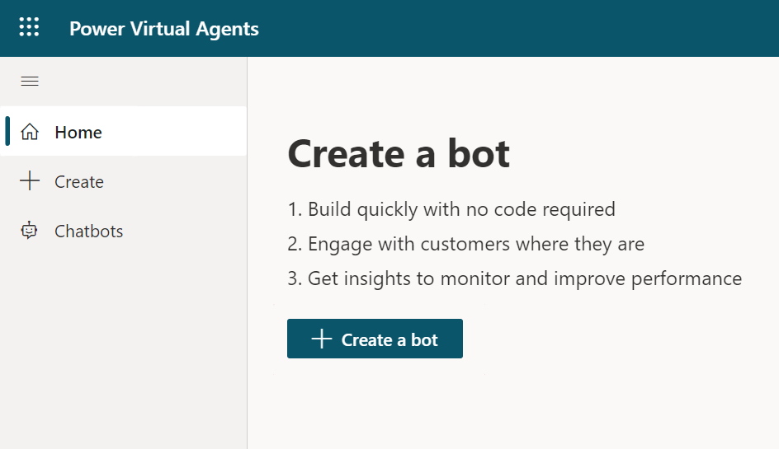

Screenshot of the app-level home page.

**TIP** To navigate back to the home page from a bot, select **Power Virtual Agents** in the top menu bar.

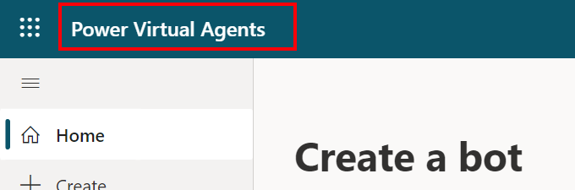

Screenshot of Power Virtual Agents top menu bar.

1. In the side navigation select **Create**, or select **Home** and select **Create a bot**.
2. Name the bot Reservation Bot and select **Create**.

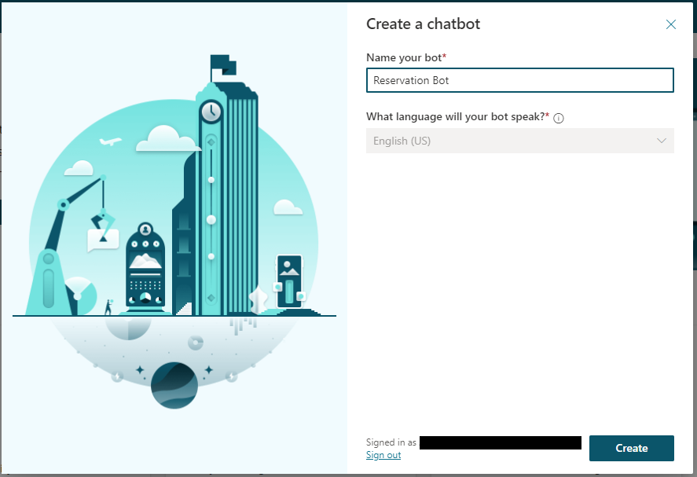

Screenshot of the create a chatbot dialog.

**IMPORTANT** Bots can only be created in English in the technology preview.

## Customize greeting topic

1. In the side navigation, select **Topics**. Then select the **Greeting** topic.
2. Delete all existing **Message** nodes.
3. Add a **Message** node. Then add the following greetings as [message variations](authoring-create-edit-topics.md#message-variations):
   * Good day!
   * Hi there!
   * Hi!
4. [Add an image card](advanced-cards.md#image-card) and provide an image of the restaurant. Providing an image helps the user visually confirm that they’re booking at the correct location.

* 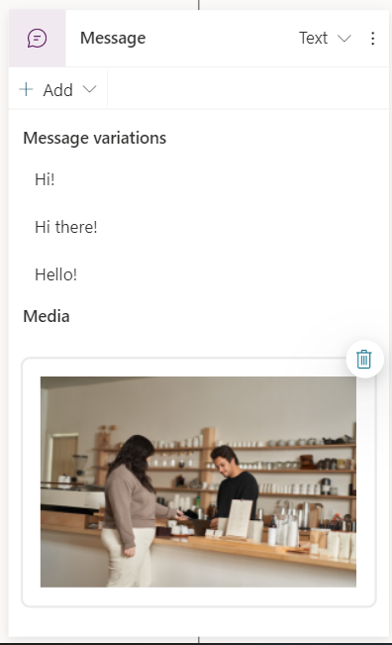
* Screenshot of speech mode toggle.

1. Add a second **Message** node and add the message We're open 9am to 5pm Monday through Friday. Please note we will be closed on May 27th.
2. Change the edit mode to **Speech**.

* The speech mode allows you to add a specific message for voice-enabled channels and enable the use of [SSML tags](advanced-custom-speech-ssml.md).
* 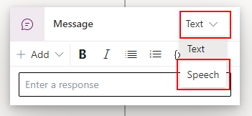
* Screenshot of speech mode toggle.

1. Add the message We're open 9am to 5pm Monday through Friday. <emphasis level="strong">Please note</emphasis><break strength="medium" /> we will be closed on May 27th.

* When the message is spoken by the bot over a phone call, it will put emphasis on “Please note” and pause for a moment before continuing.

1. Add a third **Message** node and add the message If you'd like, I can help you make a reservation. to provide a call to action for the user.
2. Add a [quick reply](authoring-create-edit-topics.md#quick-replies) with the message make a reservation.

* Adding a quick reply gives the user the option to select “make a reservation” instead of having to type it out.
* 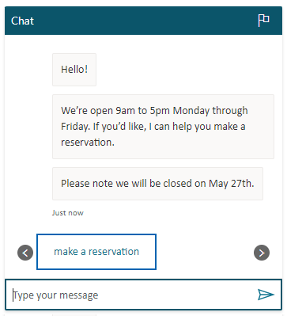
* Screenshot of the reservation quick reply.

1. Select **Save**.

## Add a reservation topic

1. In the side navigation, select **Topics** and then **New topic**.
2. Add the following trigger phrases:
   * make a reservation
   * reserve a time
3. Add a **Question** node and enter the message What is the desired time and date of your reservation?
4. For **Identify** choose **Date and time**. This [entity](advanced-entities-slot-filling.md) enables your bot to extract a date and time from the user’s response.
5. For **Save response as** [create a new variable](authoring-variables.md) named reservationDateTime.
6. [Add a **ConditionItem** node](authoring-create-edit-topics.md#add-a-condition) and [change it to a formula](advanced-power-fx.md#use-power-fx-as-a-condition).
7. Enter the [Power Fx formula](advanced-power-fx.md) DateDiff(Topic.reservationDateTime, Date(2022,5,27)) = 0. This formula will evaluate to true if the date the user provided is May 27th 2022.

* 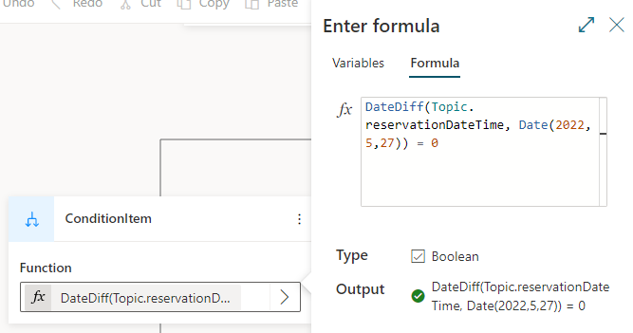
* Screenshot of Power Fx formula in a condition node.

1. Under the **ConditionItem** node add a **Message** node. This node will remind the user that the restaurant is closed on May 5th. Enter the message Sorry, but we're closed on May 27th. Please make a reservation on another day.
2. Under the **All Other Conditions** node, add a **Message** node. This node will provide a confirmation of the user’s reservation. Enter the message Your reservation has been made for {Topic.reservationDateTime}. We look forward to seeing you!.

* 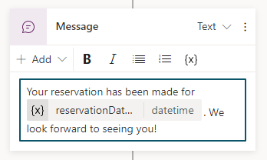
* Screenshot of variable in message node.
* When the bot responds with this message, the variable reference {Topic.reservationDateTime} will be replaced with with the value of the variable.
* 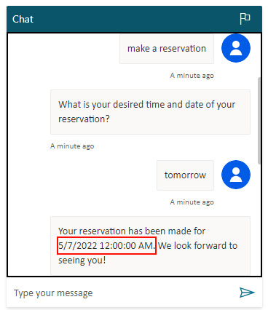
* Screenshot of the variable’s value shown in a message.

1. Add an **Redirect** node where the two condition branches meet and choose the **End of conversation** topic.
2. Name the topic Make a reservation and select **Save**.

## Next steps

1. To allows users to call your bot, you need to [enable and configure the Telephony channel](publication-connect-bot-to-telephony.md).
2. Optionally, [customize your bot’s voice font](advanced-speech-settings.md).
3. [Publish your bot](publication-fundamentals-publish-channels.md).
4. Test your bot using the [demo website](publication-connect-bot-to-web-channels.md), or by calling the phone number configured in Telephony.

# Limitations of technology preview

This technology preview doesn’t yet support some of the existing features you’re used to in Power Virtual Agents and available features have some limitations.

**IMPORTANT** These are the current limitations as of 5/12/2022.

## Limitations of current features

* Analytics may take several hours to update.
* Bots can’t be deleted.
* When sharing a bot, any Power Automate flows used in the conversation logic will not be shared. You’ll have to manually share those flows if desired.
* [Message variations](authoring-create-edit-topics.md#message-variations) do not vary in a single conversation. You’ll only see differences between different conversations.
* The **Track between topics** toggle in the [test bot pane](authoring-test-bot.md) doesn’t work.
* Quick replies are not read over [Telephony channel](publication-connect-bot-to-telephony.md).
* While co-authoring a bot with another user is possible, it’s not a fully supported feature.
* Global variables that are configured to persist across sessions will not work for all channels and is specifically not supported for the [Telephony channel](publication-connect-bot-to-telephony.md) at this time.
* Default values in multiple choice questions don’t work.
* Passing uninitialized variables to [flows](advanced-flow.md) causes an error.
* Only English is supported for the user and bot language.

## Coming in future releases

* Custom entities
* Skills
* Security options for your bot
* Channels (including Teams and Facebook Messenger)
* Agent transfers
* AI capabilities
* Authoring in Teams app
* Bots setup with application lifecycle management (ALM)
* Importing and exporting bots
* Customization of system fallback topic

# Use sample topics in Power Virtual Agents

Power Virtual Agents includes a set of three samples from which you can see examples of topics. These samples range from simple to complex scenarios that use [conditional branching](authoring-create-edit-topics.md) and [custom entities](advanced-entities-slot-filling.md).

## Access and use sample topics for new bots

When a bot is created, several samples are automatically created as topics.

While the topics are functional, they are examples for the purposes of learning how to create content for your bots. The topics aren’t designed for production use.

**Use sample topics to understand how topics work:**

1. Go to the **Topics** tab.
2. Select **Sample 1** and work through to **Sample 3**. Review the title and description, and see which trigger phrases are being used.
3. To see the bot’s flow, select each topic. The flow includes the bot’s comments, expected user responses, decision points, and entity references.

* 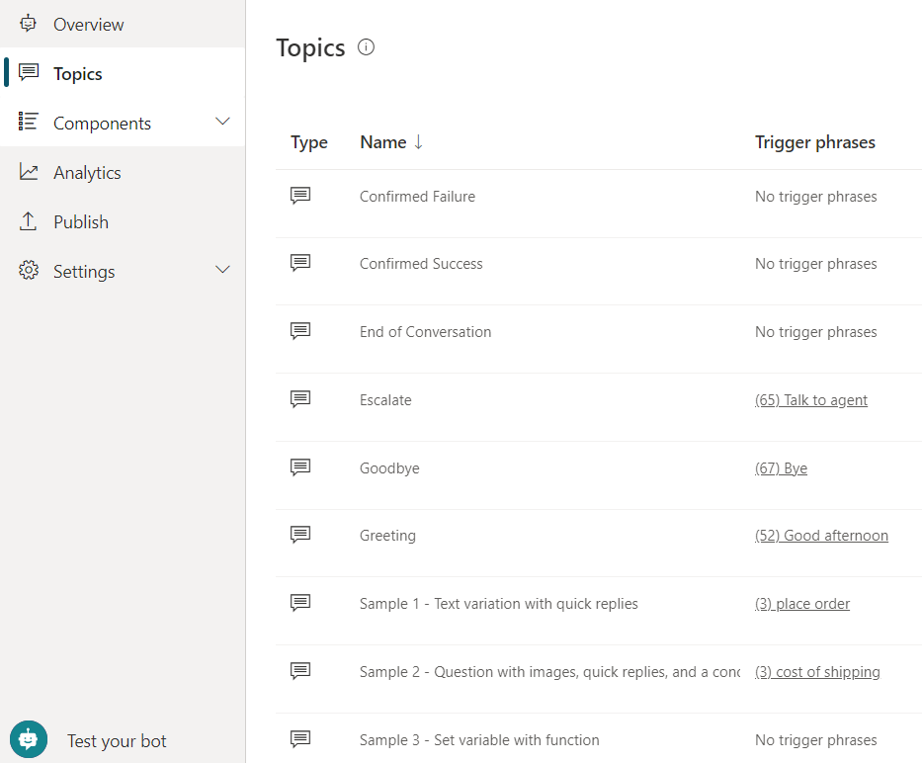
* List of sample topics.” border=“false

**IMPORTANT** You will see these samples when you create a new bot. If you have previously created a bot and don’t see them, try creating a new bot and then going to the **Topics** tab.

## Available sample topics

Each sample is designed to teach you how to use the authoring canvas to create basic and advanced bot conversations.

You should start with **Sample 1** and work through each sample in order.

### Sample 1 - Text variation with quick replies

This sample shows you how to create a simple topic with multiple text variation responses and a quick reply.

### Sample 2 - Question with images, quick replies, and a condition

This sample shows you how you to create a simple question with an image and quick reply that identifies an [entity](advanced-entities-slot-filling.md) and stores it as [a variable](authoring-variables.md), a condition, and a redirect to the next sample topic.

When you use entities in your topic, the bot can identify key information from user response and automatically fills in that information into your variables. A variable is a name for an item that will be used later in the topic flow.

In this sample, the bot uses the State entity to recognize any US state the user enters and stores it as the state variable. This variable is used in the condition, which determines which shipping message to send the user. The topic ends by redirecting to the next sample topic.

### Sample 3 - Set variable with function

This sample shows you how you to create a topic with [a variable](authoring-variables.md) and set it to the value of a function. This variable is used in the a message about shipping time, and finishes by redirecting to the End of Conversation topic.

# Create and edit topics in your Power Virtual Agents bot

In Power Virtual Agents, a topic defines a how a bot conversation plays out.

To author topics, you can [customize provided templates](authoring-template-topics.md), create topics from scratch, or get suggestions from existing help sites.

A topic has *trigger phrases* and *conversation nodes*. Trigger phrases are phrases, keywords, and questions that a user is likely to type that are related to a specific issue. Conversation nodes define how a bot should respond to a trigger phrase and what it should do.

The AI uses natural language understanding (NLU) to parse what a customer types and find the most appropriate trigger phrase or node.

For example, a user might type “Open hours” into your bot. The AI matches that to the **Store hours** topic, begins a conversation that asks which store the customer is interested in, and then displays the hours the store is open.

The **Test bot** pane shows how the bot conversation plays out at every step. You can use the **Test bot** pane to fine-tune a topic without having to exit the Power Virtual Agents portal.

## Use system and sample topics

When you create a bot, several topics are created for you.



Screenshot of the Topics list showing sample topics and system topics.

These automatically created topics fall into two categories:

* [Sample topics](authoring-template-topics.md) help you understand simple to complex ways to use nodes to create bot conversations.
* You can edit sample topics or delete them entirely.
* System topics are topics you’re likely to need during a bot conversation.
* You can’t delete or disable system topics or edit their trigger phrases. However, you can customize the nodes on the authoring canvas. We recommend that you don’t customize these topics until you’re comfortable creating an end-to-end bot conversation.

## Create a topic

1. In the left pane, select **Topics**.

* 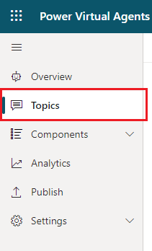
* Screenshot of the Power Virtual Agents navigation pane, highlighting Topics.

1. Select **New topic**.
2. The **Trigger phrases** pane should open. If it doesn’t open, select **Trigger phrases**.

* 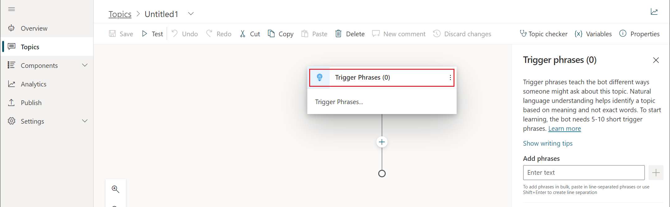
* Screenshot of the topic authoring canvas, highlighting Trigger phrases.

1. Specify one or more trigger phrases for the topic in the **Trigger phrases** pane.

* 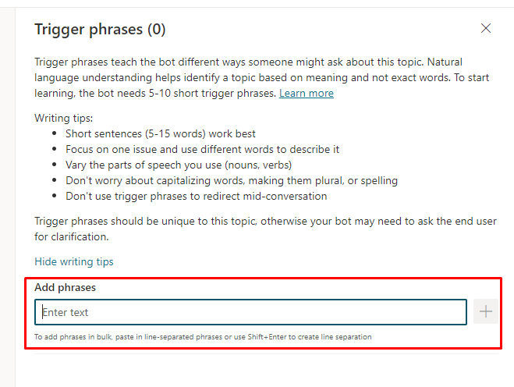
* Screenshot of the topic authoring canvas, highlighting adding trigger phrases.
* A trigger phrase is a phrase that a customer enters in the chat window to start a conversation with the bot. Once the conversation is started, the conversation follows the path you define.
* You can specify more than one trigger phrase for a topic. You can include punctuation in a trigger phrase, but it’s best to use short phrases rather than long sentences.

1. Select **Details** to open the topic details pane.

* 
* Screenshot of the topic authoring canvas, highlighting Details.

1. Enter a **Name** for your topic and, optionally, a **Display name** and **Description**.

* The bot uses the **Display name** when it needs to know which topic the person is asking about.
* The **Description** is never shown to users. Use it to describe the purpose of the topic to yourself and other bot makers.
* 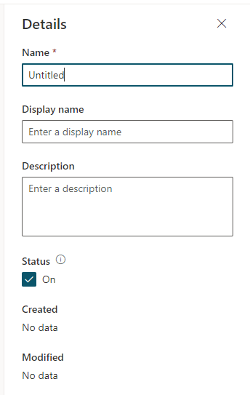
* Screenshot of the topic details pane showing Name, Display name, and Description.
* You can also rename the topic by selecting its name and entering a new value.
* 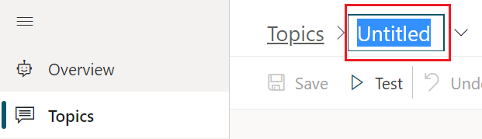
* Screenshot of the topic authoring canvas, highlighting the topic name.

1. Select **Save** to add the topic to the topics list.

## Design the topic’s conversation path

1. In the topic list, select the topic you want to edit.

* Power Virtual Agents opens the topic in the authoring canvas and displays the topic’s trigger phrases. The authoring canvas is where you define the conversation path between a customer and the bot.
* For existing or system topics, several nodes are created automatically. You can edit these nodes just as you would edit other nodes.
* When you create a new topic, a **Trigger phrases** node and a blank **Message** node are inserted for you.

1. To add a node, select the plus (**+**) icon on the line or branch between or after nodes.

* 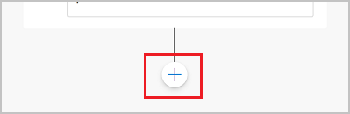
* Screenshot of adding a node.

### Insert nodes

You have several options when you add a node. Each option has a specific node or nodes that will be inserted in the conversation path.

When you add a node after the **Trigger Phrases** node or between **Message nodes**, you can:

* Send a message
* Ask a question
* Add a condition
* Set a variable value
* Manage topics
* Call an action

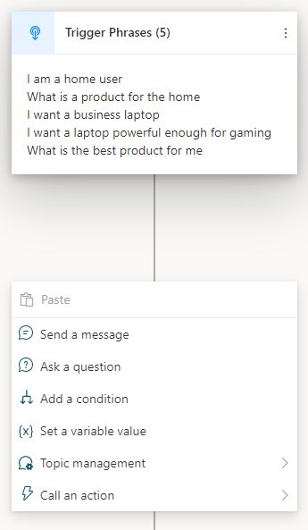

Screenshot of adding a node between existing nodes from the options.

#### Ask a question

1. To have the bot ask a question and get a response from the user, select **+** to add a node, and then select **Ask a question** to add a new **Question** node.

* 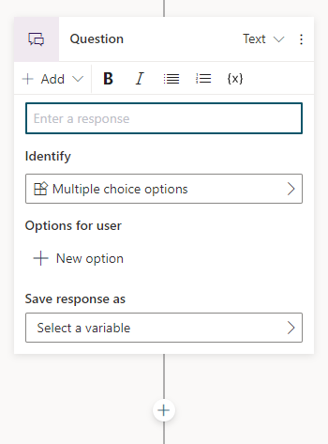
* Screenshot of adding a new question mode.

1. Enter the question phrase in **Ask a question**.
2. Optionally, you can add variations of the question.
3. In the **Identify** list, select an option for the user’s response.

* The options determine what the bot should listen for when the user responds. For more information, see [Use entities in a conversation](advanced-entities-slot-filling.md#use-entities-in-a-conversation).

1. Depending on what you selected in **Identify**, enter the options the user should have.

* For example, if you selected **Multiple choice options**, enter the choices the user can specify in **Options for user**. Each choice is presented to the user as a multiple choice button, but users can also type their answer.

1. In **Save response as**, select an existing variable or create a new one in which to save the user response.
   * For **Save response as**, you can use an existing variable or create a new one.
   * If you create a new variable, select the variable name to display the variable properties, where you can modify the variable’s settings, including its name.
   * 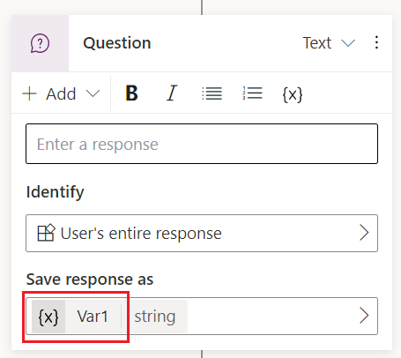
   * Select variable name to display variable properties
2. Optionally, open the properties pane for the question node to modify addition settings, such as maximum retry count and what to do if the user exceeds that count.

Later, you can add a condition to create branching logic or add nodes to control how the bot responds based on each variable.

**TIP** Define synonyms for each option to help the bot determine the correct one if it isn’t clear what the user’s response should map to.

1. Select the **Edit synonyms** icon for the option you want to add additional keywords to.

* 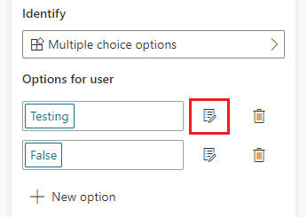
* Screenshot highlighting the synonyms icon.

1. Add the keywords individually. When you’ve entered all the synonyms you want, select **Done**.

#### Call an action

To [call Power Automate Flows](advanced-flow.md) and insert authentication nodes, select **Call an action**.

If you’ve configured hand-off to omnichannel with voice-based capabilities, you’ll see more actions.

#### Send a message

1. To specify a response from the bot, select **+** to add a node, and then select **Send a message** to add a new **Message** node.
2. Enter what you want the bot to say in the text box.

* You can apply some basic formatting, such as bold, italics, and numbering. You can also [use variables](authoring-variables.md) that you defined elsewhere in your bot conversation.

1. Optionally, you can add message variations.

To enhance messages with rich multimedia cards, see [Add multimedia cards to messages](/advanced-cards.md).

#### Go to another topic

1. To have the bot move to a different topic, select **+** to add a node, and then select **Topic Management**, then **Go to another topic**.

* 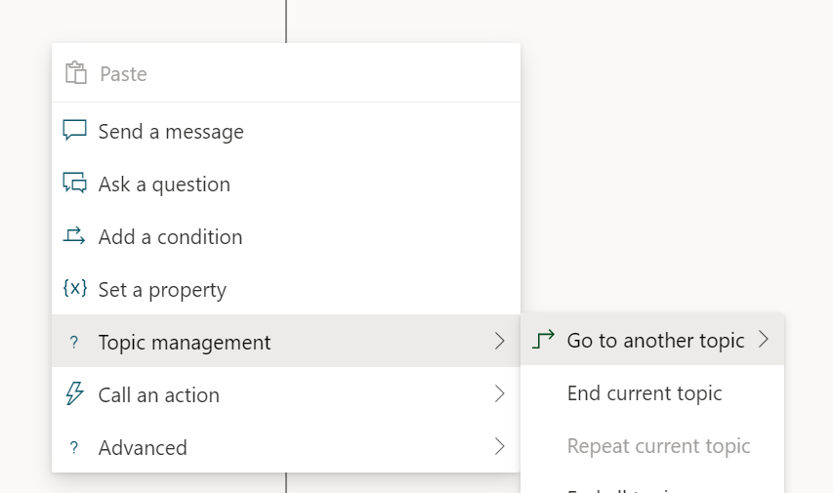
* Screenshot showing redirection to another topic node with options for other topics.

1. Select an existing topic from the list, or **Create a topic**.

* **TIP** Before creating a new topic, save your current topic first. Creating a new topic will open the new topic in the authoring canvas, and any unsaved edits you have in the current topic will be lost.
* 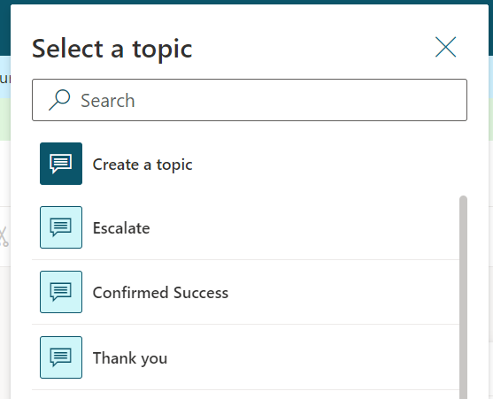
* Screenshot of redirect topic list.

1. If there are any [input](/authoring-variables.md#receive-values-from-other-topics) or [output](/authoring-variables.md#return-values-to-original-topics) variables in the next topic, enter or select a value for each one.
2. Save your topic, then use the test bot pane to confirm that your bot successfully calls the next topic.

In the authoring canvas for the original topic, you can insert additional nodes under the **Redirect** node.

When the path for the topic chosen in the **Redirect** node is finished, the bot will return to the original topic. The bot will then follow the nodes that are under the **Redirect** node.

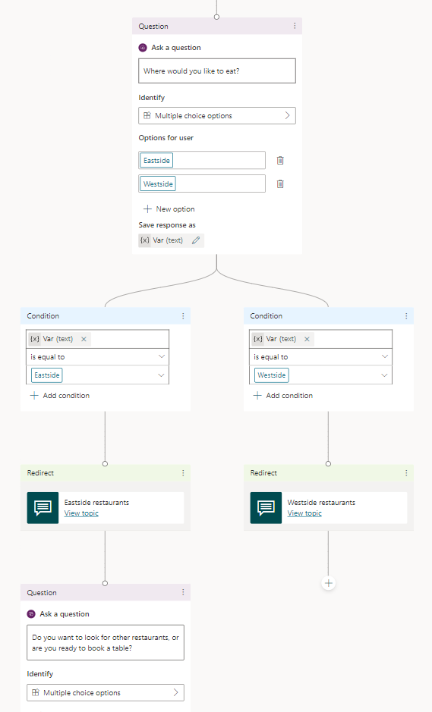

Screenshot of the authoring canvas showing nodes under a redirected topic node.

#### End the conversation or topic

If you redirect to any of the following system topics, the current conversation flow will end. Unless modified, these topics have the following behavior. To provide a consistent user experience at the end of a conversation, you can redirect to these topics or implement your own.

| Topic | Behavior |
| --- | --- |
| Confirmed Failure | The user can ask another question or request to talk to an agent, which redirects to the Escalate topic. |
| Confirmed Success | The user is presented with a satisfaction survey, and then can ask another question or leave the conversation, which redirects to the Goodbye topic. The survey response is collected on the [customer satisfaction analytics page](analytics-csat.md). |
| End of Conversation | The user is asked if their question was answered. Based on their response, the bot redirects to the Confirmed Success or the Confirmed Failure topic. |
| Escalate | This topic is incomplete. You can hand the conversation over to a live agent if you’re using a suitable customer service portal, such as Omnichannel for Customer Service. |
| Goodbye | Thanks the user and indicates to the user’s client that the session is over. The behavior varies based on the client. On the telephony channel, for example, the client will hang up. |
| Start over | Resets the conversation and resets [global variables](authoring-variables-bot.md) for the current session. |

Use the following nodes to design conversation flow in your bots.

1. Select **+** to add a node, and then select **Topic Management**, then one of the following:

* 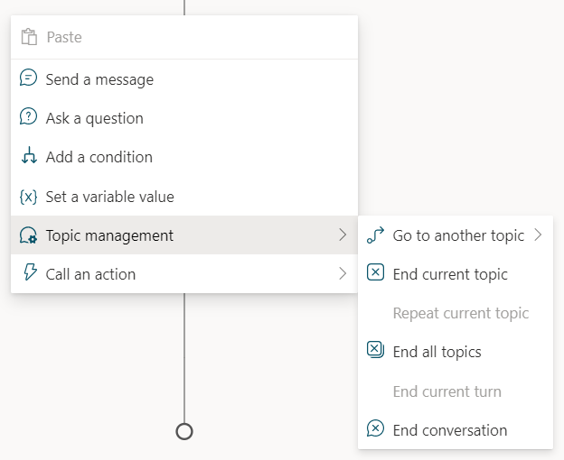
* Screenshot showing options for ending a conversation.
  + Select **End conversation** to notify the user’s client that the session is over. The behavior varies based on the client. On the telephony channel, for example, the client ends the call.
  + Select **End all topics** to clear all active topics and start the conversation from the beginning. However, this does not clear or reset any global variables. To clear global variables, redirect to the Start over system topic.
  + Select **End current topic** to end the current topic and return to the calling topic, if any. You can use this node to create a one conversation branch that exits the topic while another branch continues.
  + Select **Go to another topic** to *call* or redirect to another topic. When that topic ends, control returns to calling topic.

#### Add a condition

1. To add branching logic based on [variables](authoring-variables.md), select **+** to add a node, then select **Add a condition**.
2. In the first condition node, select the variable and condition that will determine how the bot conversation should branch at this point.
   * For example, if you’ve set up user authentication, you might specify a different message if the user is signed in (which may have happened earlier in the conversation).
   * You can create a condition using the basic editor or you can switch to a the Power Fx formula editor and manually enter an expression.
   * To switch from the formula editor back to the basic editor, reset the node; however, you will need to enter your condition again.
   * Use the *node menu* (⋮) to switch editing modes or reset the node.

* 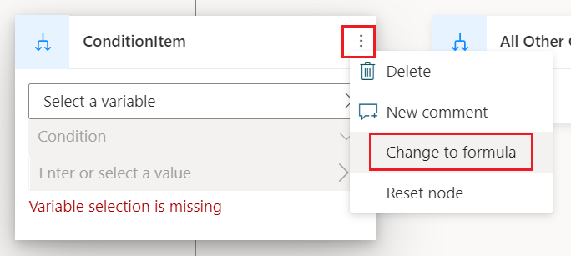
* Switch to the Power Fx expression editor

1. When working with a string variable in the basic condition editor, you can enter a string literal in the value field, such as Contoso. For other variable types, such as Boolean, use the Power Fx editor to compare the variable to a literal value, such as true.
2. Use the **+** that precedes the condition, then **Add a condition** to add more branches.

### Quick replies

The **Message** and **Question** nodes allow you to add *quick replies*. To add a quick replies select **Add**, then **Quick reply**, and then provide information for each *quick reply*.

* A quick reply generates a button the user can select.
* You can select what type of action the button initiates, such as sending a message from the user’s client, opening a URL, or calling a phone number.
* The quick reply buttons are removed from the chat history when the bot or user sends another activity.

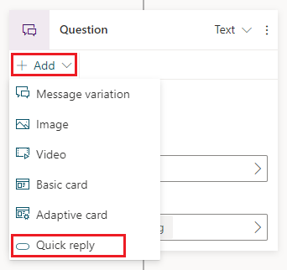

Add quick replies to a question node” border=“false

A quick reply works like a suggestion that the user can use or ignore. To enforce a choice from a finite list, use a multiple choice question node.

[TIP] Some user clients do not support quick replies, in which case the client may not render them. Some user clients have an upper limit on the number of quick replies that they allow.

#### Set a variable value

See [Set variable value](authoring-variables.md#set-a-variable).

### Message variations

The **Message** and **Question** nodes allow you to add message variations. When you do this, the bot will respond randomly with one of the variations.

1. Select **Add** and then **Message variation**. This will add an additional text box for a message variation.

* 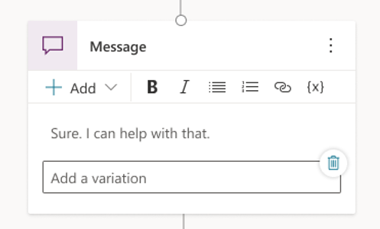
* Select the synonyms icon.” border=“false

1. Enter what you want the bot to say. You can apply some basic formatting, such as bold, italics, and numbering.
2. Repeat to add as many variations as you like.

### Delete nodes

Select the menu icon at the top of the node’s title, and then select **Delete**.

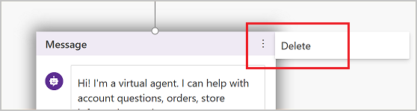

Screenshot highlighting the node menu button and the Delete button.

## Edit topics with the code editor

The code editor shows the topic in [YAML](https://yaml.org/), a markup language which is easy to read and understand. Use the code editor to copy and paste topics from other bots, even ones created by other authors.

**IMPORTANT** Designing a topic entirely in the code editor is currently not fully supported.

In this example you’ll copy and paste YAML into the code editor to quickly add a topic that asks the user if they prefer cats or dogs.

1. On the topic list, create a **New topic**.
2. Select the three dots icon then select **Open code editor**

* 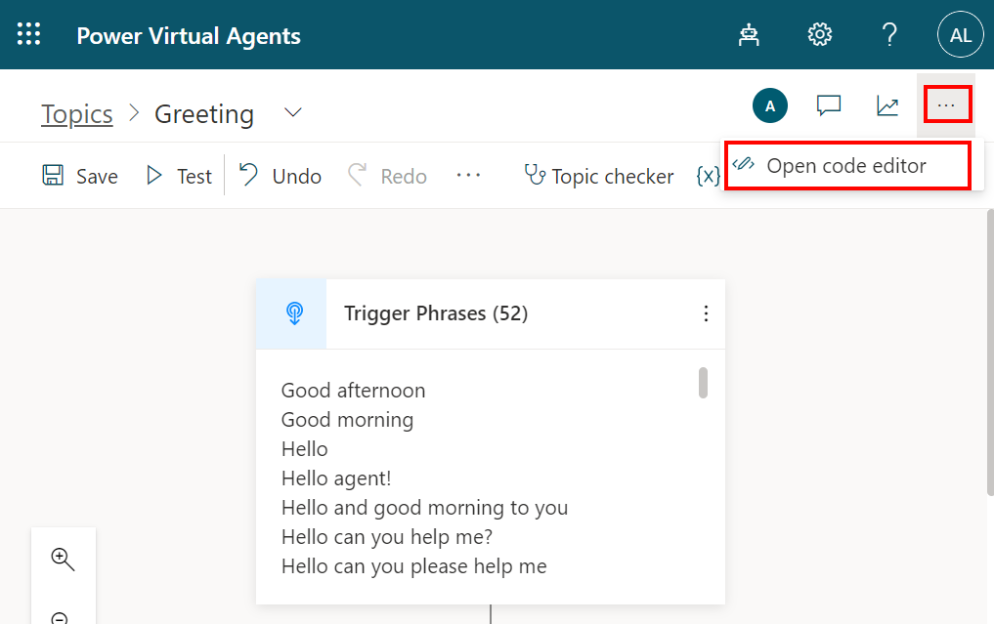
* Screenshot of how to open the code editor.

1. Remove all of the existing YAML. Then copy and paste the following:

* kind: AdaptiveDialog  
  id: FL9xjs  
  autoEndDialog: true  
  beginDialog:  
  kind: OnRecognizedIntent  
  actions:  
   - kind: Question  
   id: question_Pf6ZSq  
   disabled: false  
   allowInterruptions: true  
   property: Topic.chosenAnimal  
   prompt:  
   kind: Message  
   text:  
   - Do you like cats or dogs?  
    
   maxTurnCount: 3  
   entity:  
   kind: EmbeddedEntity  
   definition:  
   kind: ClosedListEntity  
   items:  
   - id: pD60EN  
   displayName: Cats  
    
   - id: aZdKO5  
   displayName: Dogs  
    
   - kind: Condition  
   id: condition_65zClW  
   conditions:  
   - id: conditionItem_7mbFIC  
   condition: =Topic.chosenAnimal = 'cr08a_codeEditor050922.topic.Untitled.main.question_Pf6ZSq'.pD60EN  
   actions:  
   - kind: SendMessage  
   id: sendMessage_3IR6t8  
   disabled: false  
   message:  
   text:  
   - Meow!  
    
   - id: conditionItem_XN7izI  
   condition: =Topic.chosenAnimal = 'cr08a_codeEditor050922.topic.Untitled.main.question_Pf6ZSq'.aZdKO5  
   actions:  
   - kind: SendMessage  
   id: sendMessage_uVbAox  
   disabled: false  
   message:  
   text:  
   - Woof!  
    
  id: main  
  intent:  
   displayName: Animal  
    
  inputType: {}  
  outputType: {}  
  variables:  
  - name: chosenAnimal  
   scope: Dialog  
   isExternalInitializationAllowed: false  
   initializer:  
   kind: ActionInitializer  
   action:  
   triggerId: main  
   actionId: question_Pf6ZSq  
    
  disabled: false

1. Select the three dots icon then select **Close code editor**. On the authoring canvas you’ll see the new conversation path generated from the YAML.

* 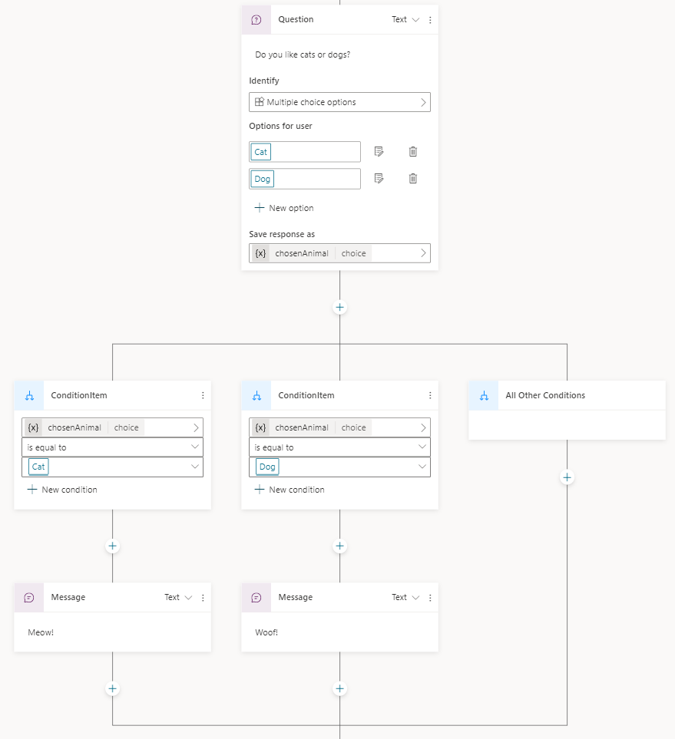
* Screenshot conversation created from YAML.

## Test and publish your bot

[Test your bot](authoring-test-bot.md) when you make changes to your topics, to make sure that everything is working as expected.

After you’ve designed and tested your bot, [publish it to the web, mobile or native apps, or Microsoft Bot Framework channels](publication-fundamentals-publish-channels.md).

# Manage topics in Power Virtual Agents

There are a number of ways you can manage your topics. Power Virtual Agents includes a topic checker that lets you know if there are errors in your topics, you can turn topics on or off so they don’t appear to people chatting with your bot, and you can copy or duplicate topics to make it easier to create new ones.

* Manage topics in Power Virtual Agents
  + Topic errors
    - Types of errors
  + Topic status
  + Copying a topic

## Topic errors

When you save a topic, you’ll be notified if there are errors or warnings. Warnings won’t stop the bot from working, but they may cause individual topics to not work as expected, so you should fix them when you see them.

Errors will prevent the bot from working and must be fixed before you can publish your bot.

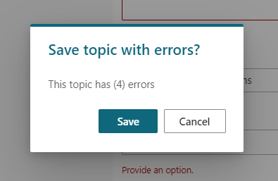

The message indicates you have errors you should fix.

You can see the error state of a topic on the Topics page.

**NOTE** The Topics page only shows errors as they will stop your bot from working, unlike warnings.

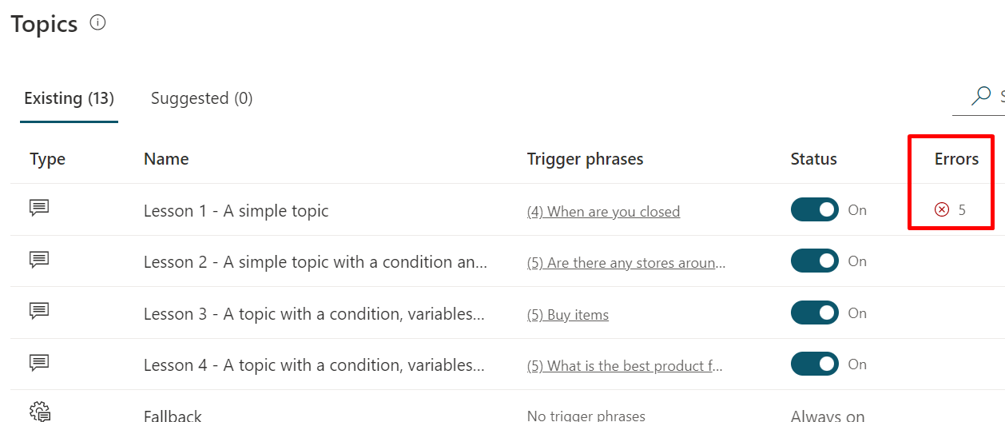

The topics page identifies the number of errors in your topic.

Select the error count to open the authoring canvas to where the first error is. Select **Topic checker** to see a list of the errors. Selecting each error goes directly to the error.

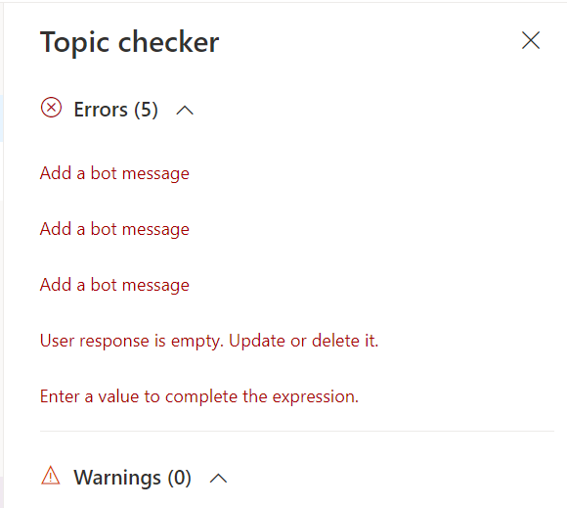

The topic checker is on the top bar and shows all errors and warnings.

**NOTE** You can save topics with errors. Topics with errors can’t be published.

### Types of errors

There are four types of errors that appear in the topic checker and in the authoring canvas:

* *Node*: The entire node is incorrect and is highlighted red.
* *Field*: The field might be missing required data and is highlighted red.
* *Expression*: The expression might be invalid and is highlighted red.
* *Variable deletion*: A variable in a topic was deleted and is highlighted red wherever it was used. This causes the variable to become “orphaned”, and it must be either removed or replaced.

## Topic status

Topics can have a status of **On** or **Off**. This refers to their ability to be used or triggered in a bot conversation.

When a topic is **On**, it will trigger as expected, either as a result of its trigger phrases or when it is redirected to from another topic. The majority of your topics are likely to be in the **On** state.

When a topic is **Off**, it will not trigger at all. This means that if its trigger phrases are used in a bot conversation, it will not trigger, just as if the topic doesn’t exist. An **Off** topic will also not be redirected to, even if another topic has specified that it should be.

When a bot is published, all topics (**On** or **Off**) will be published, but the **Off** topics will not trigger.

**TIP** Turning a topic to **Off** allows you to work on a particular topic and leave it in a draft state while publishing changes to other topics that are ready to go live.

Leave the topic that you are still working on as **Off** before publishing the bot.

You can change this with the toggle in the **Status** column on the Topics page.

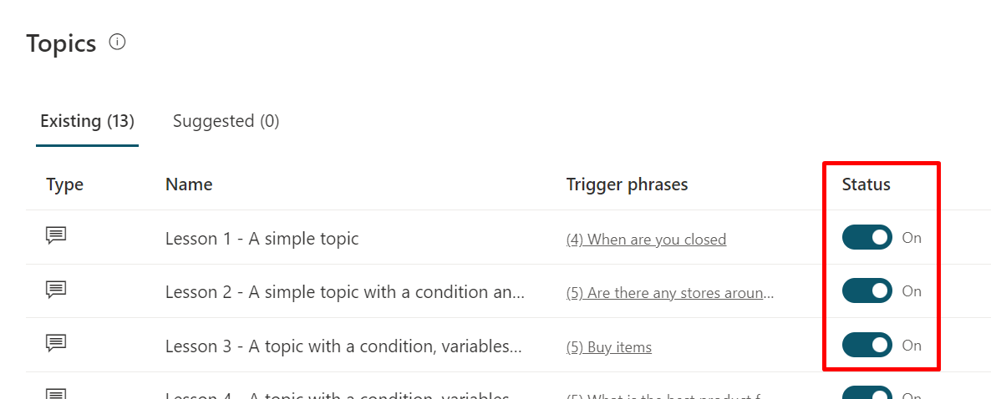

The Status column shows each topic with an On or Off toggle switch.

By default new topics will be created with their status set to **On**.

**NOTE** The Topic Checker will identify an error if a topic redirects to an ‘off’ topic.

## Copying a topic

Once you have created a few topics, you may want to use a previous topic as a baseline when creating new topics.

On the Topics page, select the menu icon on a topic’s name and then **Make a copy**.

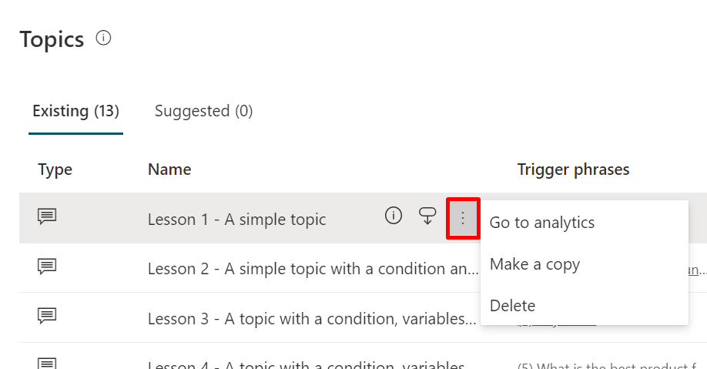

Make a copy from the menu icon.” border=“false

This option creates a duplicate of the selected topic with *(Copy)* added to the name. All of the topic content - such as the description, trigger phrases, and the entire conversation - is copied over to the new topic.

A copied topic has a status of **Off** by default when it is copied to avoid confusion on which topic will trigger, since the trigger phrases are the same as the original topic.

Once you are done editing the new topic, you can turn it **On** to [test it in the Test bot](authoring-test-bot.md) and, when ready, publish the new topic.

There is no limit to the number of times a topic can be copied. A number will be added to the name and each topic will have its own internal ID.

# Add comments to bots (Preview)

Comments are notes that are associated with items in your bot. Use comments to help your team collaborate on the bot and provide feedback, or provide additional information on implementation details in your bot.

In Power Virtual Agents comments can be attached to topics and individual nodes within topics. The comments are stored in a table in Dataverse in the default solution.

Comments are commonly questions, feedback, or ideas that can provide important context for other makers who work on your bot’s topics.

You can create comment threads to track a single or multiple issues, and you can delete or resolve them if they’re no longer relevant.

Comment threads are created when someone replies to an existing comment. Using threads means you can discuss a single issue without getting confused with lots of replies about different things.

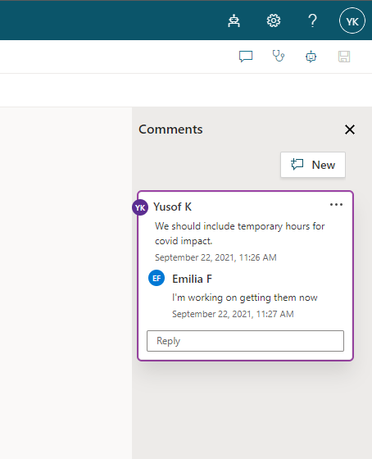

Screenshot of the Comments pane.

## Manage comments

The **Comments** pane lets you create new comment threads, resolve or delete comment threads, and add or delete individual comments.

You open the pane by selecting the **Comments** icon at the top of the authoring canvas for a topic.

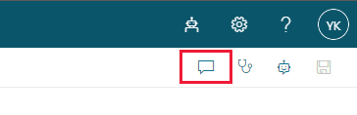

Screenshot with the Open comments menu icon selected, the menu icon looks like a chat box.

Comment threads can be created at both the topic level and for individual nodes within the topic.

Both types of comment threads are shown in the **Comments** pane. Topic-level topics will show first, in order of when they were created, and node-level topics will show in the order of where the node appears in the topic.

Selecting a node-level comment thread will move the authoring canvas to the associated node and highlight it.

Selecting a topic-level comment thread will move the authoring canvas to the last selected node.

### Create a topic-level comment thread

To create a new topic-level comment thread, open the **Comments** pane and select **New**.

Enter your comment and select **Post comment** at the bottom of the comment entry field. You can also press **Ctrl+Enter** to post the comment.

### Create a node-level comment thread

To create a new topic-level comment thread, select the menu icon (. . .) at the top of the node, and then **New comment**.

Enter your comment and select **Post comment** at the bottom of the comment entry field. You can also press **Ctrl+Enter** to post the comment.

A comment icon will appear next to a node that has comments. You can select the icon to open the **Comments** pane and go to the first comment for that node.

### Edit, delete, and resolve comment threads

Select the menu icon at the top of the comment thread to edit the initial comment, delete the entire thread, or resolve the entire thread.

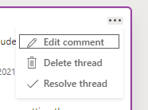

Screenshot of the menu that appears with the items Edit comment, Delete thread, and Resolve thread.

* Editing the initial comment lets you change only that comment. Other comments in the thread won’t be affected.
* Deleting a thread removes it completely. You can’t restore deleted comments or threads.
* Resolving a thread causes it to appear faded, and places the label **Resolved** at the top of the thread. Select the arrow icon at the top of the thread to unresolve a thread. Unresolving a thread lets you add more comments.

### Edit and delete individual comments

Select the menu icon at the top of an individual comment, next to the your name, to edit or delete a comment.

You can only edit or delete comments that you created.

* Editing the comment lets you change that comment.
* Deleting the comment removes it completely from that thread. You can’t restore deleted comments.

## Additional notes

* Comments won’t be exported when you export a bot with a solution.
* You can’t @ mention other bot makers in a comment.
* New comments will show for other bot makers who are editing the same topic when they refresh the page. The topic doesn’t need to be saved for new comments to show.

# Test your Power Virtual Agents bot

As you design your bot in Power Virtual Agents, you can use the **Test bot** pane to see how the bot leads a customer through the bot conversation.

To help you find and fix unexpected behavior, you can enable tracking between topics to take you through the bot conversation step-by-step, and go to the corresponding node in the authoring canvas.

## Test a topic in the Test bot pane

1. If the **Test bot** pane is hidden, open it by selecting **Test your bot**.

* 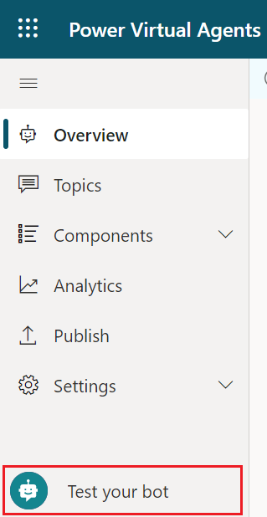
* The Test your bot button is at the bottom of the side pane.” border=“false

1. It’s a good idea to select **Reset** at the top of the **Test bot** pane to clear previous conversations. Clearing previous conversations makes it easier to see the flow of the topic you want to see without getting confused by previous conversations.

* 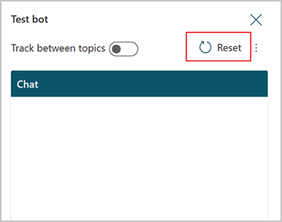
* Click Reset at the top of the Test bot pane to clear conversation history.” border=“false

1. At the **Type your message** prompt at the bottom of the **Test bot** pane, enter a trigger phrase for the topic.

* The trigger phrase starts the topic’s conversation, and the **Test bot** pane displays the bot responses and user response choices you specified.

1. Continue the conversation, testing that it flows in the intended as [designed in the topic](authoring-create-edit-topics.md).
2. Select a response in the **Test bot** pane, which will take you to the response in the conversation editor for that topic. The authoring canvas displays highlighted nodes in green.

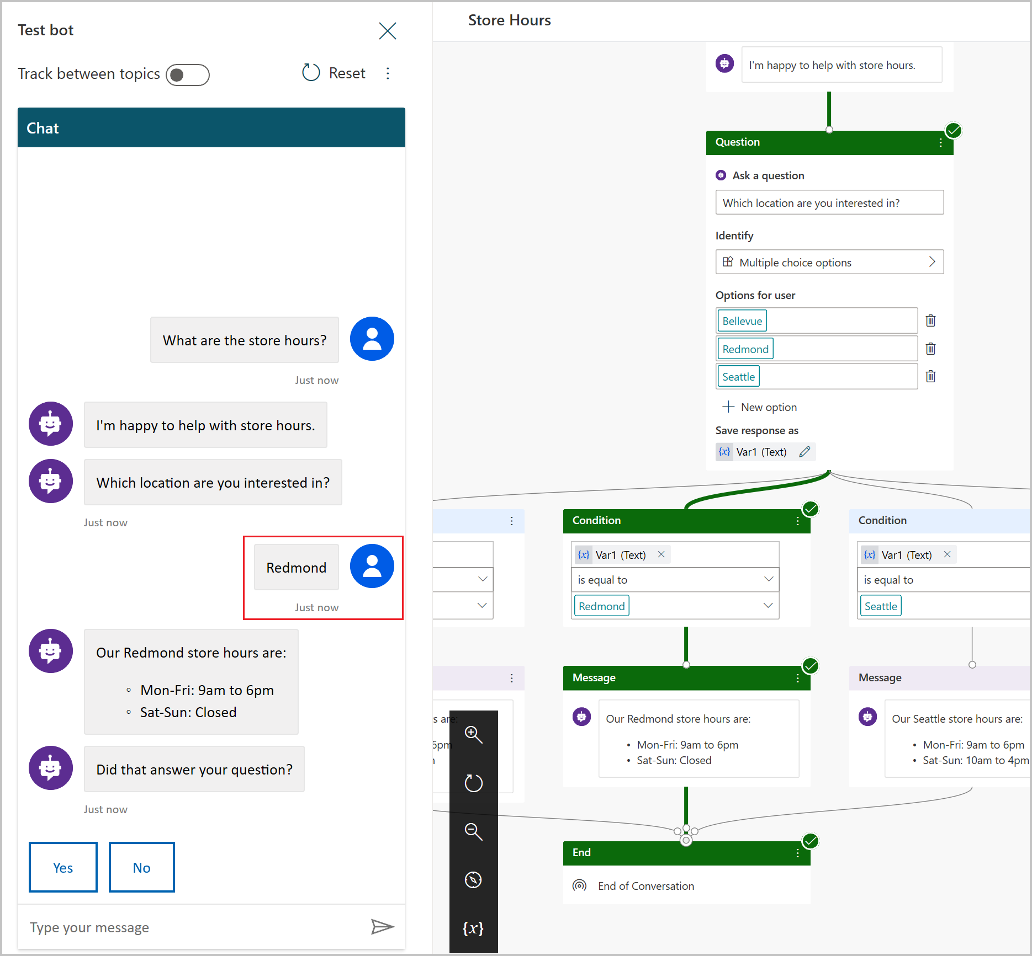

Select any response in the conversation to see the authoring canvas highlighted to that response.” border=“false

You can return to the authoring canvas for the topic at any time to revise it’s conversation path. The **Test chat** pane will automatically refresh itself when you save changes to a topic.

## Save conversation snapshots

While testing your bot in the **Test bot** pane, you can use the **Save snapshot** command to get conversational diagnostics data. This data can help you troubleshoot issues, such as the bot not responding in the way you expect.

**WARNING** The snapshot contains all of your bot content, which may include sensitive information.

1. At the top of the **Test bot** pane, select the menu icon (three vertical periods) and then **Save snapshot**.

* 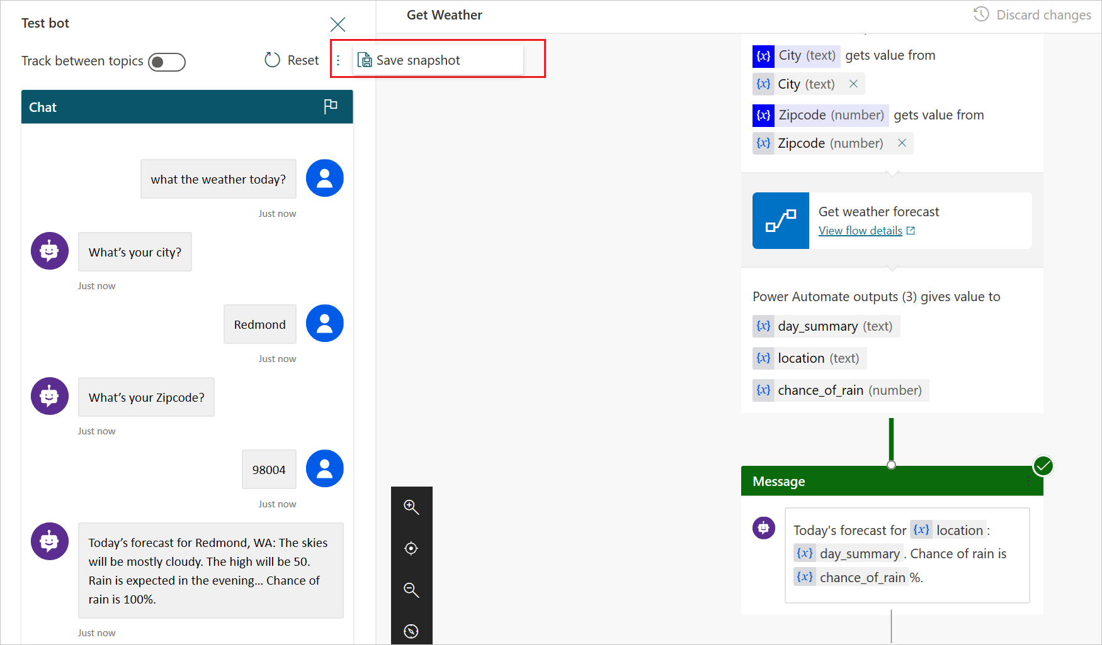
* Save snapshot.

1. In the window that appears, select **Save**.

* 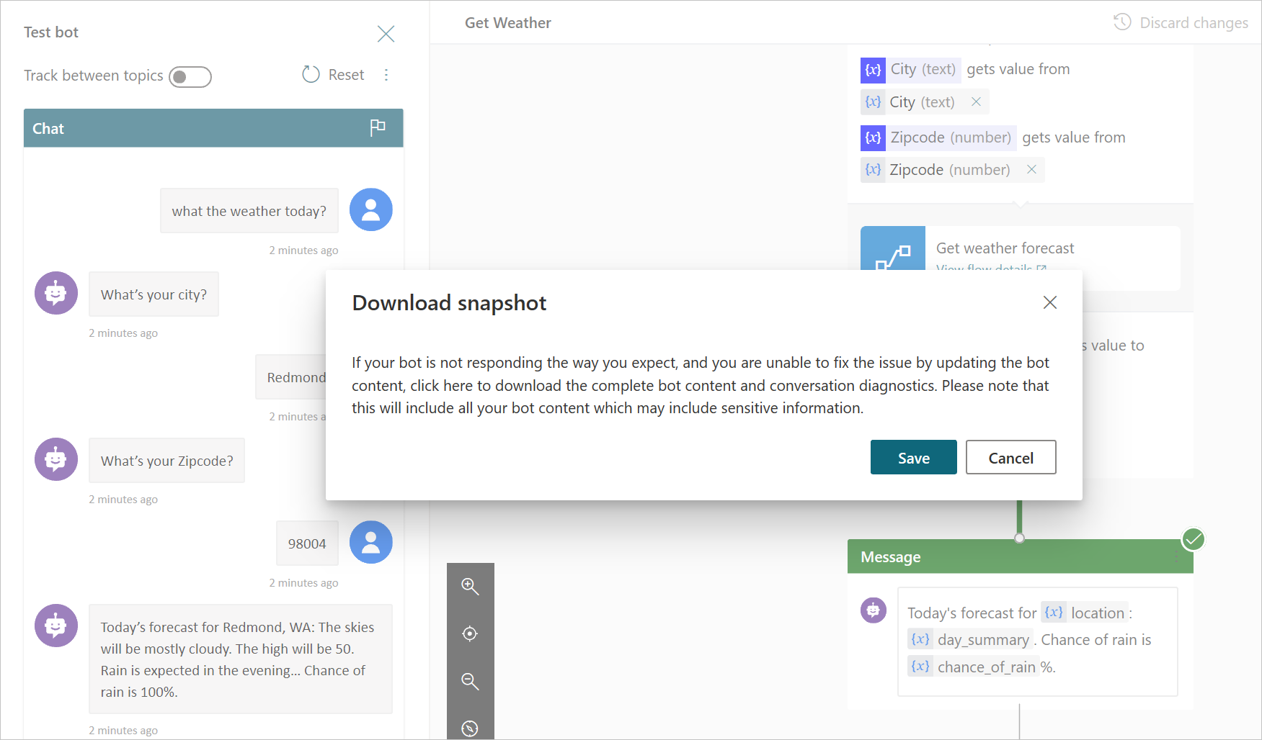
* Save snapshot message.

1. The bot’s content and conversational diagnostics will be saved in a .zip archive file called *DSAT.zip*.

* 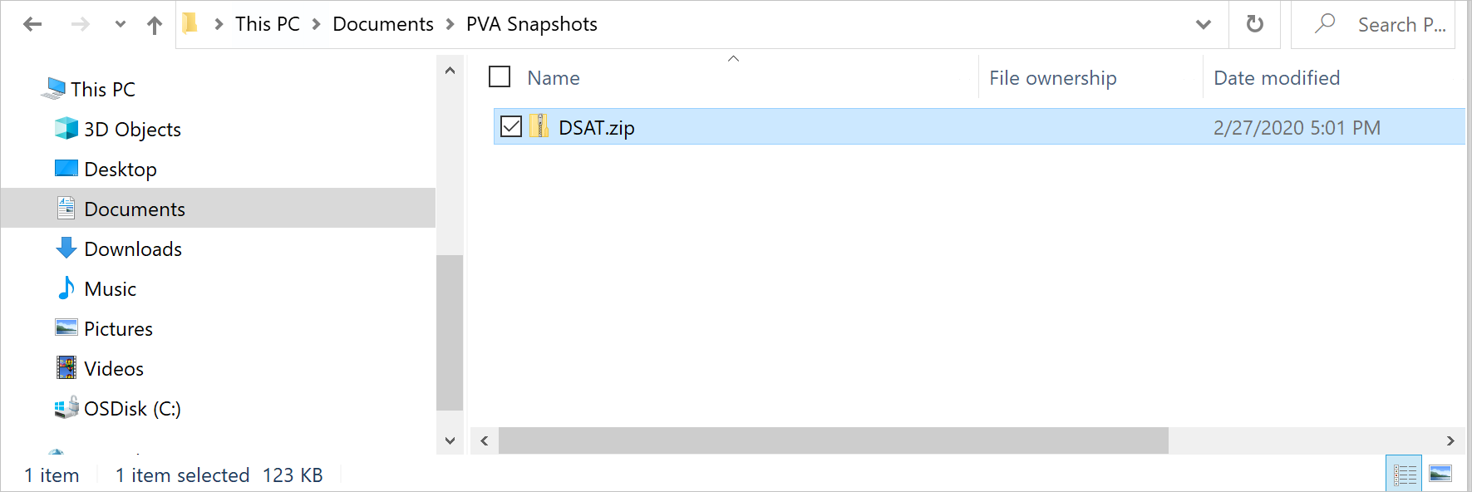
* Conversational diagnostics archive.

1. The *DSAT.zip* file contains two files: *botContent.json* and *dialog.json*.
   1. *dialog.json* contains conversational diagnostics, including detailed descriptions of errors.
   * 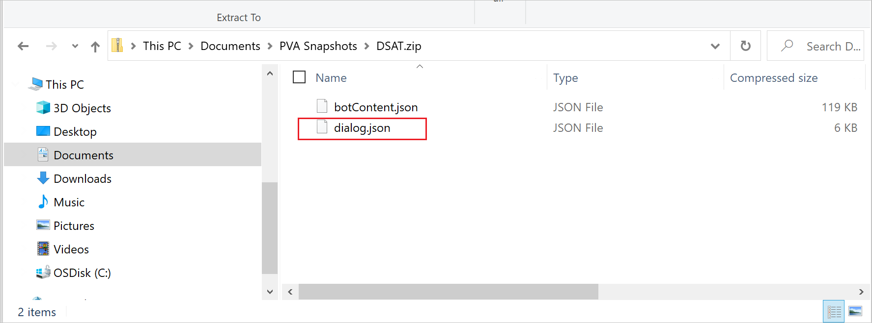
   * Conversational diagnostics file.
   1. *botContent.json* contains the bot’s topics and other content, including entities and variables used in the bot.

Help us improve Power Virtual Agents by flagging issues with the **Flag an issue** command on the test bot pane. This submits your conversation ID to Microsoft, which is a unique identifier that Microsoft uses to troubleshoot the issue of the conversation. Other information, such as that in the *DSAT.zip* file, is not sent when you flag an issue.

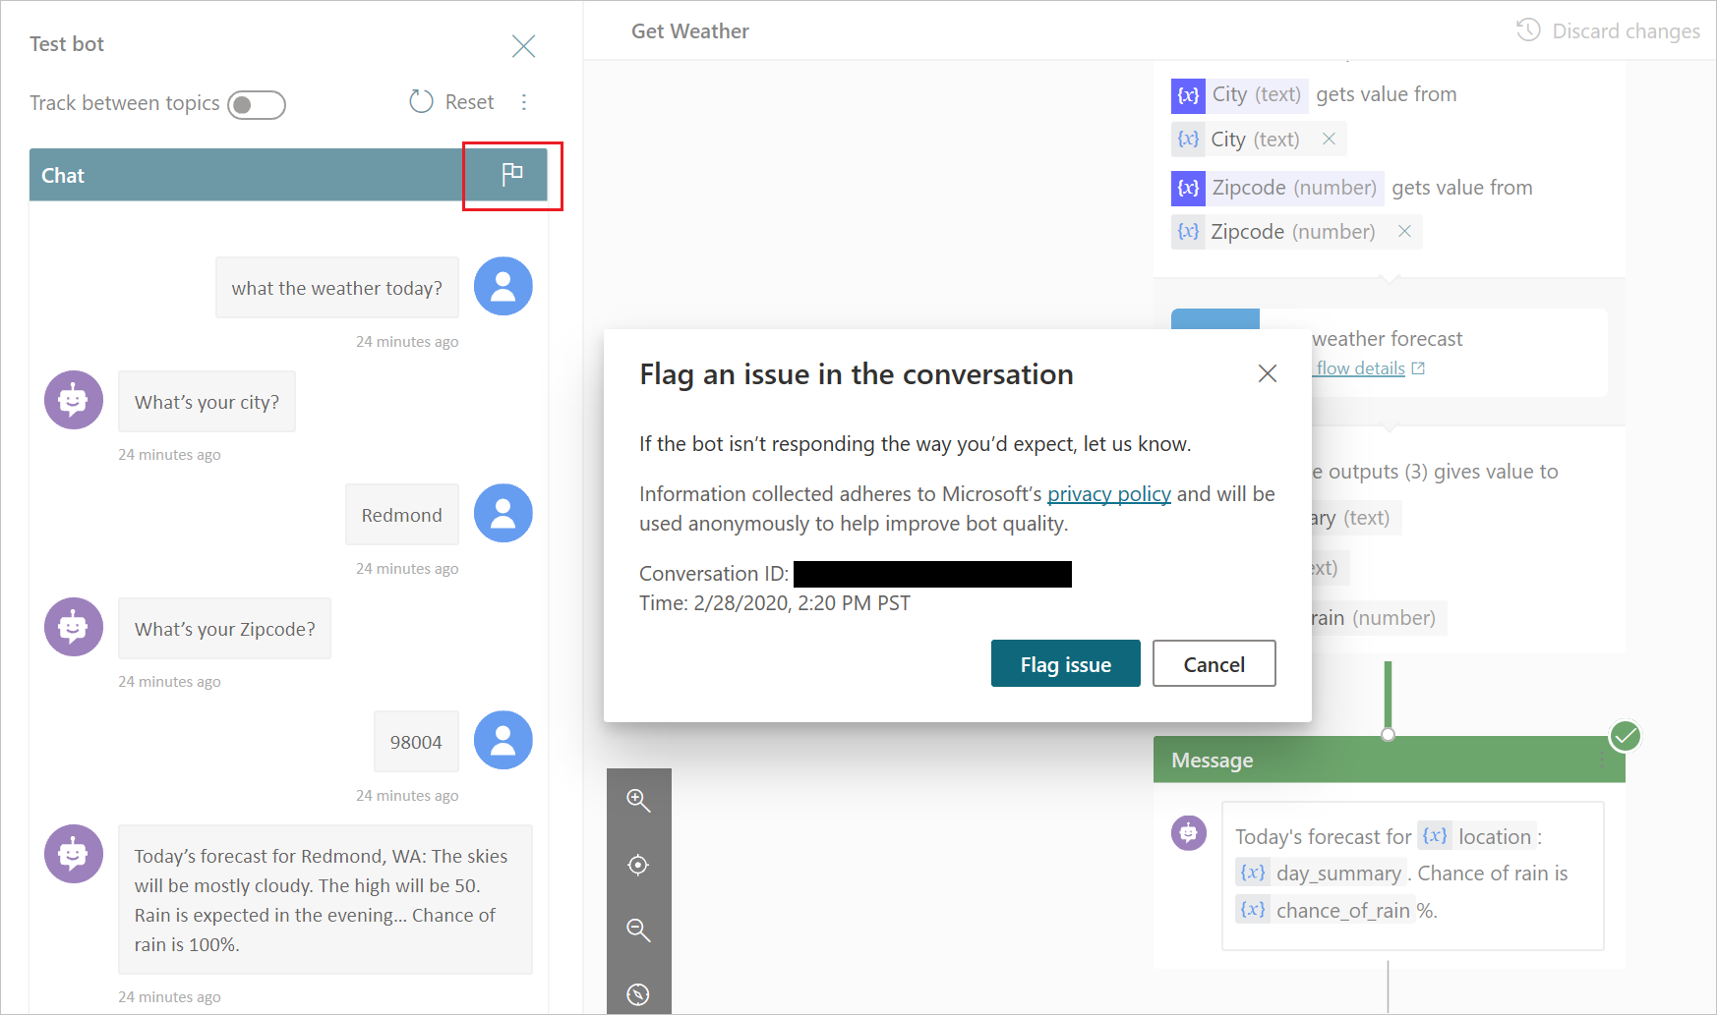

Flag an issue.

All information collected is anonymous and will be used to help improve bot quality.

# Use entities and slot filling in Power Virtual Agents bots

A big part of bot conversations in Power Virtual Agents is natural language understanding, which is the ability for the AI to understand a user’s intent. For example, natural language understanding is involved when a user might say “I tried to use my gift card but it doesn’t work” and the bot is able to route the user to the topic related to gift cards not working—even if that exact phrase isn’t listed as a trigger phrase.

One fundamental aspect of natural language understanding is to identify *entities* in a user dialog. An entity can be viewed as an information unit that represents a certain type of a real-world subject, like a phone number, zip code, city, or even a person’s name.

## Prebuilt entities

Out of the box, Power Virtual Agents comes with a set of prebuilt entities, which represent the most commonly used stereotype information in real-world dialogs, such as age, colors, numbers, and names.

With the knowledge granted by entities, a bot can smartly recognize the relevant information from a user input and save it for later use.

## Use entities in a conversation

1. Go to the [**Topics page**](./authoring-create-edit-topics.md) for the bot you want to edit.
2. Open the authoring canvas for the topic you want to add an entity to.
3. Select the plus (**+**) icon and then select **Ask a question**.

* 
* Screenshot of adding a node.” border=“false

1. Under **Identify**, select an entity.

* 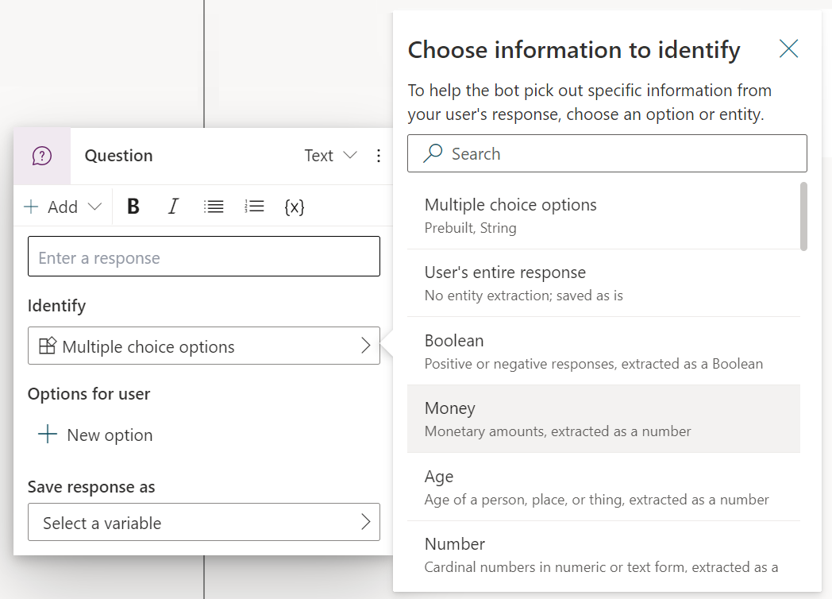
* Question node with entity selection.” border=“false

1. Name the variable for the output of the user’s response, if necessary.

# Use variables

Save customers’ responses in a bot conversation to variables and reuse them later in the conversation. Or, use variables to create logical expressions that dynamically route the customer down different conversation paths.

For example, save a customer’s name in a variable called UserName and the bot can address the customer by name as the conversation continues.

You can also pass variables to [Power Automate](advanced-flow.md) and [Bot Framework skills](/azure/bot-service/bot-builder-skills-overview) as input parameters, and save the output results from those actions.

## Variable types

A variable is associated with a **type**. The type determines what values the variable can contain and the operators that you can use when you construct a logical expression with the corresponding variable.

| Type | Description |
| --- | --- |
| String | A sequence of characters used to represent text. |
| Boolean | A logical value that can only be true or false. |
| Number | Any real number. |
| Table | A list of any number of values, but all values must the same type. |
| Record | A collection of name-value pairs where values can be any type. |
| DateTime | A date, time, day of the week, or month relative to a point in time. |
| Choice | A list of string values that have associated synonyms. |
| Blank | A placeholder for “no value” or “unknown value”. See [Blanks in Power Fx](/power-platform/power-fx/data-types#blank). |

A variable’s type is set based on the value it is first assigned.

Once a variable has been assigned a type, it can’t be assigned values from other types. For example, a variable given the starting value of 1 is assigned the type **Number**. Attempting to assign it to a **String** value of "apples" will result in an error.

When you’re testing a bot, a variable may appear temporarily as the type **Unspecified**. An **Unspecified** variable is one that hasn’t been assigned a value yet.

## Entities

Power Virtual Agents uses [entities](advanced-entities-slot-filling.md) to identify a specific type of information from a user’s responses. Each entity maps to a **base type**, as listed in the following table.

| Entity | Variable Base Type |
| --- | --- |
| Multiple choice options | Choice |
| User’s entire response | String |
| Age | Number |
| Boolean | Boolean |
| City | String |
| Color | String |
| Continent | String |
| Country or region | String |
| Date and time | DateTime |
| Email | String |
| Event | String |
| Integer | Integer |
| Language | String |
| Money | Number |
| Number | Number |
| Ordinal | Number |
| Organization | String |
| Percentage | Number |
| Person name | String |
| Phone number | String |
| Point of interest | String |
| Speed | Number |
| State | String |
| Street address | String |
| Temperature | Number |
| URL | String |
| Weight | Number |
| Zip code | String |
| Custom entity | Choice |

## Create a variable

Variables can be created in any node that prompts you to select a variable, such as the **Set Variable Value** node.

1. Select **+** to add a node, select **Set a variable value**.
2. In the **Set variable** box, select the **>** arrow.

* 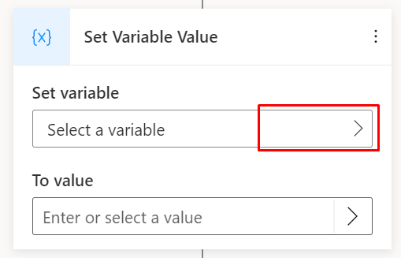
* Screenshot of selecting a variable in the Set Variable Value node.

1. In the flyout menu that appears, select **Create a new variable**.

* 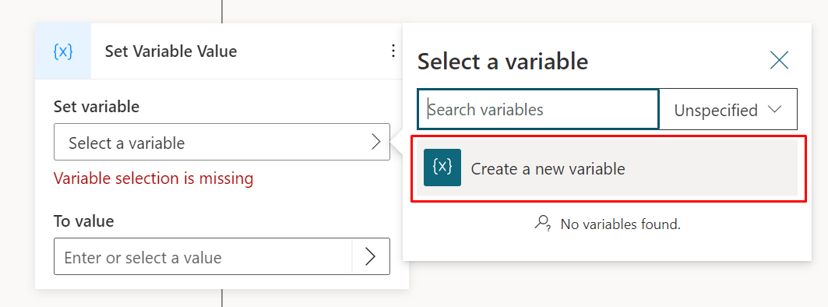
* Screenshot of Create a new variable button.

A new variable will be created with a type that’s appropriate for its usage. Use the variable properties pane to rename it.

## Set a variable

Typically you’ll use a [question node](authoring-create-edit-topics.md#ask-a-question) to save user input to a variable, but there may be situations where you want to set the value manually.

1. To assign a value to a [variable](authoring-variables.md), select **+** to add a node, select **Set a variable value**.
2. For **Set variable**, choose or create a new variable.
3. For **To value**, directly enter a value or select another variable.

## System variables

There are a number of built-in system variables that provide additional information about a conversation.

If you want to use system variables in a Power Fx formula, you must add System. before the name. For example, you’d need to use System.User.DisplayName instead of User.DisplayName.

Some system variables are hidden from the variable context menu, and must be accessed with a [Power Fx formula](advanced-power-fx.md).

| Name | Type | Hidden | Definition |
| --- | --- | --- | --- |
| Conversation.Id | string |  | Unique ID for the current conversation. |
| Conversation.TopicInitialUserMessage | string |  | User message which triggered the current topic. |
| LastActivity.Id | string |  | ID of the previously sent [activity](/azure/bot-service/bot-activity-handler-concept). |
| Activity.Channel | choice |  | Channel ID of the current conversation. |
| Activity.ChannelId | string | ✔ | Channel ID of the current conversation, as a string. |
| Channel.DisplayName | string | ✔ | Display name of the channel. |
| Activity.Text | string |  | Last message sent by the user. |
| Activity.ChannelData | any | ✔ | An object that contains channel-specific content. |
| Activity.Value | any | ✔ | Open-ended value. |
| Activity.Type | choice |  | Type of [activity](/azure/bot-service/bot-activity-handler-concept). |
| Activity.TypeId | string | ✔ | Type of [activity](/azure/bot-service/bot-activity-handler-concept), as a string. |
| Activity.Name | string |  | Name of the event. |
| Activity.From.Id | string | ✔ | Channel-specific unique ID for the sender. |
| Activity.From.Name | string | ✔ | Channel-specific user-friendly name of the sender. 1 |

1 For the [Telephony channel](publication-connect-bot-to-telephony.md), this will include the phone number of the caller.

## Use literal values

You can type a literal value into any variable input field instead of selecting a variable from the menu.

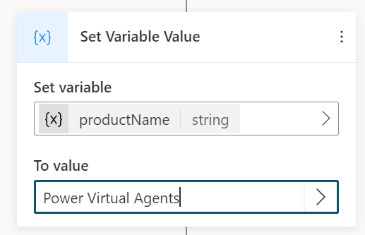

Screenshot showing the use of literal values for action inputs.

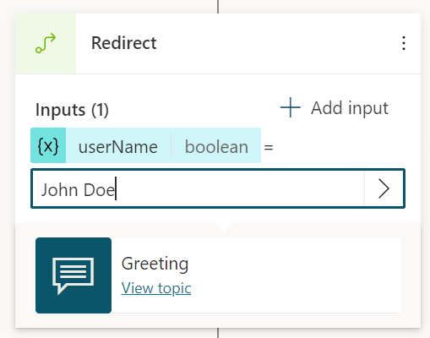

Screenshot of the authoring canvas showing literal input on an input variable in a redirect node.

Values entered directly will always be treated as a string. To set a specific type, use the appropriate [Power Fx formula](advanced-power-fx.md) as per the following table:

| Type | Example formulas |
| --- | --- |
| String | hi, hello world!, chatbot |
| Boolean | Only true or false |
| Number | 1, 532, 5.258, -9201 |
| Table | [1], [45, 8, 2], ["cats", "dogs"] |
| Record | { id: 1 }, { message: "hello" }, { name: "John", info: { age: 25, weight: 175 } } |
| DateTime | Time(5,0,23), Date(2022,5,24), DateTimeValue("May 10, 2022 5:00:00 PM") |
| Choice | Not supported |
| Blank | Only Blank() |

## Variables pane

To open the variables pane, in the topic’s menu bar, select **Variables**.

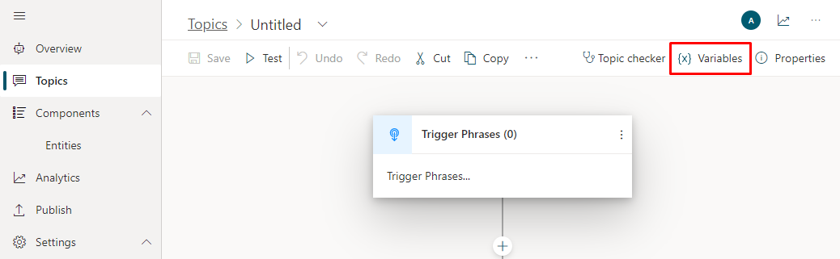

Screenshot of the variables button.

For each of the variables in the topic, select whether you want the values to be passed, received, or both between topics.

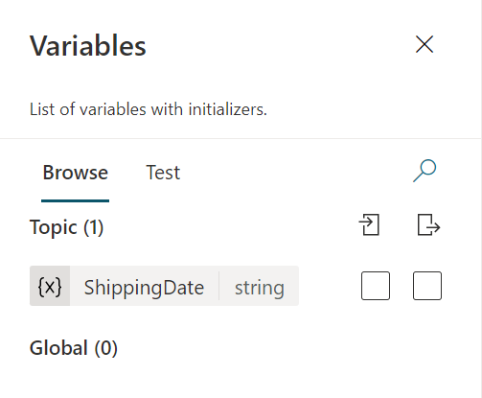

Screenshot of the variables pane.

## Variable properties pane

To open the variable properties pane, select a variable in the variables pane.

You can also open the variable properties pane by selecting a variable in any node.

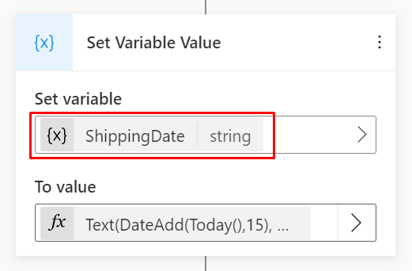

Screenshot of selecting a variable to open the variable properties pane.

In the variable properties pane you can rename a variable, see where a variable is used, or convert a variable to a [global variable](authoring-variables-bot.md).

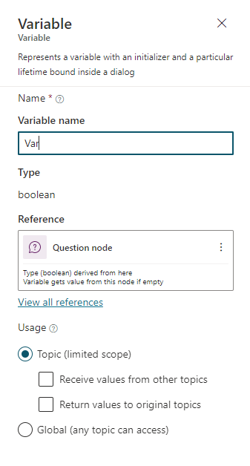

Screenshot of the properties pane.

## Use variables in action nodes

When you use a variable in an action node, if its base type matches a parameter type that’s specified for a flow or Bot Framework skill, you can pass it to that parameter. The output from action nodes generates new variables.

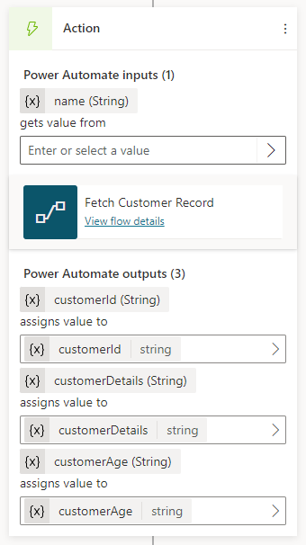

Screenshot of using an entity in an action node.

## Passing variables between topics

When you redirect to other topics, you can pass values into variables in the destination topic or get variables back from it. Passing variables between topics is especially useful when you already have information that the topic needs. Your users will appreciate not having to answer the question again. It’s also helpful when you refactor and separate your topics into reusable components and you want to pass variables across the topics.

**NOTE** Variables of type Custom Entity, Date Time, and Duration can’t be passed between topics.

### Receive values from other topics

When a topic defines a variable (for example, by a question node), the bot asks the user the question to fill in the variable’s value. If the bot has already acquired the value, there’s no reason to ask the question again. In these cases, you can define the variable as **Receive values from other topics**. When another topic redirects to this one, it can pass a variable (or literal values) into this variable and skip the question. The experience for the user talking to the bot is seamless.

To receive values from other topics, set the variable’s property:

1. In the **Question** node, select the variable that you want to receive values from other topics.
2. In the **Variables properties** pane, under **Topic (limited scope)** select **Receive values from other topics**.

* 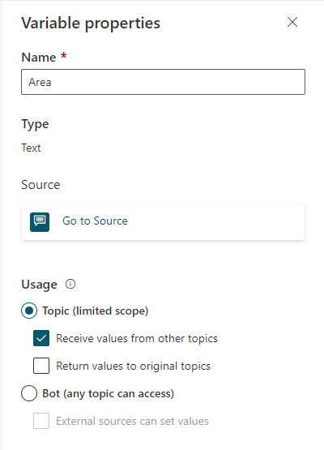
* Screenshot of the authoring canvas showing the Variable properties pane with Receive values from other topics selected.

1. Save the topic.
2. Go to a topic that you want to redirect to. Follow the steps in [Redirect to another topic](authoring-create-edit-topics.md#go-to-another-topic) to redirect to the correct topic.
3. Select **+ Add input for destination topic**.

* 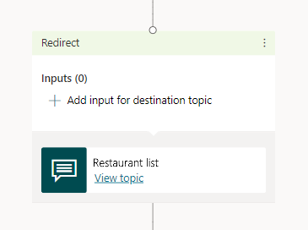
* Screenshot of the authoring canvas showing adding input for the destination topic.

1. Select a variable in the redirected topic that you want to pass the variable to.

* 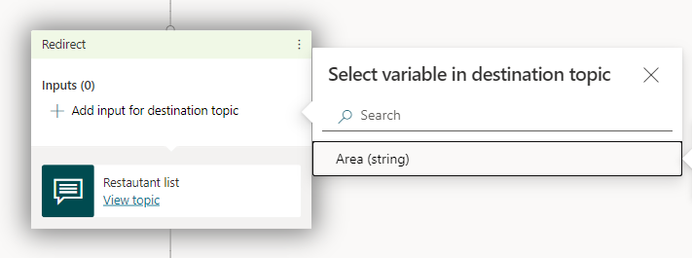
* Screenshot of the authoring canvas showing selecting the variable in the redirected topic.

1. Under **Enter or select a value**, select the variable in the current topic that you want to pass to the redirected topic.

* 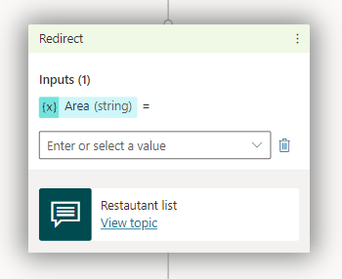
* Screenshot of the authoring canvas showing selecting the variable from the list of options.
* The variable is shown in the redirected node.
* 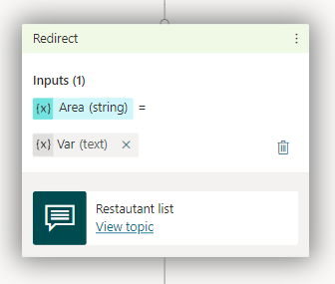
* Screenshot of the authoring canvas showing the variable being passed into the redirected node.

### Return values to original topics

When a topic asks a question, or obtains a variable from an action in some other way, the variable can be returned to the original topic that redirected to it.

In this case, the variable also becomes part of the original topic and can be used like any other variable. This helps you construct the topic so that information the bot obtains is available across topics, reducing the need for global variables.

To return a variable to the original topic, set the variable’s property:

1. In the **Question** node, select the variable that you want to receive values from other topics.
2. In the **Variables properties** pane, under **Topic (limited scope)** select **Return values to original topics**.

* 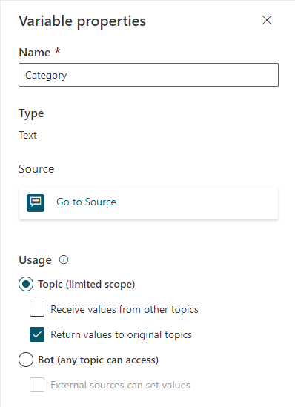
* Screenshot of the authoring canvas showing the Variable properties pane with Return values to original topic selected.

1. Save the topic.
2. Go to a topic that you want to redirect to. Follow the steps in [Redirect to another topic](authoring-create-edit-topics.md#go-to-another-topic) to redirect to the correct topic.

* The variable that’s being returned to the topic is shown in the redirected topic. Use the returned variable in your topic.
* 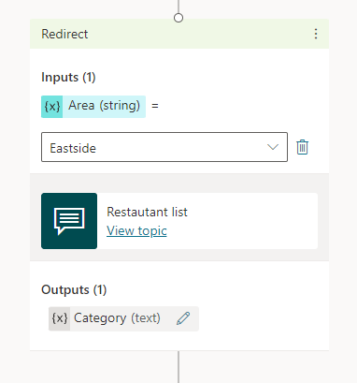
* Screenshot of the authoring canvas showing a redirected topic with both values input and returned.

## Related links

* [Reuse variables across topics](authoring-variables-bot.md)
* [Customize the look and feel of the bot](customize-default-canvas.md)

# Reuse variables across topics

[Variables](authoring-variables.md) let you save responses from your customers. For example, you can save a customer’s name in a variable called UserName. The bot can then address the customer by name as the conversation continues.

By default, a variable’s value can only be used in the topic where this variable gets created. However, you might want the bot to use the same value across topics. This means the bot can remember the necessary context when a conversation spans multiple topics.

For example, in a “Welcome” topic, the bot asks for the customer’s name and email. Then when the conversation goes to another topic, such as an “Appointment booking” topic, you want the bot to remember this customer’s name and email address.

These variables are called **global variables**, because they apply across the entire bot.

Global variables apply during a single user session. Specify the global variables to distinguish them from topic-level variables.

## Create a global variable

1. Create a [new variable](authoring-variables.md#create-a-variable) or [use the variables pane](authoring-variables.md#variables-pane) to open an existing variable.
2. On the **Variable properties** pane, under **Usage**, select **Bot (any topic can access)**.
3. The variable name will be given a prefix string global., to differentiate it from the topic-level variables. For example, the variable UserName is now shown as global.UserName.

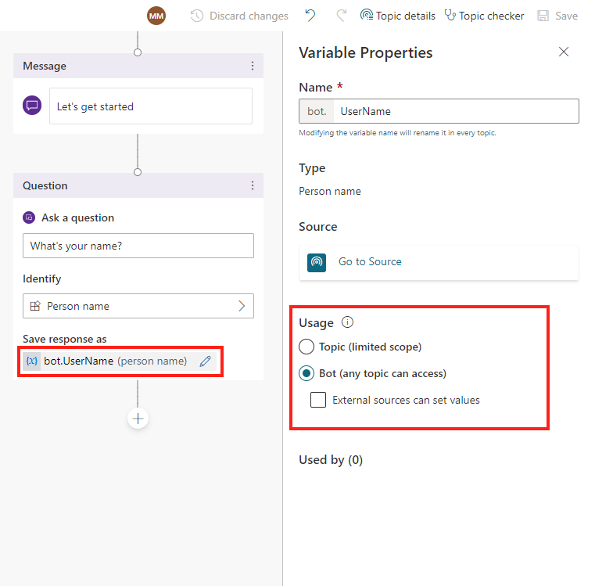

Screenshot showing the Variable Properties pane, with the Usage section highlighted

**NOTE** A global variable’s name must be unique across all topics. In the case of a conflict, you’ll need to rename the variable before saving your change.

## Use global variables

After you set a global variable, it will be available to all topics.

When you’re composing a bot message in a message node or question node, select the {x} button to see the global variable. Variables are sorted in alphabetical order, so you’ll find that all global variables are grouped together in the variable menu because they all begin with Global..

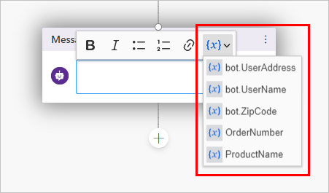

Screenshot showing selection of the x variable icon to display a list of variables.” border=“false

When you use a condition node, a flow action node, or a skill node, you’ll also see global variables available there.

## Manage global variables

After you’ve created a global variable, you can see where it’s first defined and what other topics are using it. This can be useful if you’re working on a new bot, or if you have multiple variables and [complex topic branching](authoring-create-edit-topics.md#add-a-condition).

### Go to the source of a global variable’s definition

1. Select any variable in the authoring canvas.
2. On the **Variable properties** pane, select **Go to source**.

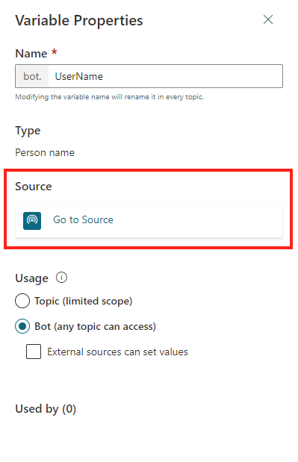

Screenshot showing the Variable Properties pane, with the Go to Source button highlighted

This will take you to the node in the topic where the global variable was created.

### Find all topics using a global variable

1. Select any global variable in the authoring canvas.
2. On the **Variable properties** pane, in the **Used by** section, select any of the topics where the variable is used to go straight to that topic and node.

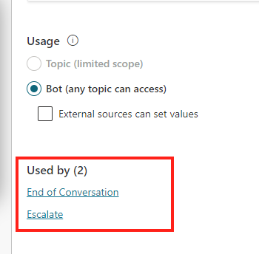

Screenshot showing the list of topics used by a variable in the Variable Properties pane.

## Global variable initialization

If a global variable is triggered before it has been initialized (or “filled in”), the bot will automatically trigger the part of the topic where the global variable is first defined—even when it’s in a different topic—before returning to the original topic. This allows the bot to have all the variables filled in without interrupting the conversation.

For example, the customer starts the conversation on the “Appointment booking” topic, in which a global variable global.UserName is used. However, the global.UserName variable is first defined in the “Welcome” topic.

When the conversation comes to the point in the “Appointment booking” topic where global.UserName is referenced, the bot will seamlessly pivot to the question node where global.UserName is first defined.

After the customer answers the question, the bot will resume the “Appointment booking” topic.

## Global variable behavior when implementing Actions via Power Automate flows or skills

Sometimes, you might use a flow or skill to initialize or fill in a variable in a chatbot.

When a user interacts with the chatbot, however, the variable might be filled in at an earlier point in the conversation, or you may have already set the variables externally.

In this situation, the flow or skill will still run and fill in the variable, overwriting whatever was previously stored in the variable.

## Global variables lifecycle and resetting its value

Global variables are accessible from any topic, and the global variable’s assigned value persists throughout [the session](analytics-billed-sessions.md#definition-of-a-billed-session).

The value is only cleared when the bot user ends up at [the **Start over** system topic](authoring-create-edit-topics.md#use-system-and-sample-topics), either via redirection from the bot or when the user triggers it directly (for example, by typing *Start over*). In this case, all global variables are reset.

## Set a global variable’s value from external sources

If you want to make sure the bot starts a conversation with some context, you can set a global variable to be initialized with an external source.

For example, if your site already knows a user’s name, then when they bring up a bot chat, you can let the bot know the customer’s name before they start typing their first question. This lets the bot have a more intelligent conversation with the customer without having to ask for their name again.

### Set global variable from external source

1. Select any variable in the authoring canvas.
2. On the **Variable properties** pane, in the **Usage** section, select the checkbox **External sources can set values**.

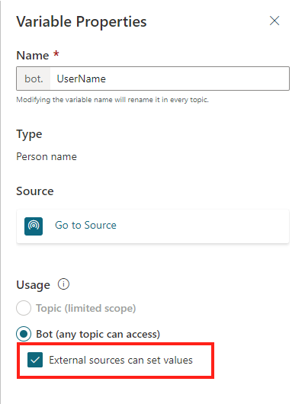

Screenshot of the Usage section on the Variable Properties pane, with the Bot option and External sources can set values checkbox both selected

1. If you’re [embedding your bot in a simple webpage](publication-connect-bot-to-web-channels.md#custom-website), you can append the variables and their definitions. Or, if you’d like a little more control, you can use a <script> code block to call and use variables programatically.

* **NOTE** The variable name in the query string must match that of the global variable, without the global. prefix. For example, a global variable global.UserName must be rendered as UserName=.

In the examples described here, a simple declaration is made for the variables. In a production scenario, you might pass in as the query parameter or variable definition another variable that has already stored the user’s name (for example, if you have the user name from a sign-in script).

### To add the variable to an embedded bot

1. Append the variables and their definitions to the bot’s URL as [query string parameters](https://en.wikipedia.org/wiki/Query_string) (in the format of botURL?variableName1=variableDefinition1&variableName2=variableDefinition2). For example:
   * You have a global variable named global.UserName.
   * Your bot’s URL is *https://web.powerva.microsoft.com/webchat/bots/12345*.
   * To pass in the user name when starting a bot conversation on a website, you can attach the UserName= query string as: *https://web.powerva.microsoft.com/webchat/bots/12345?UserName=Renata*.
2. The parameter name is case-insensitive. This means username=Renata will also work in this example.

**To add the variable to a** [**custom canvas**](customize-default-canvas.md)

1. In the <script> section on the page where you have your bot, define the variables as follows, substituting variableName1 for the variable name without the global. prefix and variableDefinition1 for the definition. Separate multiple variables with commas ,.

* const store = WebChat.createStore({}, ({ dispatch }) => next => action => {  
   if (action.type === 'DIRECT_LINE/CONNECT_FULFILLED') {  
   dispatch({  
   type: "WEB_CHAT/SEND_EVENT",  
   payload: {  
   name: "pvaSetContext",  
   value: {  
   "variableName1": "variableDefinition1",  
   "variableName2": "variableDefinition2"  
   }  
   },  
   });  
   }  
   return next(action);  
   });

1. Within your <script> section, call the store when you embed your bot, as in the following example where store is called just above where styleOptions is called (you’ll need to replace the BOT_ID with your ID):

* const BOT_ID = "12345-5678";  
  const theURL = "https://powerva.microsoft.com/api/botmanagement/v1/directline/directlinetoken?botId=" + BOT_ID;  
    
  fetch(theURL)  
   .then(response => response.json())  
   .then(conversationInfo => {  
   window.WebChat.renderWebChat(  
   {  
   directLine: window.WebChat.createDirectLine({  
   token: conversationInfo.token,  
   }),  
   store,  
   styleOptions  
   },  
   document.getElementById('webchat')  
   );  
   })  
   .catch(err => console.error("An error occurred: " + err));

## Delete global variables

When removing a global variable used in other topics, the references to that variable in the topics will be marked as Unknown.

You’ll receive a warning about deleting the global variable before you can confirm the operation.

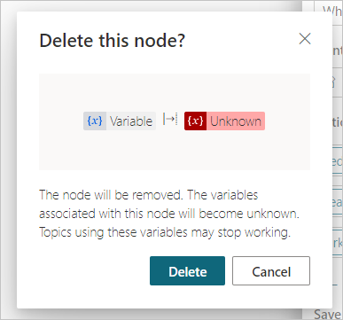

The global variable delete message indicates that references to that variable will be labeled as unknown.” border=“false

Nodes that contain references to the deleted global variable will tell you they contain an unknown variable.

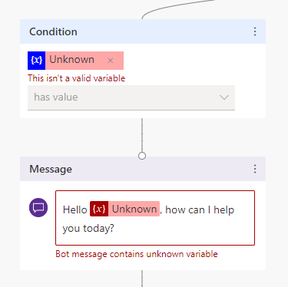

Screenshot of a node with references to an unknown variable, which are marked as red within the message node’s text, and indicated with a warning that says Bot message contains unknown variable

Topics with nodes that contain references to deleted global variables might stop working. Ensure that you remove or correct all the topics that were using the deleted variable before publishing.

## Related links

* [Use variables](authoring-variables.md)
* [Customize the look and feel of the bot](customize-default-canvas.md)

# Microsoft Power Fx in Power Virtual Agents

Power Fx is a low-code language that makers can work with directly in an Excel-like formula bar. Use Power Fx to create complex bot logic via formulas to manipulate data, such as setting the value of variables, parsing a string, or using expressions in conditionals.

For more information, see [Power Fx overview](/power-platform/power-fx/overview) and [formula reference](https://aka.ms/pfx-reference) documentation.

## Prerequisites

* [Create and edit topics](authoring-create-edit-topics.md)
* [Use variables](authoring-variables.md)

## Use variables in a formula

To use a variable in a Power Fx formula, you must add a prefix depending on the variable’s scope:

* For [system variables](authoring-variables.md#system-variables), use System.
* For [global variables](authoring-variables-bot.md), use Global.
* For [topic variables](authoring-variables.md), use Topic.

For example, you’d need to use System.Conversation.Id to access the respective [system variable](authoring-variables.md#system-variables).

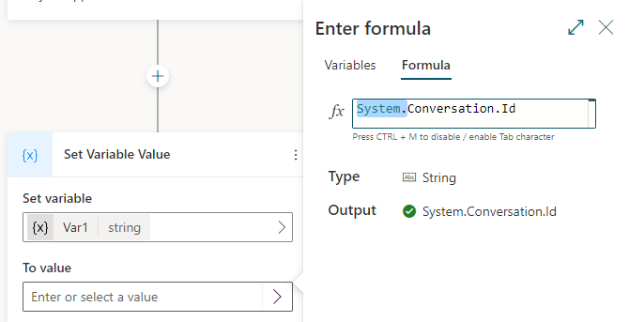

Screenshot of the Question node with the user’s response set to a variable named Var1.

## Use Power Fx to set a variable

In this example, a Power Fx expression is used to convert the user’s name to uppercase.

1. Create a new topic.
2. Select the **+** icon and then choose **Ask a question**.
3. For **Enter a response**, enter What is your name?.
4. Select the **Identify** box, and in the flyout menu, choose **Person name**.
5. In the **Save response as** box, select the **>** arrow and **Create a new variable** named Var1.

* 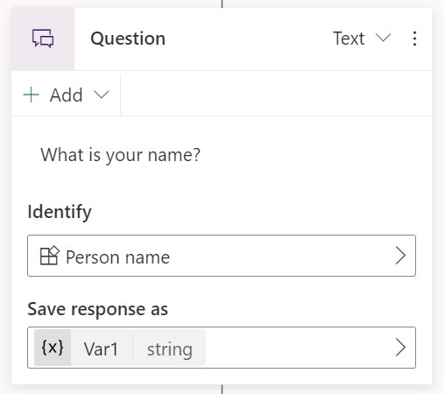
* Screenshot of the Question node with the user’s response set to a variable named Var1.

1. Under the **Question** node, select **+** and choose **Set a property**.
2. In the **Set variable** box, select the **>** arrow and **Create a new variable** named Var2.
3. In the **To value** box, select the **>** arrow.
4. Select the **Formula** tab. In the **fx** box, enter Upper(Text(Topic.Var1)) and select **Insert**.

* 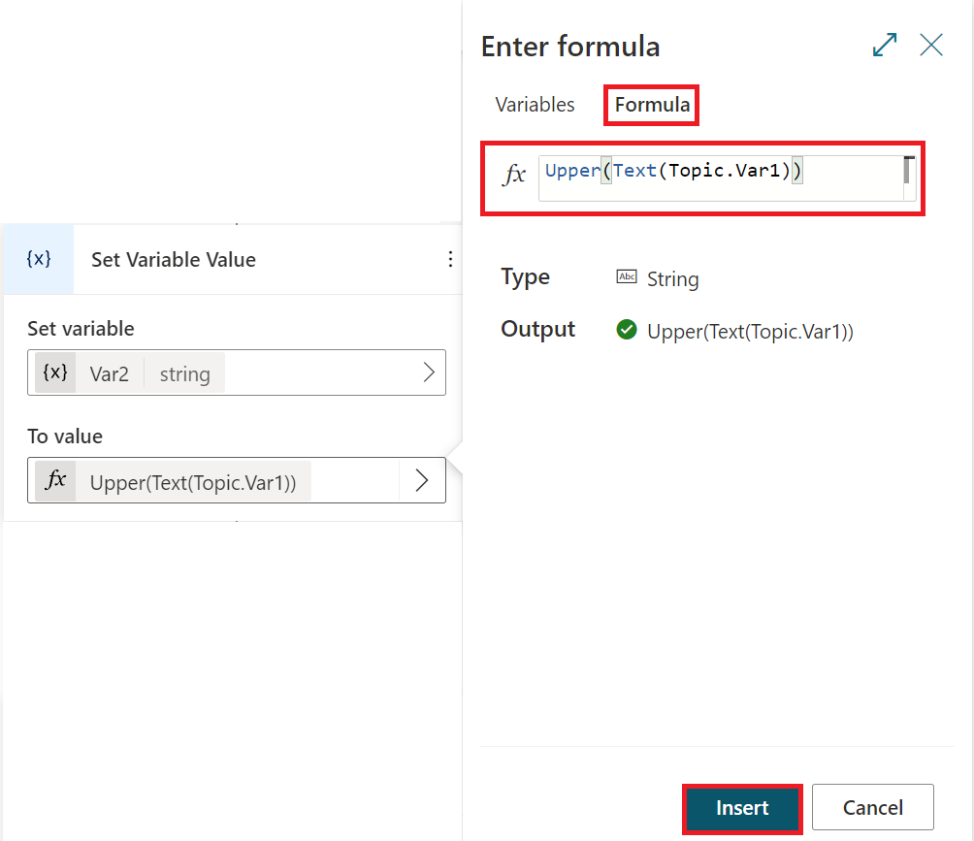
* Screenshot of the Set a Variable node with a Power Fx formula.

1. Under the **Question** node, select **+** and choose **Send a message**.
2. Enter the User Name: and then add Var2.

* 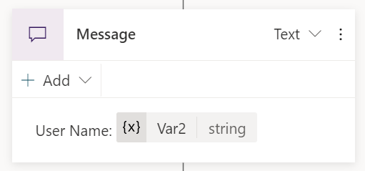
* Screenshot of the Send a Message node with a message defined.

## Use Power Fx as a condition

To evaluate more complex expressions, Condition nodes can be configured to use Power Fx formulas.

In this example, the bot will determine if a booking date qualifies for discount. To do this, it checks if the booking date provided by the user is 14 days or more from the current date.

1. Create a new topic.
2. Select the **+** icon and then choose **Ask a question**.
3. For **Enter a response**, enter Booking date?.
4. In the **Identify** box, select the **>** arrow and choose **Date and time**.
5. In the **Save response as** box, select the **>** arrow and **Create a new variable** named Var1.

* 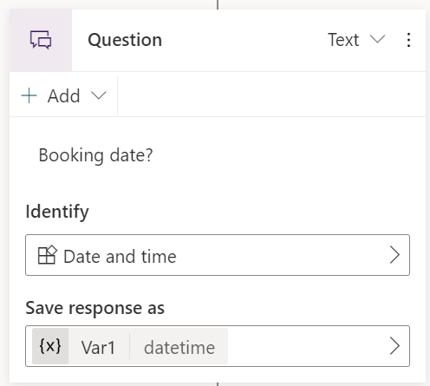
* Screenshot of question node with date and time entity chosen and variable set.

1. Select the **+** icon and then choose **Add a condition**.
2. In the **ConditionItem** node, select **Node menu** (vertical three dots), then **Change to formula**.
3. In the **Enter or select a value** box, select the **>**.
4. Select the **Formula** tab. In the **fx** box enter Topic.Var1 > (DateAdd (Now(), 14)) and select **Insert**.

* 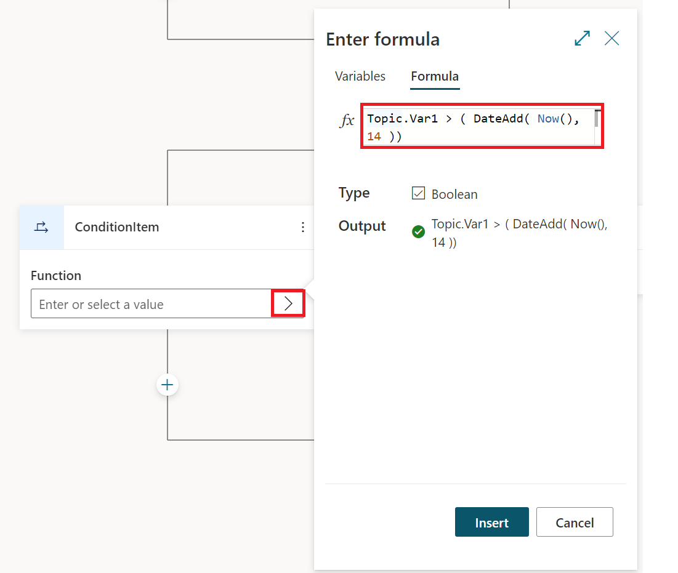
* Screenshot of Power Fx formula entered into condition node.

1. Under the **ConditionItem** node, add a **Send a message** node to let the user know they qualify for a discount. Enter the message You qualify for a discount.
2. Under the **All Other Conditions** node, add a **Send a message** node. Enter the message Sorry, you don't qualify for a discount.

* 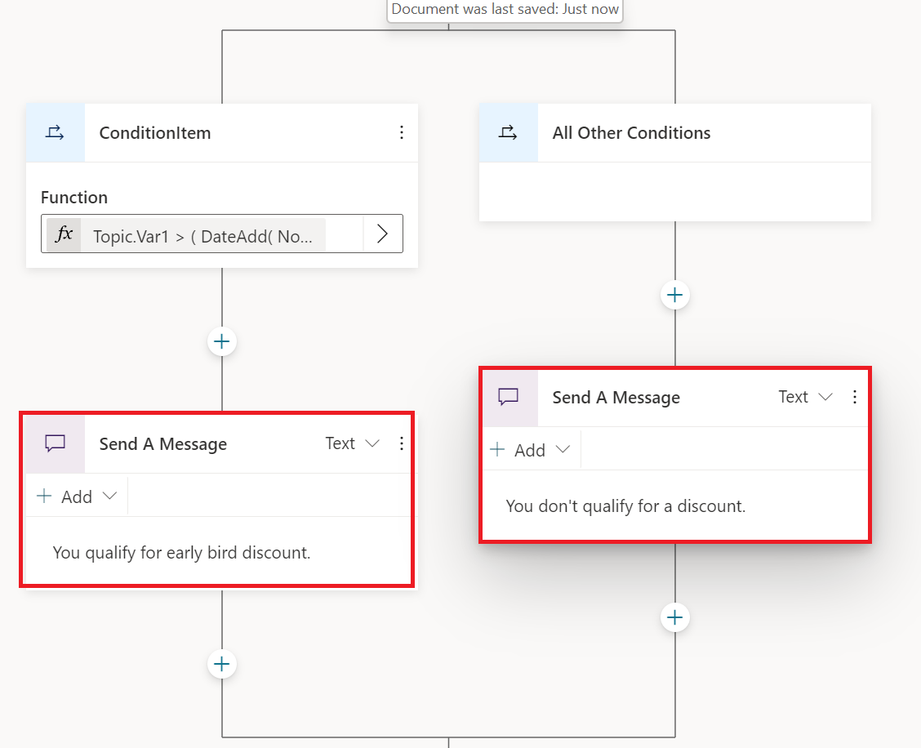
* Screenshot of message nodes in condition branches.

# Add actions to a bot using Power Automate

You can enable your bot to perform an action by calling a Microsoft Power Automate flow. Flows can help you automate activities, or call backend systems. For example, you can use flows with end-user authentication to retrieve information about a user after they’ve signed in.

You call flows from within topics, as a discrete **Call an action** node. You can utilize flows that have already been created in your Power Apps environment, or you can create a flow from within the Power Virtual Agents [authoring canvas](authoring-create-edit-topics.md).

**IMPORTANT** To use flows within Power Virtual Agents, they must meet the following requirements:

* A flow can only be called from a topic located in the same [Microsoft Dataverse environment](/powerapps/maker/common-data-service/data-platform-intro) as your bot.
* Flows must also be in a solution in Power Automate. You can move flows into solutions so they are listed in the authoring canvas.
* Flow values must be returned synchronously to Power Virtual Agents.

Flows typically use variables to input and output information. The variables can then be used in other nodes within the topic.

## Create a new flow from the Power Virtual Agents authoring canvas

1. Go to the [**Topics page**](authoring-create-edit-topics.md) for the bot you want to edit.
2. Open the authoring canvas for the topic from which you want to call a flow.
3. Select the plus (**+**) button below an existing node to add a new node.
4. In the node selection window, select **Call an action**, and then select **Create a flow**.

* 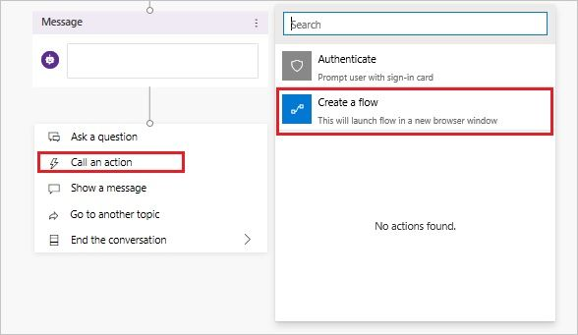
* Create a new Power Automate flow.” border=“false

Using the **Create a flow** option opens a starter flow template in the [Power Automate portal](https://flow.microsoft.com/) in a separate tab.

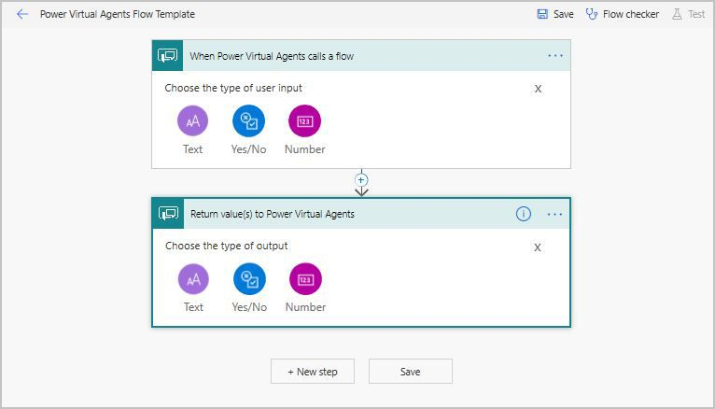

Power Automate flow template.” border=“false

**NOTE** The Power Automate portal automatically opens in the same environment as the bot (using the same user credentials).

This template is an example of a flow that can be used by bots. To be suitable for bots, a Power Automate flow requires a special **Power Virtual Agents** trigger and response action:

* Flow trigger: **Power Virtual Agents**
* 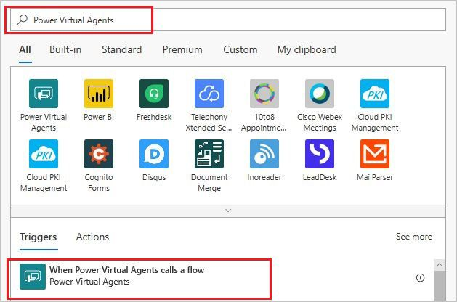
* Power Virtual Agents trigger.” border=“false
* Response action: **Power Virtual Agents**
* 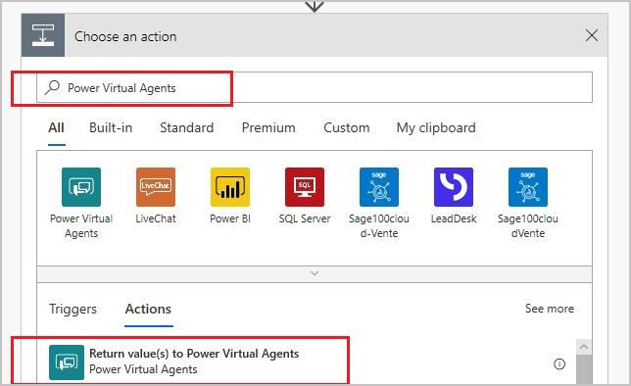
* Power Virtual Agents response.” border=“false

If you make changes to a flow in the Power Automate portal after adding the flow to Power Virtual Agents, you can reload the flow by selecting **Node menu** (vertical three dots), then **Refresh**.

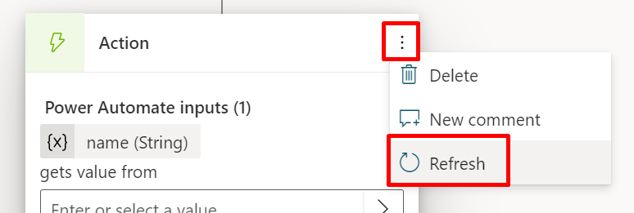

Screenshot of flow refresh button.” border=“false

The flow will then be re-validated, and any problems detected will need to be fixed before you can save.

## Input and output parameters

There is no upper limit on how many input or output parameters Power Automate flow for a bot can have. Bots can use the following types of inputs and outputs with Power Automate flows:

* Number
* String
* Boolean

The following types are not supported:

* Object
* Date
* Timestamp
* List [String]
* List [Number]
* List [Boolean]
* List [Object]
* List [Date]
* List [Timestamp]

**NOTE** A bot is able to receive up to 1 MB of data from a Power Automate flow in a single action. There is no upper limit on the maximum size of data that a bot can pass to a Power Automate flow.

### Input parameters

To specify a flow to accept input parameters from a bot, select the **Add an input** option in the **Power Virtual Agents trigger** user interface, and then select the type a - string, number, or a boolean.

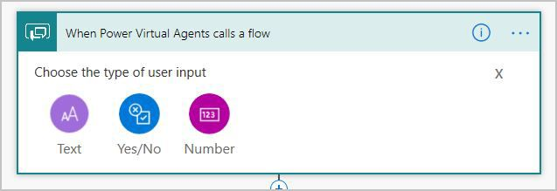

Power Virtual Agents trigger input types.” border=“false

For example, you can select **Text** and **Number** to add the following input parameters to the flow:

* **String_Input** of type string
* **Number_Input** ot type number

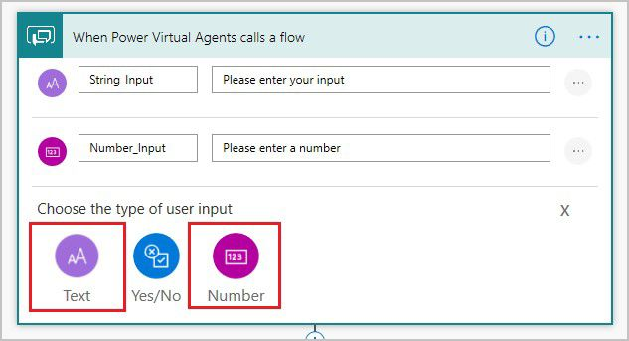

Power Virtual Agents trigger inputs.” border=“false

### Output parameters

To return output parameters to the bot that can be a string, number, or a boolean, select **Add an output** option in **Power Virtual Agents response** user interface, and then select the type for the output.

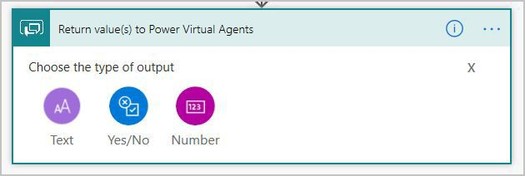

Power Virtual Agents response output types.” border=“false

For example, you can select **Text** and **Number** to add the following output parameters to the flow and assign return values for them.

* **String_Output** of type string
* **Number_Output** ot type number

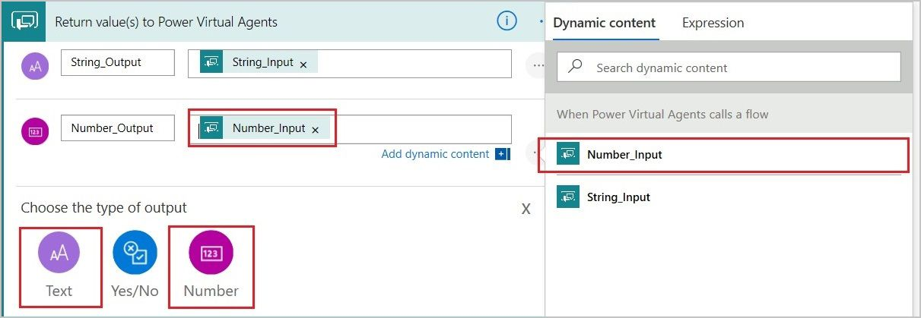

Power Virtual Agents response outputs.” border=“false

This example creates a fully functional flow that accepts two parameters, a string and a number, and returns them to a bot as outputs.

Select **Save** to save your new flow.

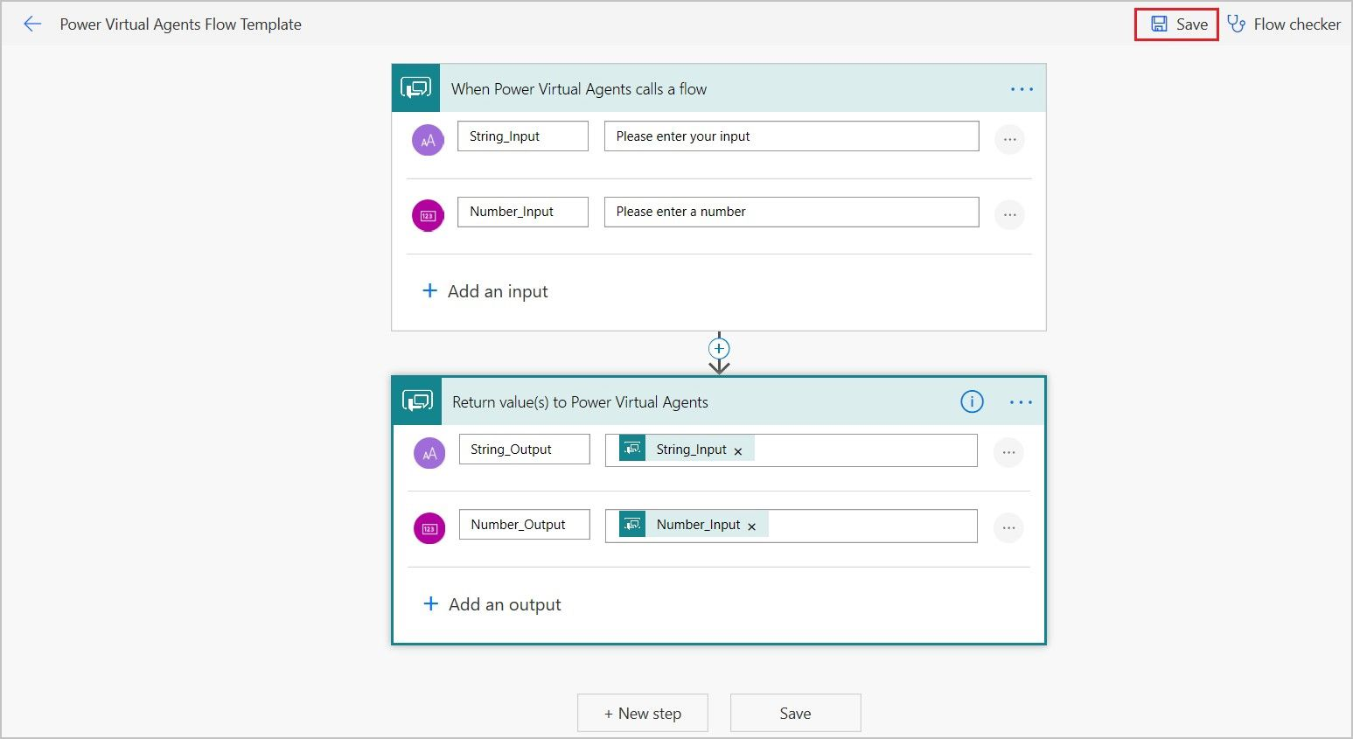

Power Automate flow template - Save.” border=“false

Your flow is saved to the **Default Solution** under the **Solutions** tab on the Power Automate portal.

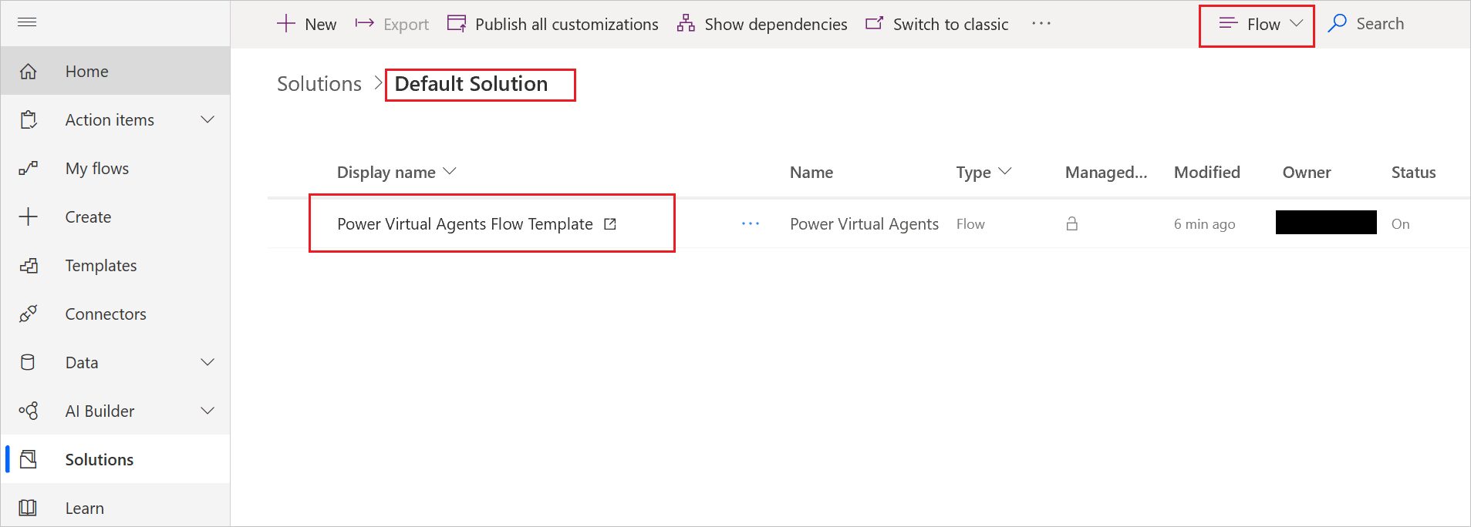

Power Automate flow template - Default Solution.” border=“false

## Flows created from the Power Virtual Agents authoring canvas are immediately available to the bot

All flows created from the Power Virtual Agents authoring canvas are saved in a **Default Solution** in Power Automate. They can be used by your bots immediately.

In Power Virtual Agents, you can now see this new flow on the list of available actions when you use the **Call an action node** in the authoring canvas.

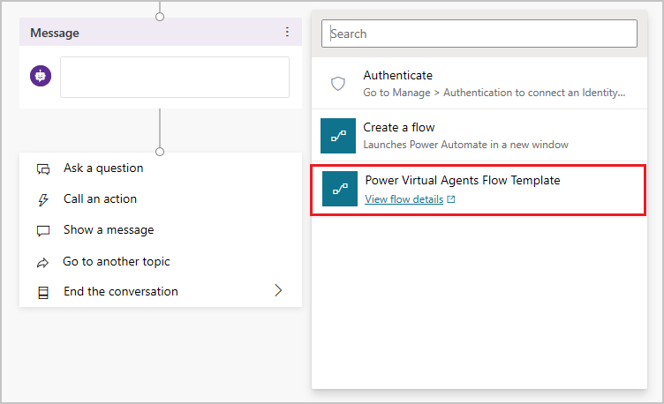

New flow shows up in Action picker.” border=“false

## Optionally move a flow from Default Solution to another solution

To be available to your bots, flows must be stored in a solution in Power Automate. If you do not want to use the **Default Solution** for this purpose, you can move your flows to another solution.

1. On the Power Automate portal, go to the **Solutions** tab where you can see the available solutions. Use any of the existing solutions or create a new solution for your flows.
2. To create a new solution, select **New solution**.

* 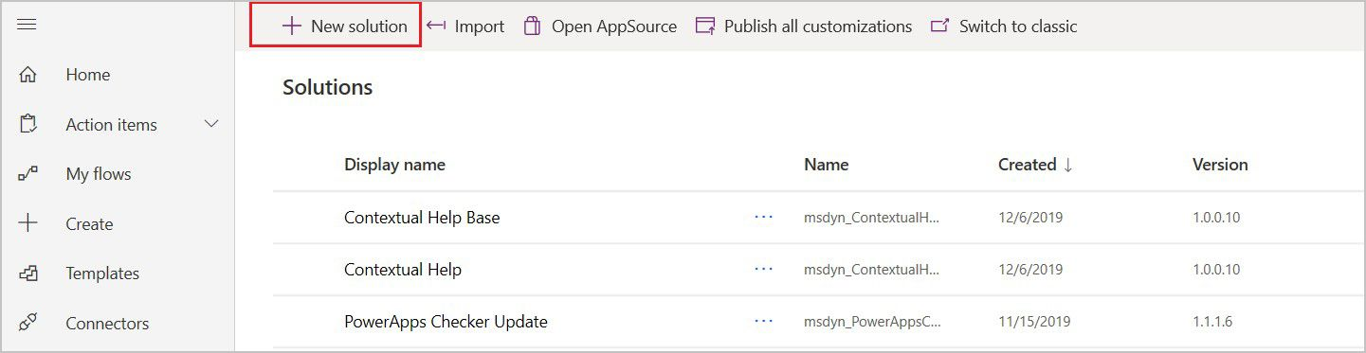
* Create a solution.” border=“false

1. Give your new solution a name, select **CDS Default Publisher** in the **Publisher** field, enter a **Version** number, and then select **Create**.

* 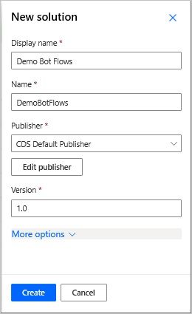
* Save a new solution.” border=“false

1. On the **Solutions** tab, go to the solution you want to use. Select **Add existing** to add a flow.

* 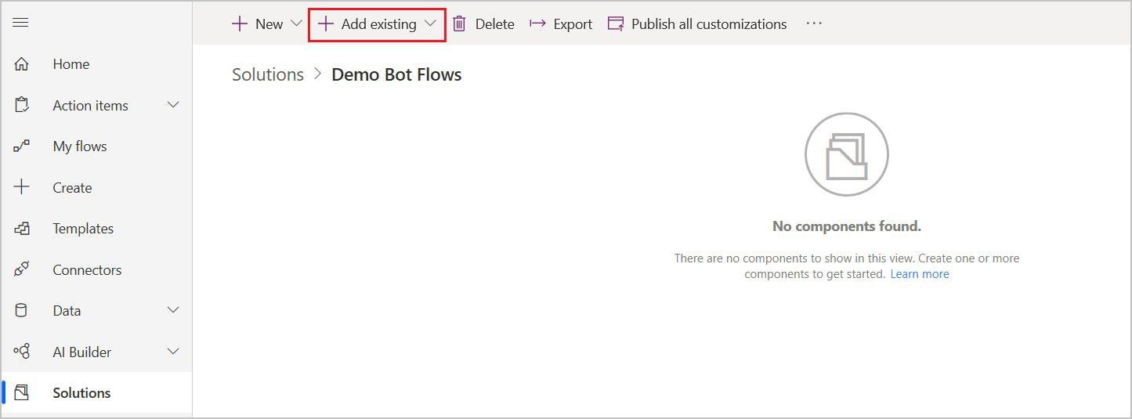
* Add existing menu.” border=“false

1. On the **Add existing flow** page, select the **From solutions** tab, and then select your flow. Select **Add** to add your flow to the solution.

* 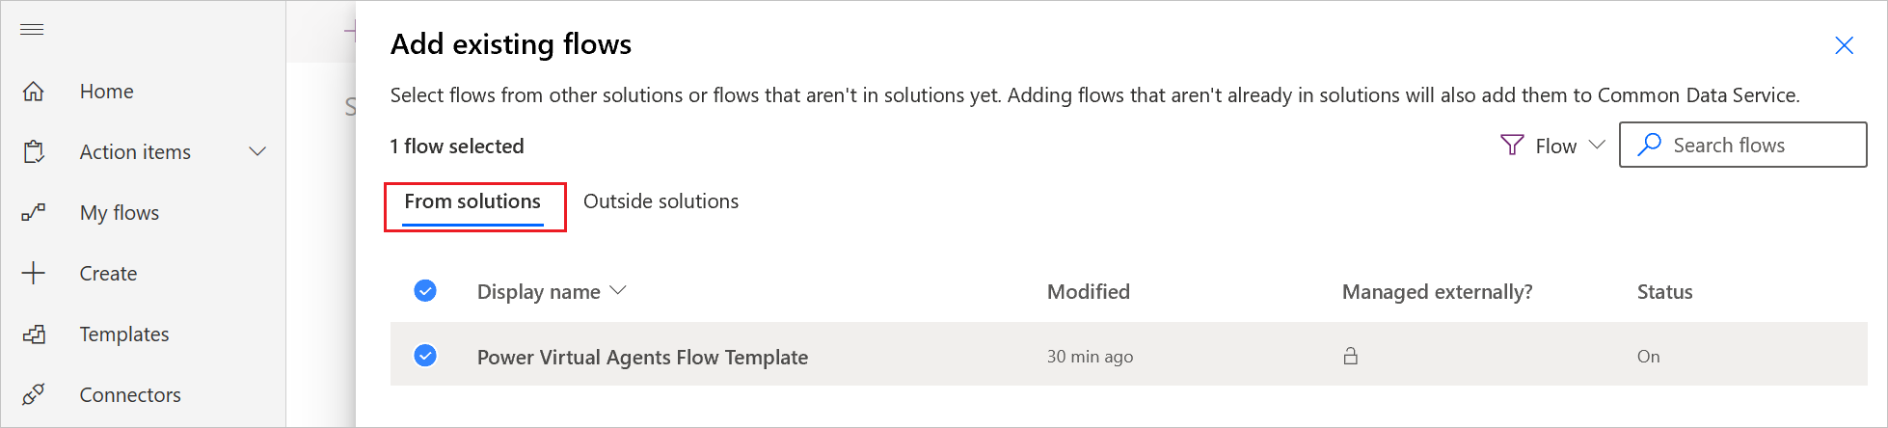
* Add flow to a solution.” border=“false
* To move a flow from **My flows** tab to a solution, select the **Outside solutions** option. Select **Add** to add your flow to the solution.
* 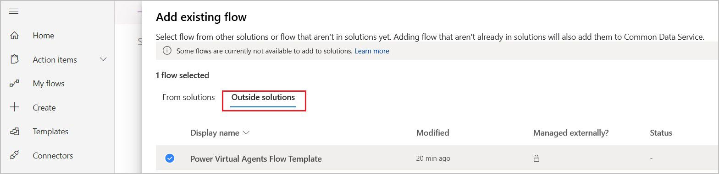
* Add flow from outside solutions.” border=“false

## Modify a flow on the Power Automate portal

You can rename and modify your flow on the Power Automate portal. For example, the flow you just created using the template can be updated to provide a weather forecast when called from a bot.

1. In Power Virtual Agents, you can open a flow by using the flow’s **View flow details** link on the list of available actions when you use the **Call an action node** in the authoring canvas.

* 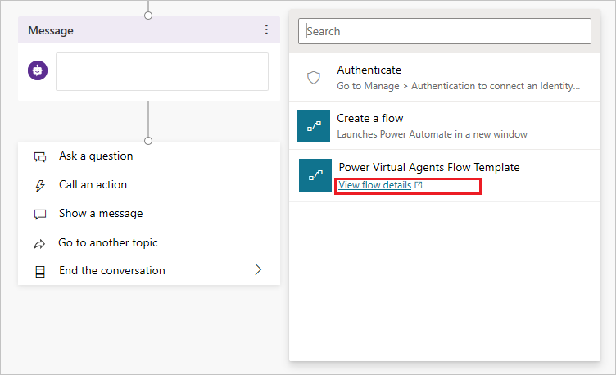
* Modify a flow from Action Picker.” border=“false
* If you want to update a flow that is already used in your dialog, the same **View flow details** link is available directly in the Action node.
* 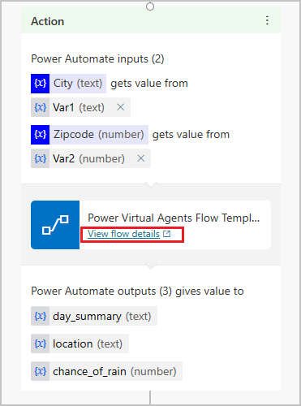
* Modify a flow from Action node.” border=“false
* Using the flow’s **View flow details** link launches the Power Automate portal in a separate browser tab, and opens the flow in a **Details** page where you can modify it using the **Edit** command.
* 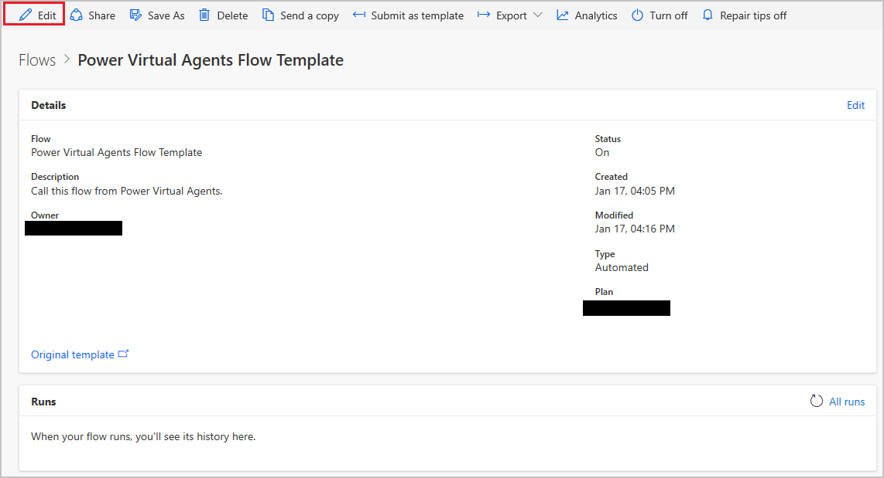
* Edit your flow using the Details page.” border=“false
* If you want to open a flow on the Power Automate portal, go to the **Solutions** tab and then open your flow’s solution. Use the flow’s **Edit menu** to open the flow for editing.
* 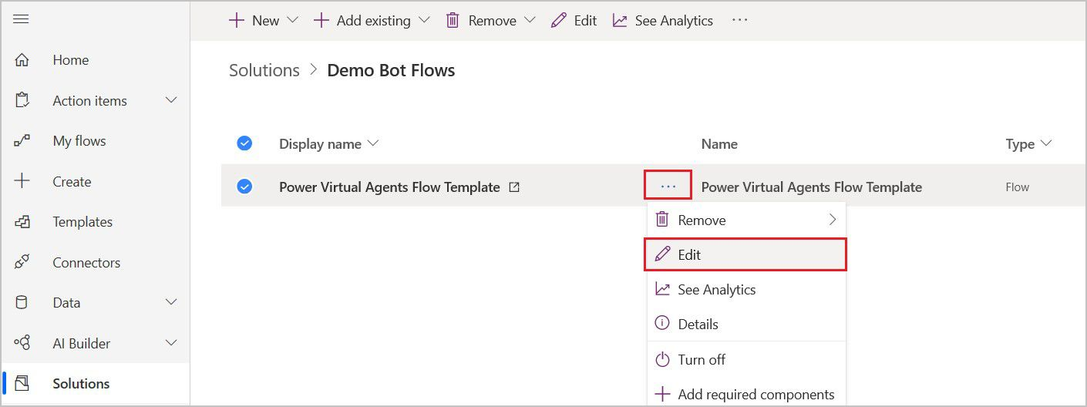
* Open your flow for editing.” border=“false

1. Rename the flow to **Get weather forecast** and then add the following flow input parameters to **Power Virtual Agents** trigger:
   * City (String)
   * Zipcode (Number)

* 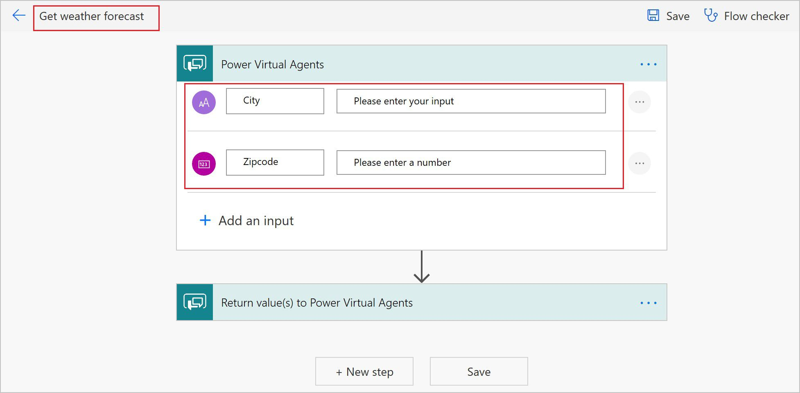
* Add inputs to the flow.” border=“false

1. Choose **Add an action** to create a new action below the **Power Virtual Agents** trigger.

* 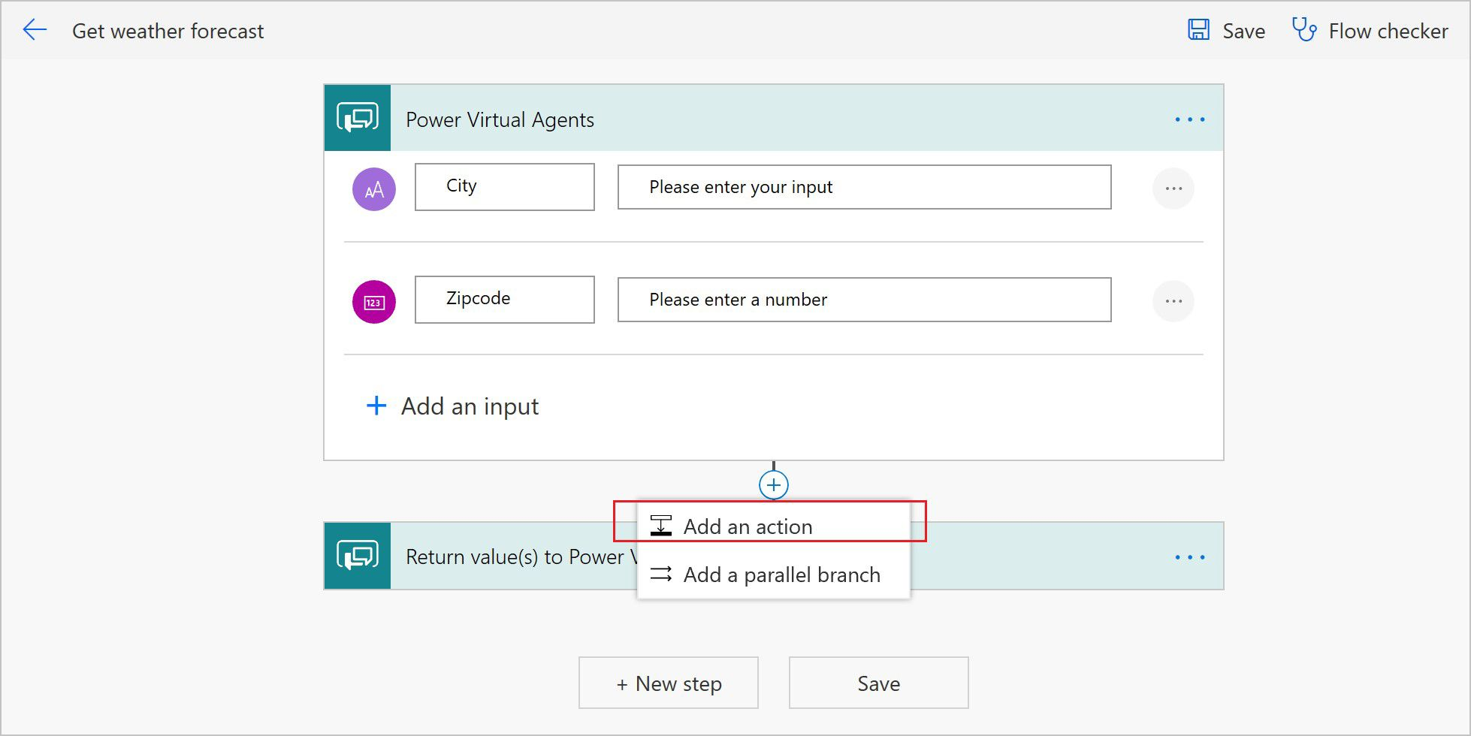
* Add flow action.” border=“false

1. Enter **MSN weather** into the search box, and then select the **Get forecast for today** action from the list.

* 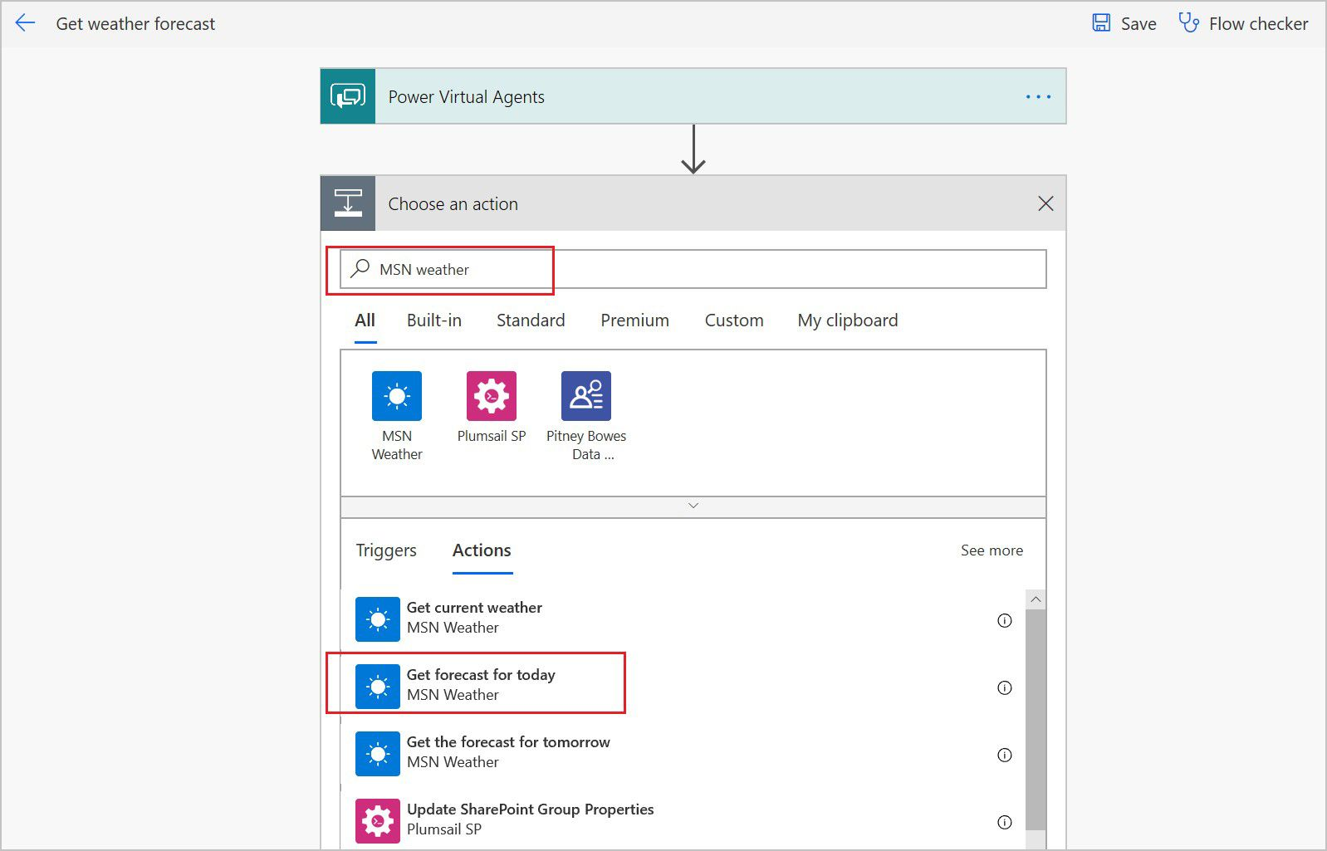
* Add Get forecast action.” border=“false

1. A new **MSN Weather Connector** is added to the flow. Under **Location**, select **Add dynamic content**. Select **City** and **Zipcode** from the list.

* 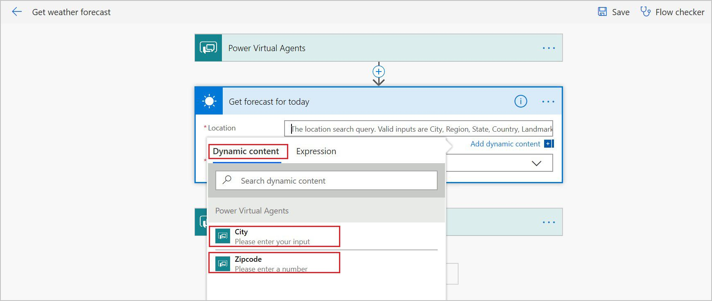
* Pass flow’s input parameters to MSN Weather connector as location.” border=“false

1. In the response node **Return value(s) to Power Virtual Agents**, add the output parameters that you want to return to the bot. **Save** your flow.
   * day_summary (String)
   * location (String)
   * chance_of_rain (Number)

* 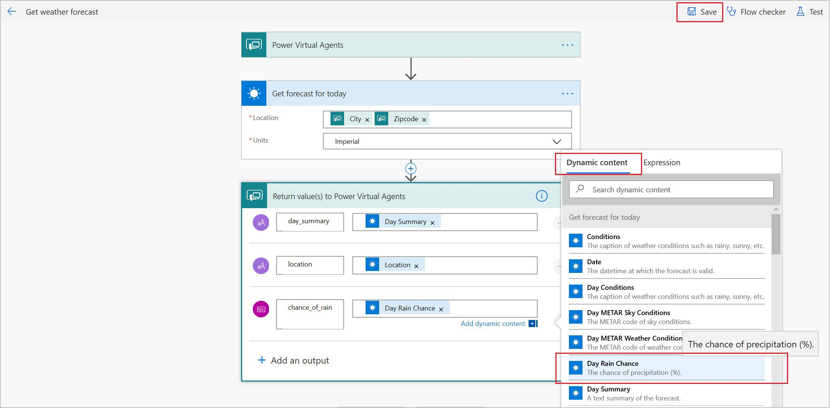
* Add dynamic variables to the flow’s response.” border=“false

This flow is now ready to be used in your bots.

## Call a Power Automate flow as an action from a bot

You can call a Power Automate flow from a bot topic using the **Call an action** node. You can then pass variables to the flow and receive flow outputs that can be used in a bot conversation.

These instructions use adding weather information to a flow as an example. If you haven’t already, follow the steps under the Modify a flow on the Power Automate portal section in this topic to create a weather forecast flow.

**Call a flow from within a topic:**

1. In Power Virtual Agents, go to the [**Topics page**](authoring-create-edit-topics.md) for the bot you want to edit.
2. Create a new topic, and name it **Get weather**.
3. Add the following **trigger phrases**:
   * will it rain
   * today’s forecast
   * get weather
   * what’s the weather

* 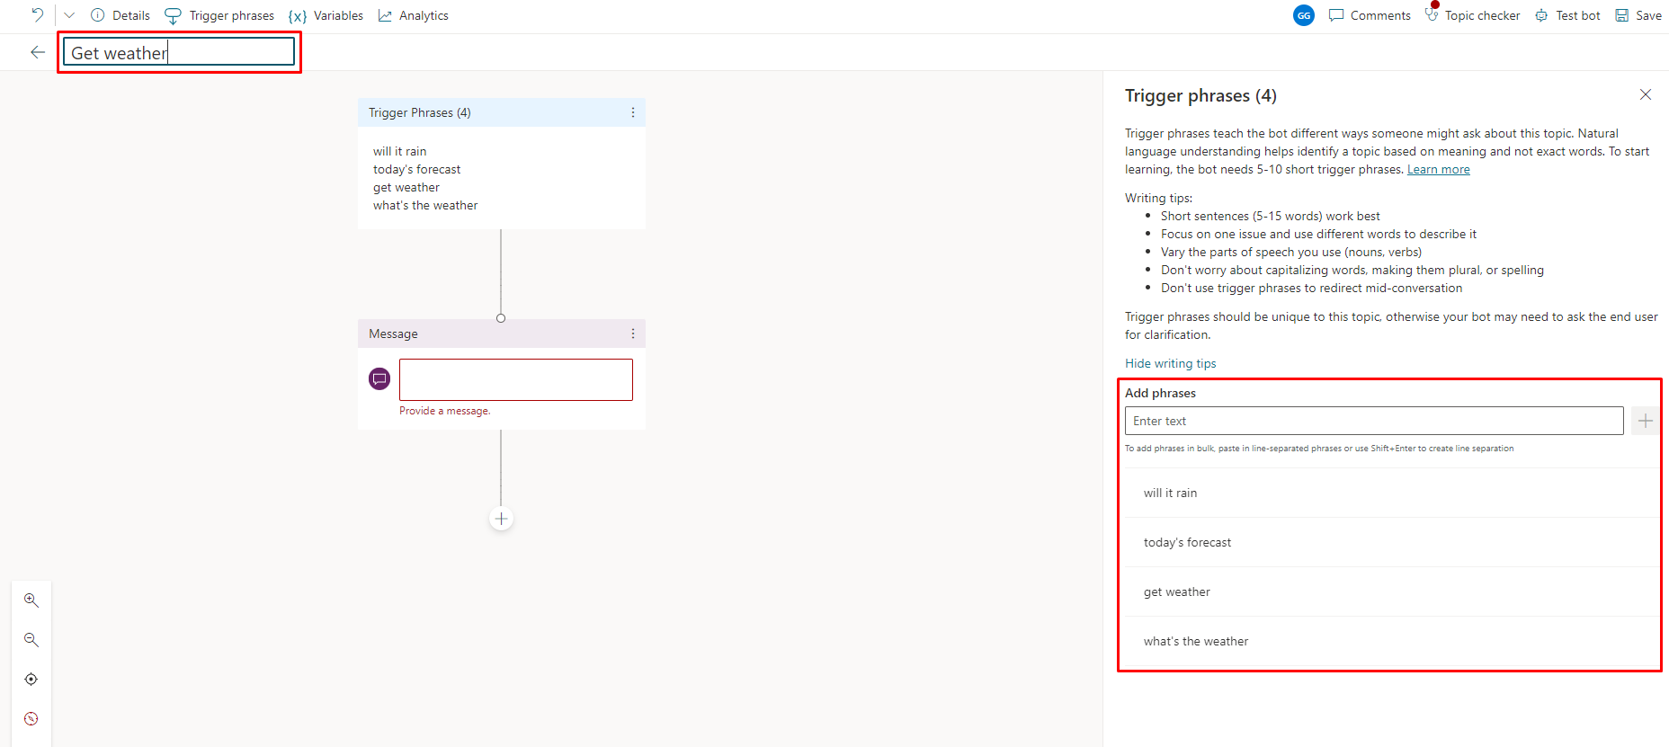
* Create a new Topic.” border=“false

1. By default, a message node is created. Enter **I can help you with that** into the node, and then select the plus (**+**) button under it to add a new node.

* 
* Screenshot of adding a node.” border=“false

1. Add two new **Ask a question** nodes to ask users for the **City (String)** and **Zipcode (Number)** inputs.

* 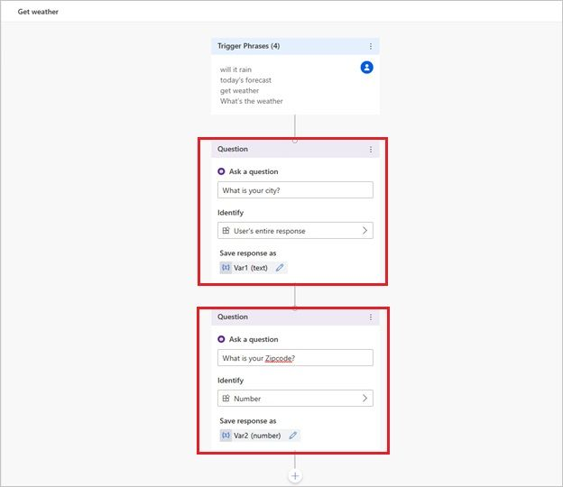
* Add Topic Dialog questions.” border=“false

1. Select the plus (**+**) button under the question nodes to add a new node. In the node selection window, select **Call an action**, and then select the flow you created earlier called **Get weather forecast**.

* 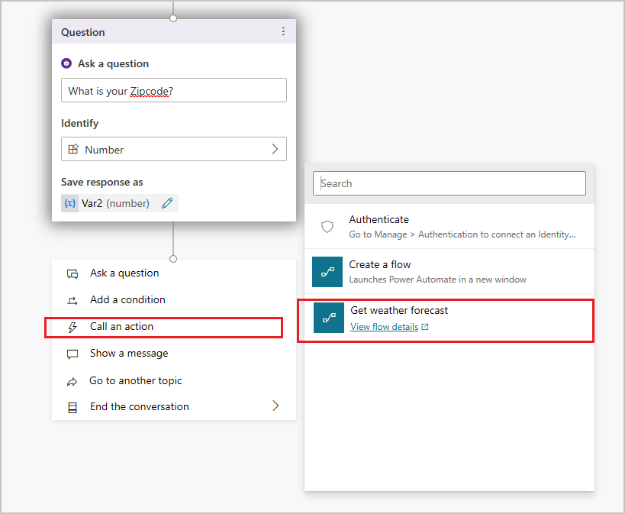
* Call action.” border=“false

1. Map the flow input blocks to the output variables from the question nodes. **City (text)** gets its value from Var1 (text) and **Zipcode (number)** gets its value from Var2 (number).
2. Under the flow’s node, add a **Message** node and then enter a message that uses the flow’s outputs. For example:

* **Today’s forecast for (x)location:{x}day_summary. Chance of rain is {x}chance_of_rain%**
* 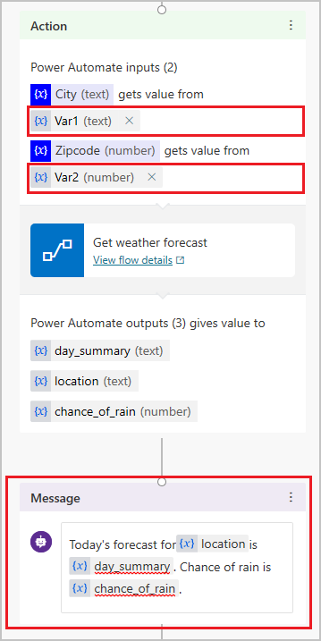
* Input the variables.” border=“false

1. Select **Save** to save your topic.

## Pass literal values into action input fields

Alternatively, if you’d rather type in a literal value for an action input instead of using a variable as an action input, you can type the value directly into the field.

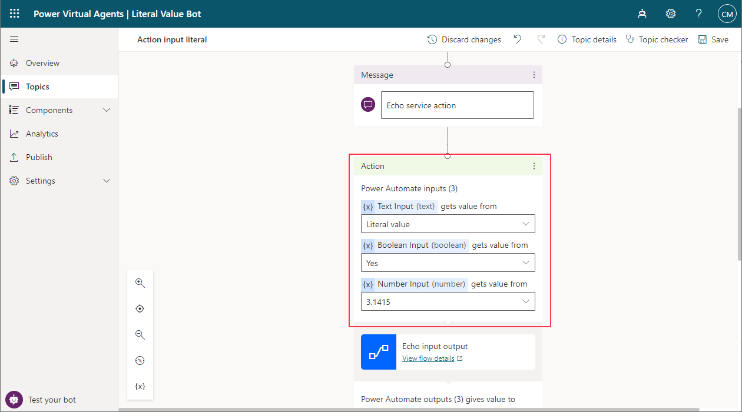

Pass literal values into action inputs.

## Test your flow and topic

In the **Test chat** pane, start a conversation with the bot by typing in a trigger phrase for the topic that contains the flow.

Enter your city and zip code at the prompt to get today’s weather forecast from the bot.

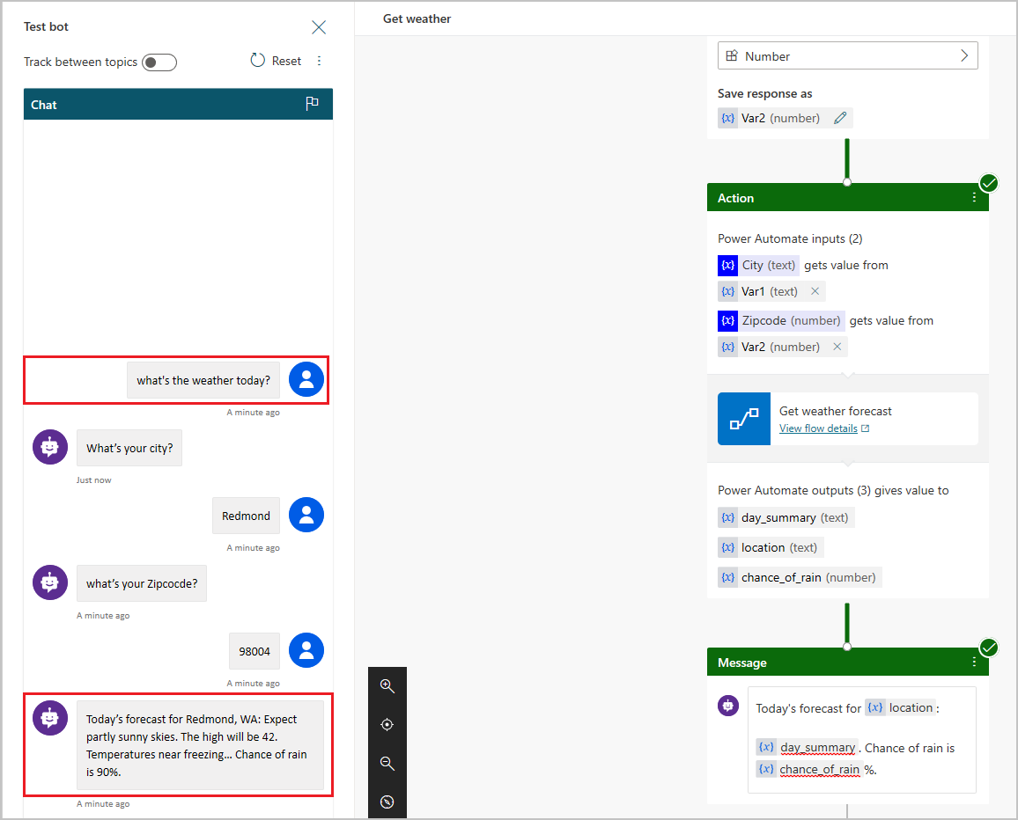

Test Dialog.” border=“false

## Disable asynchronous responses from flows

Power Virtual Agents doesn’t support Power Automate flows that return values [asynchronously](/power-automate/guide-staff-through-common-tasks-processes#when-to-use-workflows). When creating a new flow from within Power Virtual Agents, this behavior is disabled by default.

Flows that have the Asynchronous Response feature enabled may cause an error when your bot tries to run the flow. Instead of running the flow, the bot will say “Something unexpected happened. We’re looking into it. Error code: 3000.”.

If you’ve enabled [Asynchronous Response](/azure/connectors/connectors-native-http#asynchronous-request-response-behavior), you’ll need to disable it for the bot to work properly when it runs the flow:

### To disable Asynchronous Response

1. Locate and modify your flow.
2. In your Power Automate flow, locate the Power Virtual Agents step that returns values.
3. Next to the name of the flow, select the three dots, and then select **Settings**.

* 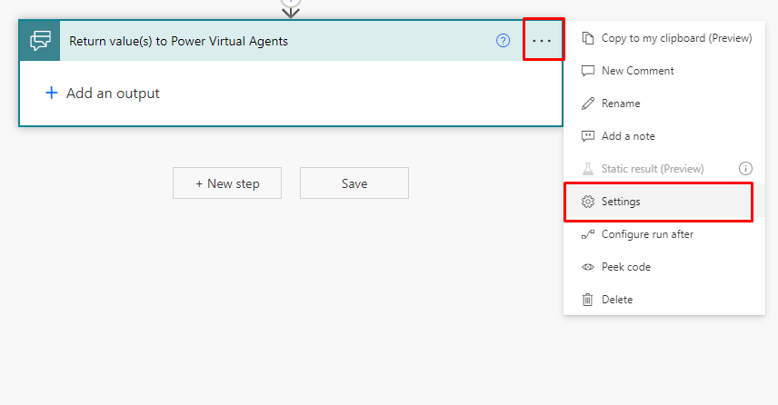
* Open step settings.

1. Set **Asynchronous Response** to **Off**, and then select **Done**.

* 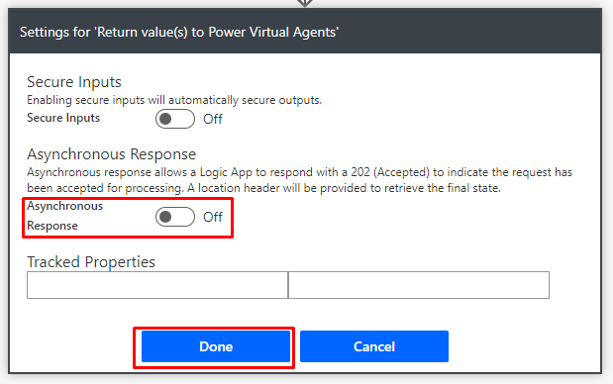
* Disable asynchronous response.

## Troubleshoot your bot

[Test your bot](authoring-test-bot.md) when you make changes to your topics and flows, to ensure everything is working as expected. When a bot encounters a problem during a conversation, it will respond with an error message.

Most flow-related issues can be found in the [Flow Checker](/power-automate/error-checker), but any issues on the authoring canvas will appear in [topic checker](authoring-topic-management.md#topic-errors).

# Add cards to bot responses

Cards add rich multimedia responses to **Question** and **Message** nodes. With cards, you can go beyond basic text replies by adding images, videos, and interactive elements.

There are several types of cards that provide different experiences to users. All types allow you to preview them on the authoring canvas in real-time.

## Prerequisites

* [Create and edit topics](authoring-create-edit-topics.md)
* [Use variables](authoring-variables.md)

## Basic Card

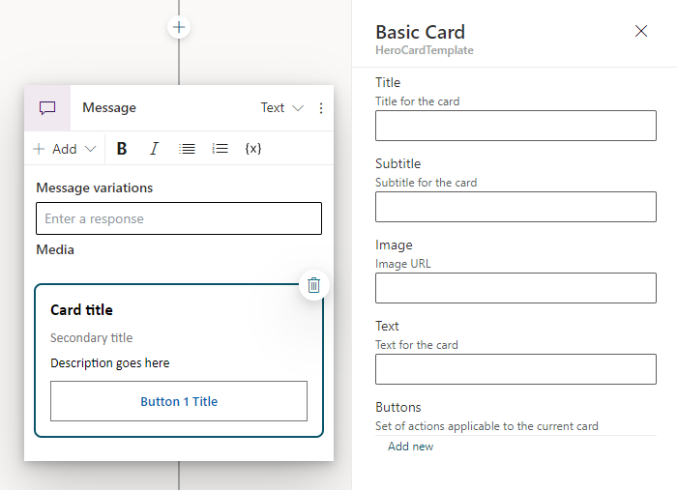

Screenshot of a message node with a basic card.

A **basic card** is a general purpose card that can be used in a variety of situations to add text, images, and interactive elements to bot responses.

1. On the authoring canvas, select the plus (**+**) icon. Then select **Show a message** to add a new **Message** node.
2. Select the **Message** node. Then select **Add** and choose **Basic Card**.
3. In the properties pane, populate the fields.

## Image Card

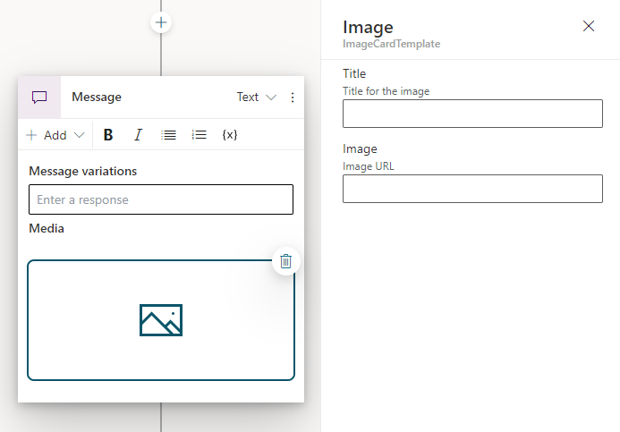

Screenshot of a message node with an image card.

An **image card** is a specialized card used to show an image to a user.

1. On the authoring canvas, select the plus (**+**) icon. Then select **Show a message** to add a new **Message** node.
2. Select the **Message** node. Then select **Add** and choose **Image**.
3. For **Image URL**, enter the URL for your image.
4. Optionally, enter a **Title** for your card.

## Video Card

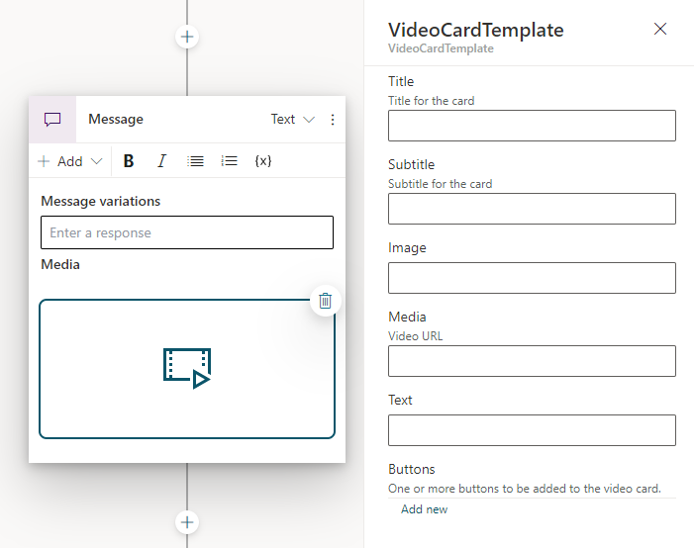

Screenshot of a message node with a video card.

A **video card** is a specialized card used to show a video to a user.

1. On the authoring canvas, select the plus (**+**) icon. Then select **Show a message** to add a new **Message** node.
2. Select the **Message** node. Then select **Add** and choose **Video**.
3. For **Media**, enter the URL for the your video.
4. Optionally set additional properties, such as the card’s **Title** and **Text**.

## Adaptive Card

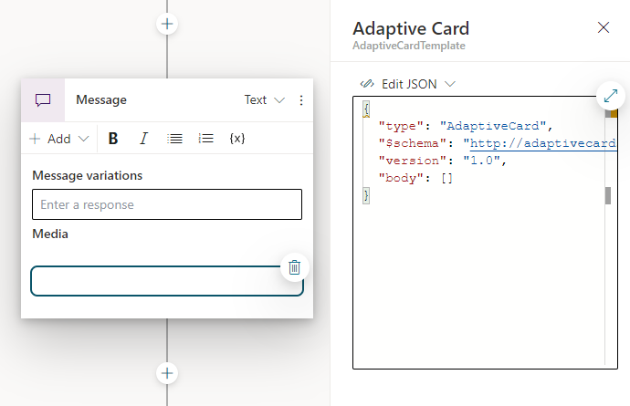

Screenshot of a message node with an adaptive card.

An **adaptive card** is fully customizable card that you can tailor to your needs. You can author adaptive cards by hand in JSON, or use the [Adaptive Cards Designer](https://adaptivecards.io/designer/) to create a card in a drag-and-drop interface.

**IMPORTANT** Power Virtual Agents only supports Adaptive Cards schema version 1.3 or lower.

1. On the authoring canvas, select the plus (**+**) icon. Then select **Show a message** to add a new **Message** node.
2. Select the **Message** node. Then select **Add** and choose **Adaptive Card**.
3. For **Edit JSON**, enter the JSON for your Adaptive Card.

* To open an expanded view of the JSON editor select **Expand**.
* 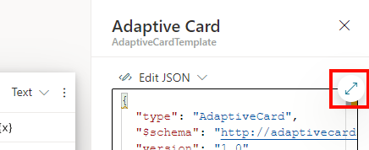
* Screenshot of the expand button.

## Manage multiple cards in the same node

If you add more than one card to a node, two display options will appear in the node’s menu when a card is selected:

* **Carousel** displays one card at a time.
* **List** displays all cards in a vertical list.

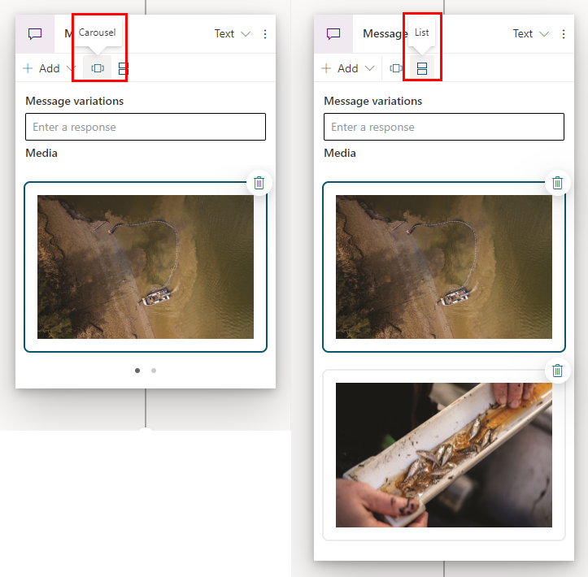

Screenshot of image cards in carousel mode and list mode.

You can remove cards from a node by selecting the **Delete** button in the corner of the card.

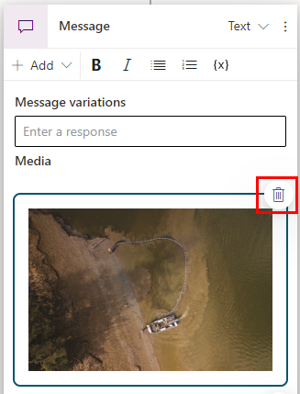

Screenshot of delete button on an image card.

# Customize speech responses with SSML

SSML (Speech Synthesis Markup Language) lets you customize your bot’s speech responses, and is one of the many ways Power Virtual Agents makes your bots sound natural. SSML is an XML-based markup language that allows bot makers to specify how input text is converted into synthesized speech. It can be used in bots that are connected to the [Telephony channel](publication-connect-bot-to-telephony.md).

## Prerequisites

* [Create and edit topics](authoring-create-edit-topics.md)
* [Telephony](publication-connect-bot-to-telephony.md)

## Create a speech message

Before customizing speech responses with SSML, you need to create a speech message in a topic.

1. Go to the authoring canvas of the topic you want to add a speech response to.
2. Add a node by selecting plus (**+**) icon on the line or branch between or after nodes. Then select **Send a message**.

* 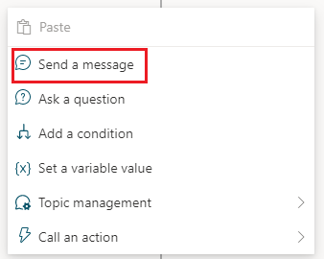
* Send a message on the authoring canvas.

1. Select the **Speech** mode in the **Message** to change the response from text to speech.

* 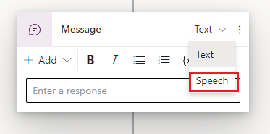
* Select Speech mode for the message.
* The following message will show after you switch from text to speech.
* 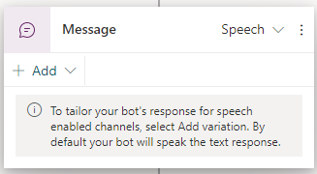
* Add speech response variation.

1. Select **+ Add** then **Message variation** to add speech response variations. Enter what you want the bot to say and add as many [message variations](authoring-create-edit-topics.md#message-variations) as needed.

You’ve created a speech message and can now add SSML to your message variations.

## Use SSML to customize speech responses

You can use SSML tags to customize your speech responses.

Select **SSML tags** from the Message. Then select the tags you want to add.

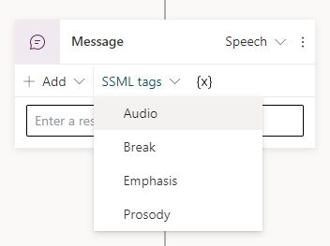

SSML helper options.

The table below describes what each tag does:

| SSML tag | Description |
| --- | --- |
| Audio | Add prerecorded audio. |
| Break | Insert pauses or breaks between words. |
| Emphasis | Increase the level of stress with which the contained text is spoken. |
| Prosody | Specify changes to pitch, contour, range, rate, and volume. |
|  |  |

You can add multiple tags to a single speech variation, as well as other SSML tags not shown above. For more information about SSML, see [Improve synthesis with SSML](/azure/cognitive-services/speech-service/speech-synthesis-markup).

# Key concepts - Publish your bot

With Power Virtual Agents, you can publish bots to engage with your customers on multiple platforms or channels. These include live websites, mobile apps, and messaging platforms like Microsoft Teams and Facebook.

After you’ve published at least once, you can connect your bot to more channels.

Each time you want to update your bot, you publish it again from within the Power Virtual Agents app itself. Publishing your bot will update the bot across all the channels where you’ve inserted or connected your bot.

## Publish the latest bot content

You need to publish the bot at least once before your customers can interact with it or before you can share it with your teammates. After the first publish, you can publish the bot again whenever you’d like your customers to engage with the latest bot content.

1. On the left side pane, select the **Publish** tab.
2. Select **Publish** to make the latest bot content available to your customers.

* 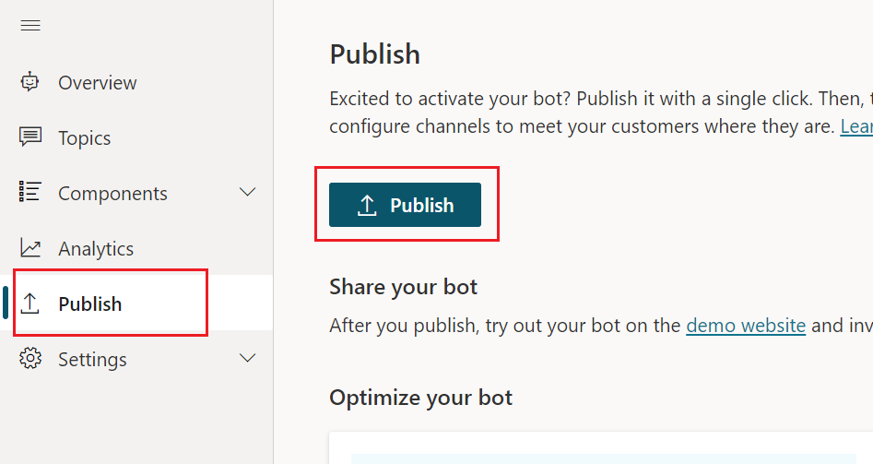
* Publish latest bot content.” border=“false
* The publishing process will take less than a few minutes as it checks for errors in the latest bot content.

1. After publishing completes, select the **demo website** link. The link will open a new tab and display a prebuilt demo website where you and your team can interact with the bot. The demo website is useful to gather feedback from stakeholders involved in the bot.

For details on updating the welcome message and help text on the demo website, go to [Configure the demo website and add the bot to your live website](publication-connect-bot-to-web-channels.md).

**TIP** **What’s the difference between the test chat and the demo website?**  
On the demo website, you can share a URL with members of your team, or other stakeholders who want to try out the bot. However, the website isn’t intended for production use, and you shouldn’t use it directly with customers.  
You can use the test chat to see whether conversation flows as expected, and to spot any errors during the bot creation process.

# Add bot to Telephony

Connect your [Azure Communication Service (ACS)](/azure/communication-services/) phone number to enable your bot to interact with users directly over the phone.

## Prerequisites

* [Publishing fundamentals](publication-fundamentals-publish-channels.md)

## Connect your bot to Telephony

1. In the side navigation under **Settings**, select **Channels**.
2. Select the **Telephony (Preview)** tile.

* 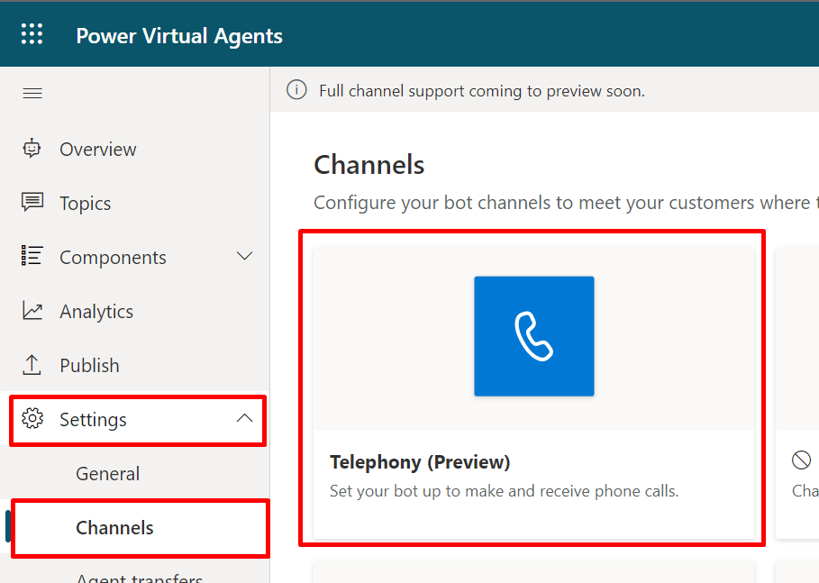
* Screenshot of Telephony tile.

1. Select **Connect existing phone number**.
2. Choose an **Azure Subscription** and **Azure Communication Services resource**, then select **Select**.

* 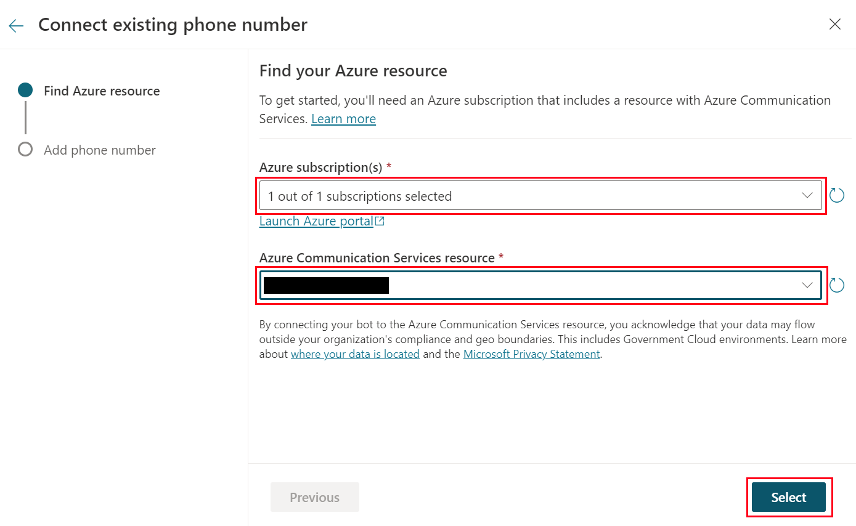
* Screenshot of selected Azure resources.

1. For **Phone number type** choose **PTSN**.

* **IMPORTANT** The **Direct routing** option is not supported in the technology preview.

1. Under **PTSN phone numbers** select the first number in the list, then select **Connect**.

* **IMPORTANT** Phone numbers have been been provisioned for the technology preview, but normally you’ll need to do this yourself in ACS.
* 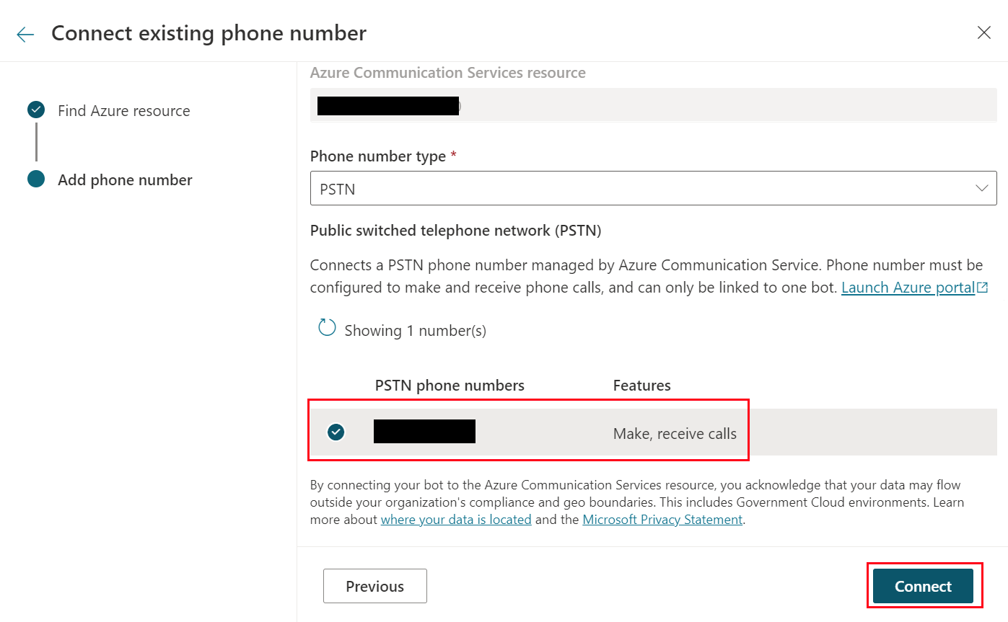
* Screenshot of selected phone number.

1. Once the connection is ready, [publish your bot](publication-fundamentals-publish-channels.md#publish-the-latest-bot-content) and test it by calling the number you selected.

To further customize how your bot speaks, learn [how to use Speech Synthesis Markup Language](advanced-custom-speech-ssml.md) and [change your bot’s voice font](advanced-speech-settings.md).

## Disconnect your bot from Telephony

Only one bot can be connected to a phone number. If you want to connect a different bot, you’ll first need to disconnect the old bot.

1. In the side navigation under **Settings**, select **Channels**.
2. Select the **Telephony (Preview)** tile.

* 
* Screenshot of Telephony tile in channel list.

1. Select **Disconnect**.

* 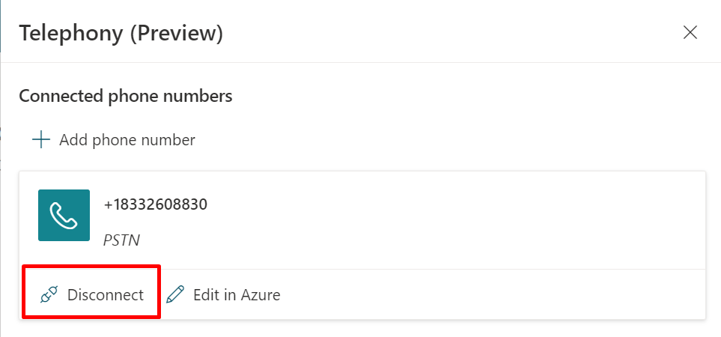
* Screenshot of disconnect button.

# Configure the demo website and add the bot to your live website

When publishing the bot to the web, you can publish to a prebuilt demo website (which you can use to share the bot with your teammates and stakeholders) and to your own live website.

**TIP** **When should I use the demo website and when should I use my own website?**  
You should use the demo website only to try out the bot and share it with your teammates or other stakeholders who want to try out the bot. It’s not intended for production uses, for example, you shouldn’t use it directly with customers.  
You should publish and use the bot on your live website for production scenarios, such as a help bot on your help webpage for customers to interact with.

## Demo website

You can edit the welcome message and suggested trigger phrases for the demo website. A welcome message helps prompt your teammates for what they should ask the bot about.

**TIP** You can change the welcome message to explain the intent or purpose of the testing, and you can change it as often as you like. So you could create a welcome message asking to test out conversations related to store hours and then, after making updates to the bot, change the welcome message to ask testers to try conversations related to gift cards.

### Update the demo website

1. On the side pane, select **Manage** then **Channels**.
2. Select the **Demo website** tile.
3. Enter the welcome message you’d like to see alongside the bot in the **Welcome message** text field.
4. Enter a list of suggested trigger phrases in the **Conversation starters** text field. Trigger phrases are what initiate specific topics, so you could customize your trigger phrases to specific topics that you want your teammates to try out.

* 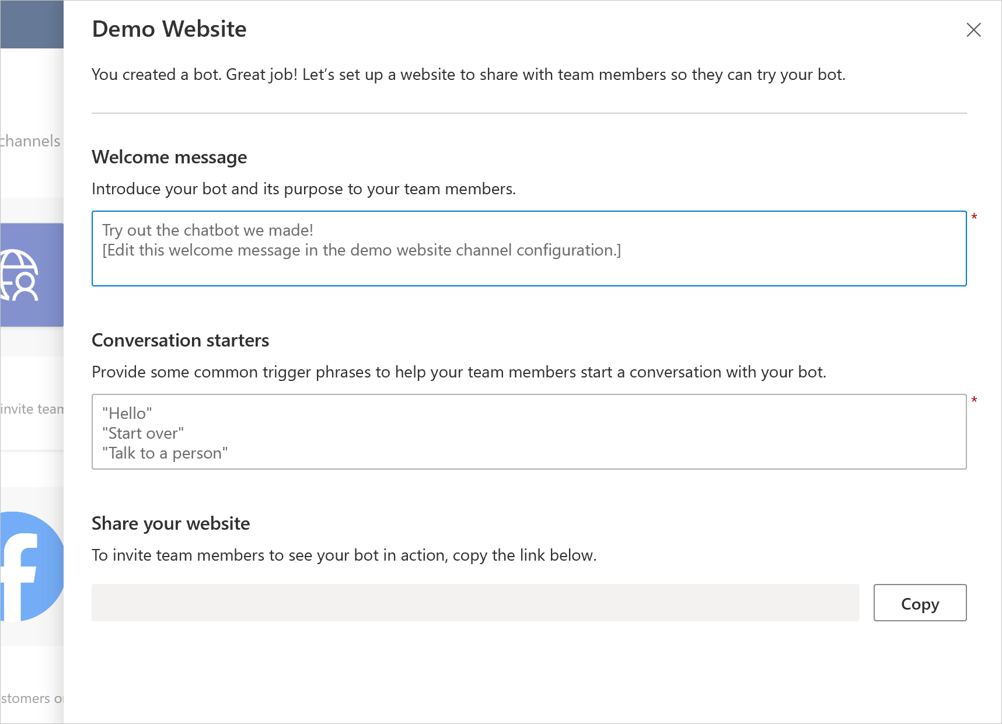
* Share demo website.

To share the demo website link, copy the demo website URL and share it with your teammates directly.

## Custom website

You can add your bot to a live website as an IFrame. Your live website can be a customer-facing external website or an internal site, like a SharePoint site.

You can also add the bot to your Power Platform admin center.

### Add bot to your website

1. On the side pane, select **Manage** then **Channels**.
2. Select **Custom website** and then select **Copy** to copy it directly to the clipboard, or **Share to email** to open a new email message with the snippet included, in your default email app.

* 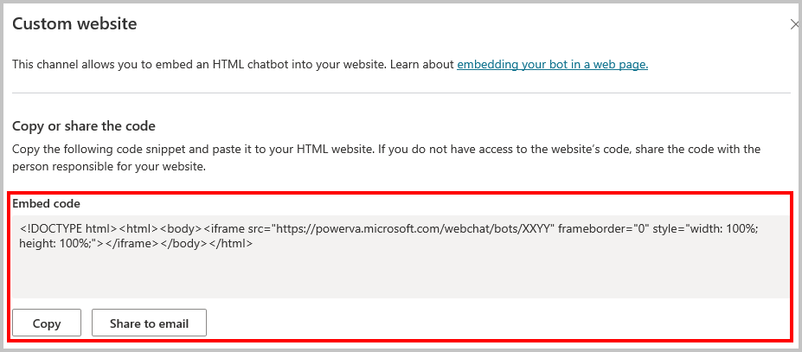
* Add bot to custom website.” border=“false

1. Provide the snippet to your web developer to add the bot to your website.

# Analysis in Power Virtual Agents

Power Virtual Agents has a comprehensive set of analytics that show you the key performance indicators for your bot.

Multiple charts show you trends and usage for your bot’s topics. These charts use AI to highlight the topics that have the greatest impact on your bot’s performance.

**NOTE** Bot analytics in Power Virtual Agents US Government Cloud plans will be released at a later date. You can use a [custom analytics solution to create a custom Power BI dashboard](https://powervirtualagents.microsoft.com/blog/custom-analytics-solution-for-power-virtual-agents/) to get bot analytics for these plans.

## Analytics in Power Virtual Agents

The analytics section is divided into a number of pages to give you multiple ways to understand bot performance.

**NOTE** Although transcripts are available immediately, the analytics dashboards are updated every hour, so there will be some delay before you see all data.

### View analytics

* In Power Virtual Agents, select **Analytics** on the side pane.
* 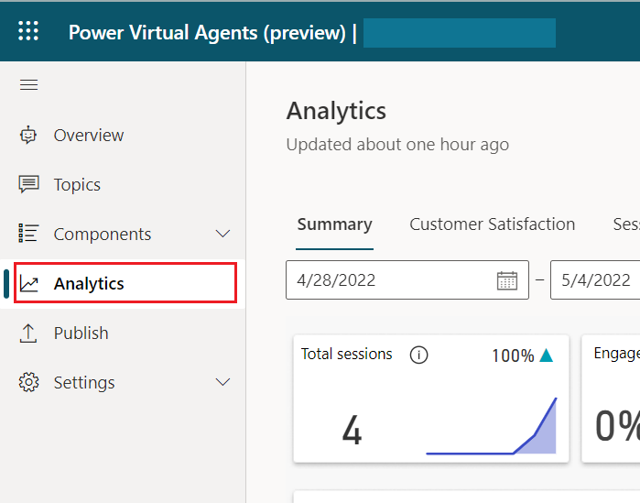
* Opening the Analytics dashboard.” border=“false

### See also

| Topic | Description |
| --- | --- |
| [Analyze bot performance and usage](analytics-summary.md) | Review overall analytics for your bots. |
| [Analyze customer satisfaction](analytics-csat.md) | Identify overall trends in customer satisfaction, and where satisfaction is falling behind. |
| [Analyze topic usage](analytics-topic-details.md) | See how individual topics are doing and how well they’re working at resolving issues. |
| [Analyze session information](analytics-sessions.md) | Review and monitor how sessions are doing, including analytics from the topics triggered during a session. |
| [Analyze billed session information](analytics-billed-sessions.md) | Understand how sessions are being billed, based on their usage. |

# Analyze bot performance and usage in Power Virtual Agents

The Summary page gives you a broad overview of your bot’s performance. It uses artificial intelligence (AI) technology to show you which topics are having the greatest impact on escalation rate, abandon rate, and resolution rate (see the table under Summary charts for more information on these metrics).

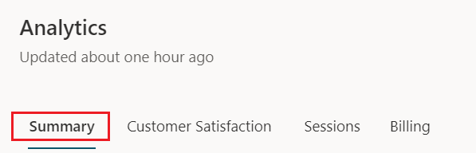

The Analytics summary page.” border=“false

The Summary page includes a variety of charts with graphical views of your bot’s key performance indicators. For information about each chart, see:

* Analyze bot performance and usage in Power Virtual Agents
  + Summary charts
  + Engagement over time chart
  + Session outcomes over time chart
  + Resolution rate drivers chart
  + Escalation rate drivers chart
  + Abandon rate drivers chart

The Engagement Rate Drivers, Abandon Rate Drivers, and Resolution Rate Drivers charts use natural language understanding to group issues as topics. These charts show you the topics that are having the most impact on the performance of your bot.

By default, the page shows you key performance indicators for the last seven days. To change the time period to the last 30 days, select **Last 30 days** from the drop-down list at the top of the page.

## Summary charts



Summary charts.” border=“false

The Summary charts summarize the key performance indicators for the specified time period and the percent change over the period.

| Description | Details |
| --- | --- |
| Total sessions | The total number of sessions within the specified time period. |
| Engagement rate | The percentage of total sessions that are engaged sessions. An engaged session is a session in which a user-created topic (as opposed to a system topic) is triggered, or the session ends in escalation. Engaged sessions can have one of three outcomes—they are either resolved, escalated, or abandoned. |
| Resolution rate | The percentage of engaged sessions that are resolved. A resolved session is an engaged session in which the user receives an end-of-conversation survey that asks the question *“Did that answer your question?”* and the user either does not respond or responds *Yes*. |
| Escalation rate | The percentage of engaged sessions that are escalated. An escalated session is an engaged session that is escalated to a human agent. |
| Abandon rate | The percentage of engaged sessions that are abandoned. An abandoned session is an engaged session that is neither resolved nor escalated after one hour from the beginning of the session. |
| CSAT | The graphical view of the average of customer satisfaction (CSAT) scores for sessions in which customers respond to an end-of-session request to take the survey. |

A blue up-and-down indicator next to the value indicates the percent change in a positive direction. A red indicator indicates the percent change in a negative direction.

## Engagement over time chart

The Engagement over time chart provides a graphical view of the number of engaged and unengaged sessions over time. An engaged session is a session in which a user-created topic is triggered or the session ends in escalation.

| Description | Details |
| --- | --- |
| Engaged | The daily number of engaged sessions. |
| Unengaged | The daily number of unengaged sessions. |

## Session outcomes over time chart

The Session outcomes over time chart provides a graphical view of the daily resolution rate, escalation rate, and abandon rate over the specified time period.

| Description | Details |
| --- | --- |
| Resolved | The daily rate of resolved sessions. A resolved session is an engaged session in which the user receives an end-of-conversation survey that asks the question *“Did that answer your question?”* and the user either does not respond or responds *Yes*. |
| Escalated | The daily rate of escalated sessions. An escalated session is an engaged session that is escalated to a human agent. |
| Abandoned | The daily rate of abandoned sessions. An abandoned session is an engaged session that is neither resolved nor escalated after one hour from the beginning of the session. |

## Resolution rate drivers chart

The Resolution rate drivers chart displays topics in order of their impact on the resolution rate over the specified time period.

| Description | Details |
| --- | --- |
| Topic | A Power Virtual Agents topic. |
| Rate | The percentage of engaged sessions for the topic that are resolved. A resolved session is an engaged session in which a customer receives an end-of-conversation survey and either does not respond to the survey or responds with *Yes*. |
| Impact | The topic’s resolution rate impact score. The resolution rate impact score is the overall resolution rate including the topic minus the overall resolution rate excluding the topic. |

The chart displays the impact as a red or blue bar. A red bar indicates that the topic’s resolution rate is greater than the average resolution rate, resulting in a negative impact on overall resolution rate. A blue bar indicates that the resolution time is shorter, resulting in a positive impact on overall resolution rate performance.

Improving the resolution rate for the top resolution-rate topics in red has the greatest impact on improving the overall resolution rate.

To see additional information about each topic, select the **Detail** link to display the topic details page. For more information, see [Topic details page](analytics-topic-details.md).

## Escalation rate drivers chart

The Escalation Rate Drivers chart displays topics in order of their impact on the escalation rate over the specified time period.

| Description | Details |
| --- | --- |
| Topic | A Power Virtual Agents topic. |
| Rate | The percentage of engaged sessions for the topic that are escalated. An escalated session is an engaged session that is escalated to a human agent. |
| Impact | The topic’s escalation rate impact score. The escalation rate impact score is the overall escalation rate including the topic minus the overall escalation rate excluding the topic. |

The chart displays the impact as a red or blue bar. A red bar indicates that the topic’s escalation rate is greater than the average escalation rate, resulting in a negative impact on overall escalation rate. A blue bar indicates that the escalation rate is smaller, resulting in a positive impact on overall escalation rate performance.

Lowering the escalation rate for the topics in red has the greatest impact on improving the overall escalation rate.

To see additional information about each topic, select the **Detail** link to display the topic details page. For more information, see [Topic details page](analytics-topic-details.md).

## Abandon rate drivers chart

The Abandon Rate Drivers chart displays topics in order of their impact on the abandon rate over the specified time period.

| Description | Details |
| --- | --- |
| Topic | A Power Virtual Agents topic. |
| Rate | The percentage of engaged sessions for the topic that are abandoned. An abandoned session is an engaged session that is neither resolved nor escalated after one hour from the beginning of the interaction. |
| Impact | The topic’s abandon rate impact score. The abandon rate impact score is the overall abandon rate including the topic minus the overall abandon rate excluding the topic. |

The chart displays the impact as a red or blue bar. A red bar indicates that the topic’s abandon rate is greater than the average abandon rate, resulting in a negative impact on overall abandon rate. A blue bar indicates that the abandon rate is smaller, resulting in a positive impact on overall abandon rate performance.

Improving the abandon rate for the top abandon-rate topics in red has the greatest impact on improving the overall abandon rate.

To see additional information about each topic, select the **Detail** link to display the topic details page. For more information, see [Topic details page](analytics-topic-details.md).

# Analyze customer satisfaction for Power Virtual Agents bots

The Customer Satisfaction page provides a detailed view of customer satisfaction (CSAT) survey data, including the average CSAT score over time and the topics that are having the most impact on the CSAT score.

The Customer Satisfaction page includes a variety of charts with graphical views of your bot’s customer satisfaction indicators. For information about each chart, select the link for the chart in the following list, or scroll to find the section about the chart later in this topic:

* Analyze customer satisfaction for Power Virtual Agents bots
  + Customer satisfaction drivers chart
  + Scores over time chart
  + Average CSAT score chart
  + CSAT survey response rate chart

The Customer satisfaction drivers chart shows you the topics that are having the most impact on customer satisfaction.

By default, the page shows you key performance indicators for the last seven days. To change the time period to the last 30 days, select **Last 30 days** from the drop-down list at the top of the page.

## Customer satisfaction drivers chart

The Customer satisfaction drivers chart uses AI to group related support cases as topics. This chart then displays topics in order of their impact on customer satisfaction over the specified time period.

| Description | Details |
| --- | --- |
| Topic | A Power Virtual Agents topic. |
| Engaged sessions | The number of engaged sessions for the topic within the specified time period. |
| Resolution rate | The percentage of engaged sessions for the topic that are resolved. A resolved session is an engaged session in which the user receives an end-of-conversation survey and either does not respond or responds **Yes**. |
| Abandon rate | The percentage of engaged sessions for the topic that are abandoned. An abandoned session is an engaged session that is neither resolved nor escalated after one hour from the beginning of the session. |
| Escalation rate | The percentage of engaged sessions for the topic that are escalated. An escalated session is an engaged session that is escalated to a human agent. |
| Avg CSAT | The average CSAT survey score for the topic. |
| Impact | The topic’s customer-satisfaction impact score. The customer-satisfaction impact score is the overall average CSAT survey score including the topic minus the overall average CSAT survey score excluding the topic. |

The chart displays the impact as a red or blue bar. A red bar indicates that the topic’s average CSAT survey score is lower than the average CSAT survey score, resulting in a negative impact on the overall average CSAT survey score. A blue bar indicates that the average CSAT survey score is higher, resulting in a positive impact on the overall average CSAT survey score.

Improving the average CSAT survey score for the top customer-satisfaction impact topics in red has the greatest impact on improving the overall CSAT score.

To see additional information about each topic, select the **Detail** link to display the Topic details page. For more information, see the [Topic details page](analytics-topic-details.md).

## Scores over time chart

The CSAT scores over Time chart provides a graphical view of the average CSAT score over the specified time period.

## Average CSAT score chart

The Average CSAT score chart provides a graphical view of the average of CSAT scores for sessions in which customers respond to an end-of-session request to take the survey. The CSAT survey asks customers to rate their experience on a scale of “terrible” to “excellent,” where “terrible” is given a value of 1 and “excellent” is given a value of 5.

## CSAT survey response rate chart

The CSAT survey response rate chart shows the number of CSAT surveys that were presented and the percentage of surveys that were completed.

# Analyze session information in Power Virtual Agents

By default, you can download up to seven days of bot conversation transcript sessions from the past 30 days directly from the Power Virtual Agents portal.

You can also download and view chat transcripts in the Power Apps portal.

See [Work with conversation transcripts](analytics-sessions-transcripts.md) for more details and tips.

Lastly, you can manage the retention period for transcripts. This can be useful if you want to increase the date range from 30 days to something else.

**NOTE** If you no longer have access to your environment, you’ll need to [create a support request](https://admin.powerplatform.microsoft.com/support) in the Microsoft Power Platform admin center.

## Download session transcript information from the Power Virtual Agents portal

1. Select **Analytics** on the side pane. Go to the **Sessions** tab.

* If your bot had a high number of sessions, they’ll be broken down into multiple rows. Each row contains 2500 sessions.

1. Click on each row to download the session transcripts for the specified time frame.

* 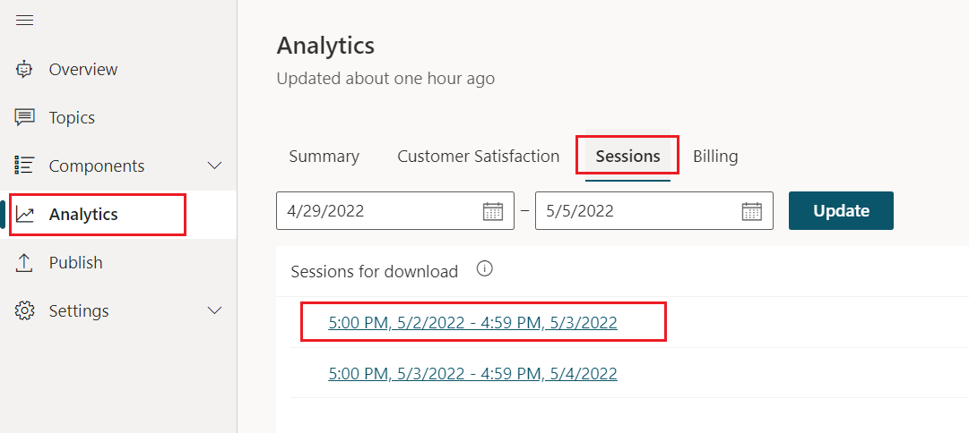
* Sessions page.” border=“false

The downloaded file contains the following information:

* SessionID: A unique identifier per session.
* StartDateTime: Time at which the session started. Entries are sorted by this column in descending order.
* InitialUserMessage: First message typed by the user.
* TopicName: Name of the last authored topic that was triggered in this session.
* ChatTranscript: Transcript of the session in the following format:
  + ***User says:****” “;* ***Bot says:****” “;* structure
  + Conversation turns are separated by semicolons
  + **Bot says** doesn’t include the options presented to the user.
  + Example:
  + User says: store hours; Bot says: Which store are you asking about?; User says: Bellevue; Bot says: Bellevue store is open from 10am to 7pm every day.;
* SessionOutcome: Outcome of the session (Resolved, Escalated, Abandoned, Unengaged).
* TopicId: A unique identifier of the last authored topic triggered in this session.

**NOTE** The download will start when you select the time period. It will be downloaded into your default browser download’s location.

## View and export bot conversation transcripts from the Power Apps portal

You can also view and export bot conversation transcripts from the Power Apps portal.

First, you’ll need to sign in to <https://www.powerapps.com> with your credentials.

### View conversation transcripts

1. In the side pane, expand the **Data** node. Select **Entities**. On the top right, expand **Default** and select **All**.

* 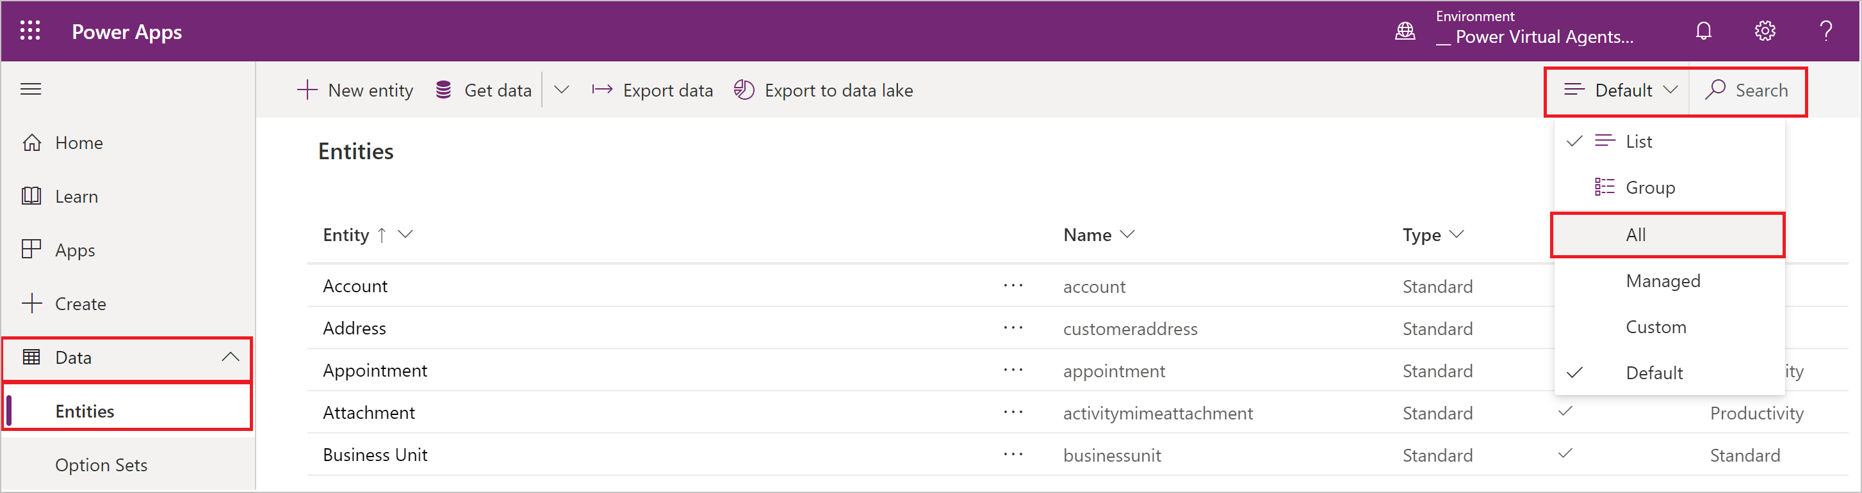
* Screenshot of the Power Apps window with Data and Entities selected.

1. Type **Conversation** in the **Search** textbox on the top right. Select **ConversationTranscript** under **Entities**.

* 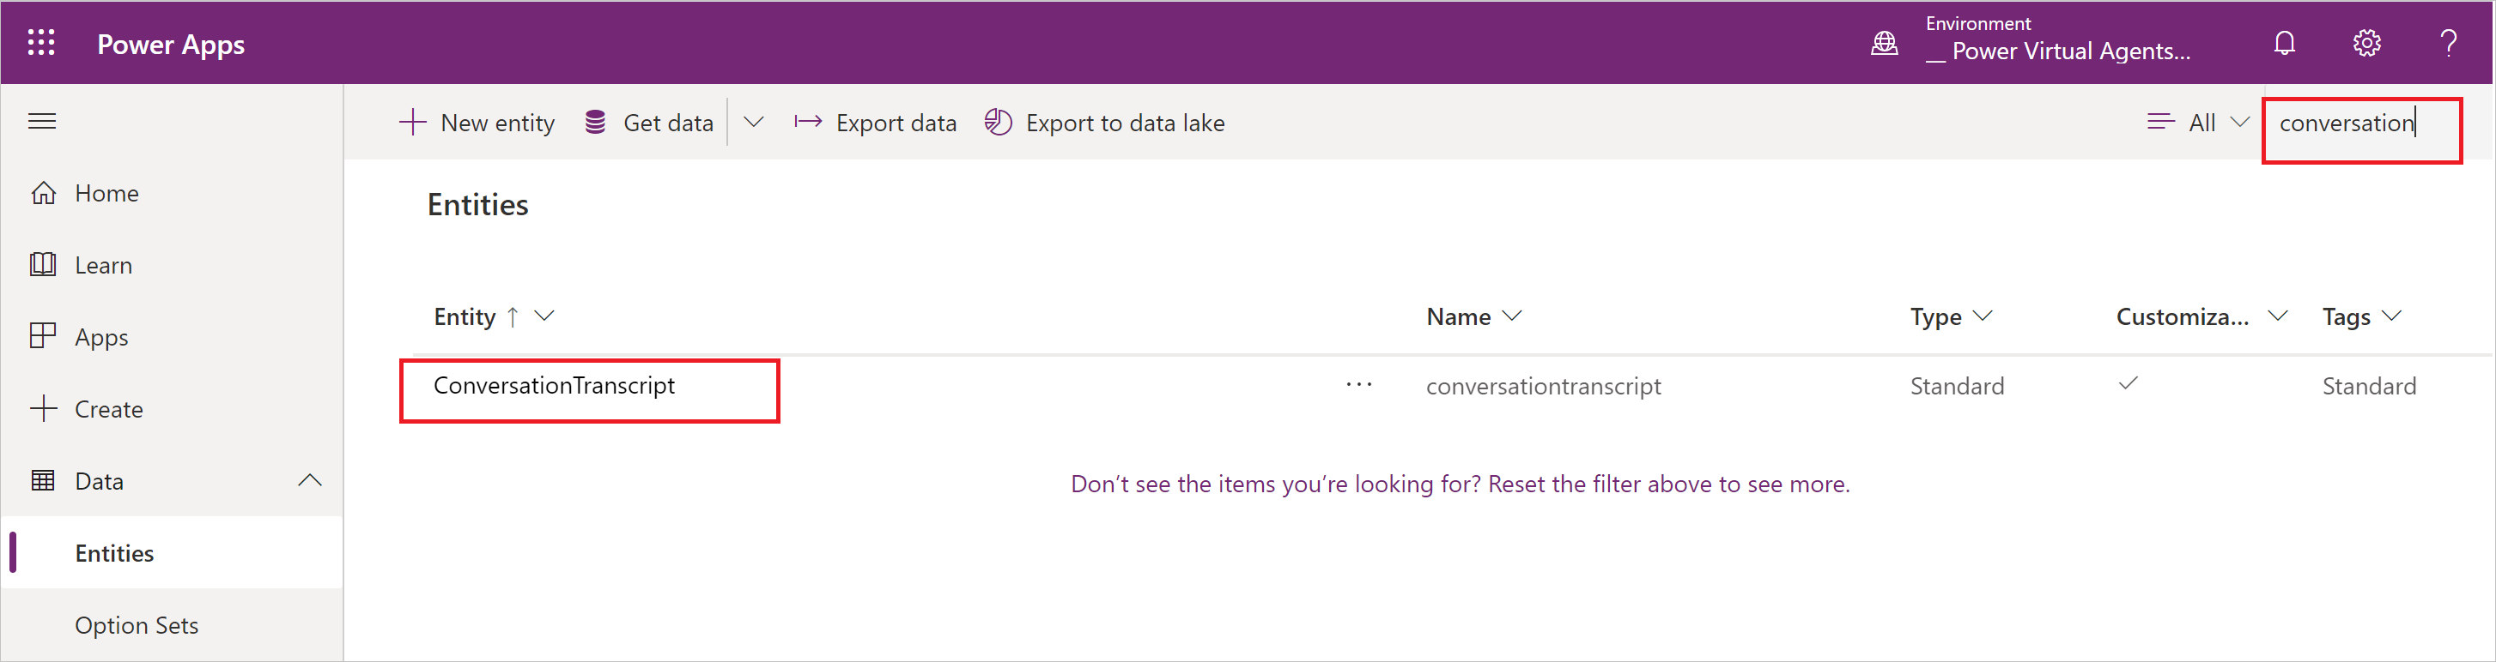
* Screenshot showing Conversation Transcript selected.

1. Select **Data** tab. Expand **Active conversationtranscripts** and then select **All fields**.

* 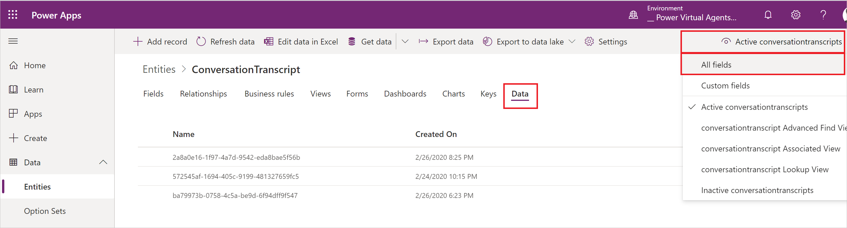
* Screenshot showing Active conversation transcripts expanded.

1. View the bot’s conversation transcripts.

* 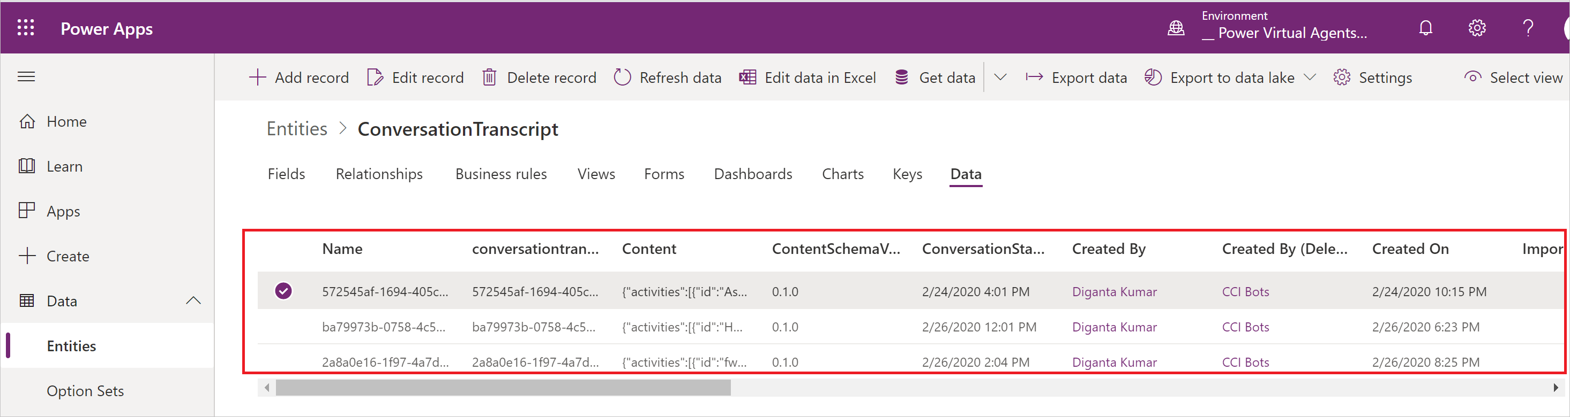
* Screenshot showing sample bot transcript entries.

### Export conversation transcripts

1. In the side pane, expand the **Data** node. Select **Entities** and then **Export data**.

* 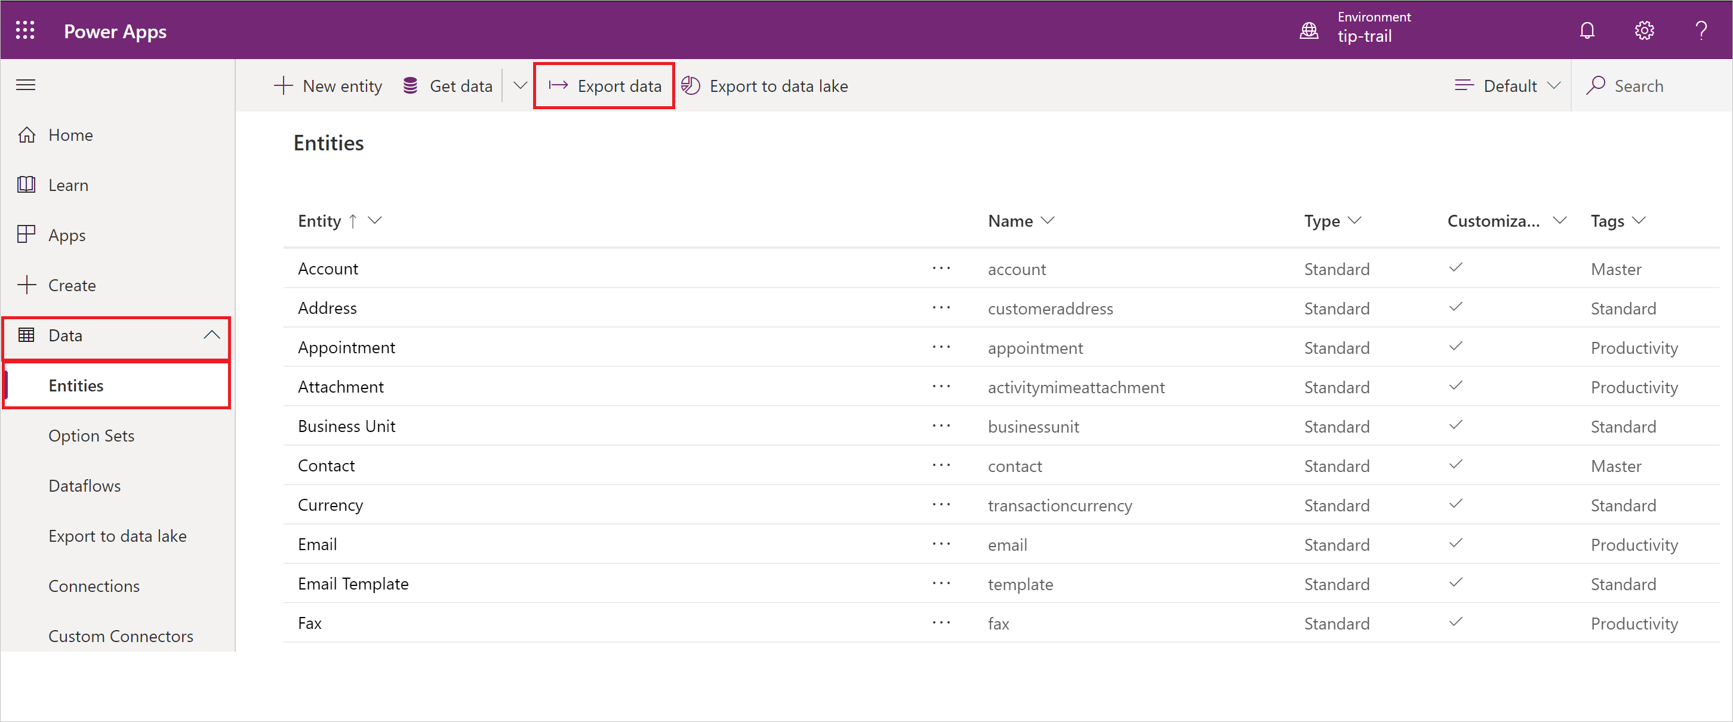
* Click path to export data.

1. On the Export data screen, select **ConversationTranscript** from the entity list. Select **Export data** at the top. Your data will take a couple of minutes to be compiled for export.

* 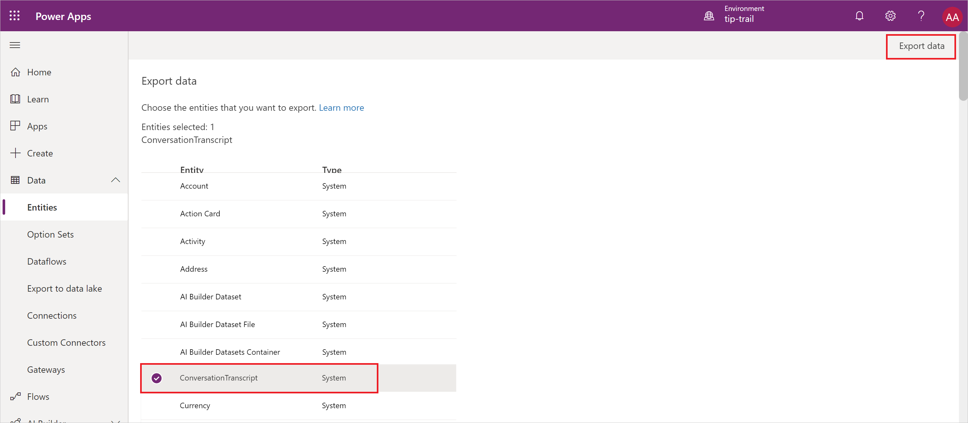
* Select entities for export.

1. Select **Download exported data** to download the content.

* 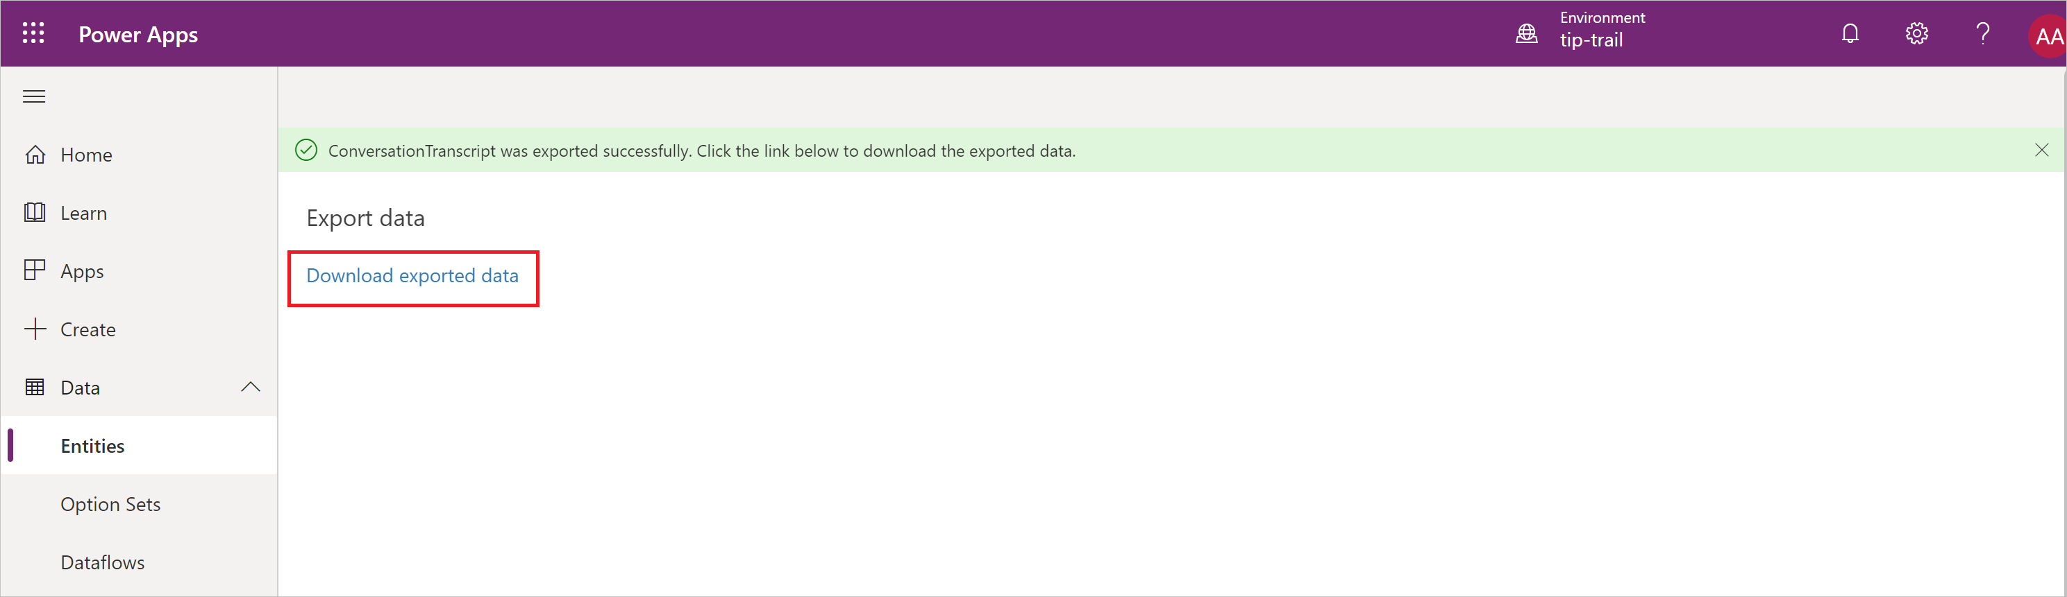
* Download exported data.

## Change the default period of session transcript retention

By default, a pre-configured bulk delete job will remove all conversation transcripts older than 30 days.

To keep the transcripts for longer, you need to disable the existing system job and create a new job.

First, you’ll need to sign in to <https://www.powerapps.com> with your credentials.

The following instructions describe how to set a job to delete transcripts that are older than 12 months.

1. At the top right, open the **Settings** menu cog icon and select **Advanced settings**.

* 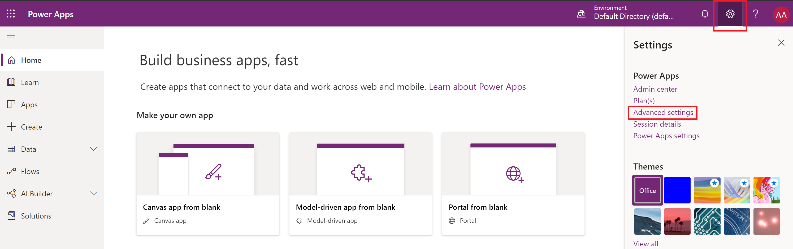
* Select the cog icon to open the settings menu.
* This will take you to the Dynamics 365 portal.
* 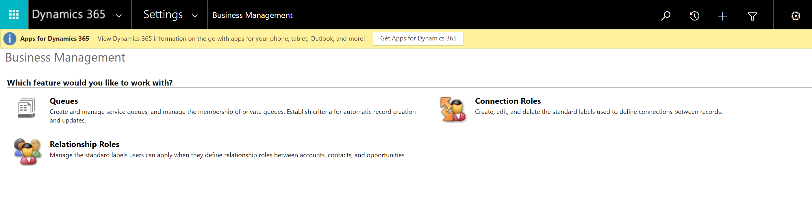
* The Dynamics 365 portal.

1. Open the **Settings** menu and select **Data Management**.

* 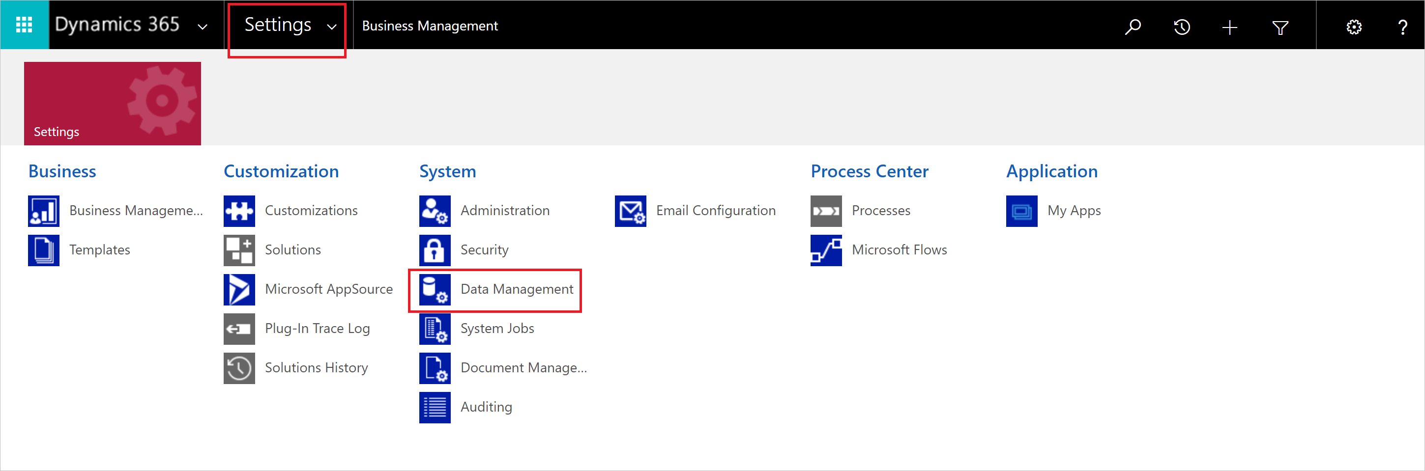
* The settings link at the top shows a number of objects, including Data Management.

1. Select **Bulk Record Deletion**.

* 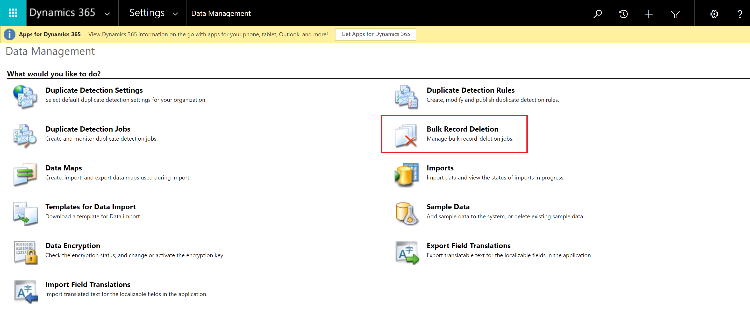
* An icon showing a table with a red x, indicating the deletion of a bulk record.

1. On the **Bulk Record Deletion** screen, expand the **View** dropdown and select **Recurring Bulk Deletion System Jobs**.

* 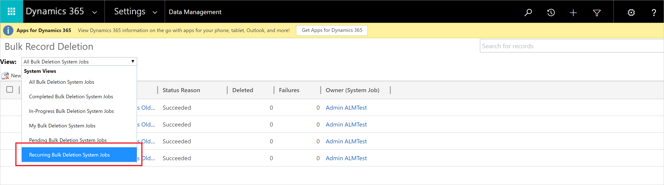
* The dropdown opens to show options.

1. Select the pre-configured bulk delete job called **Bulk Delete Conversation Transcript Records Older Than 1 Month**.

* 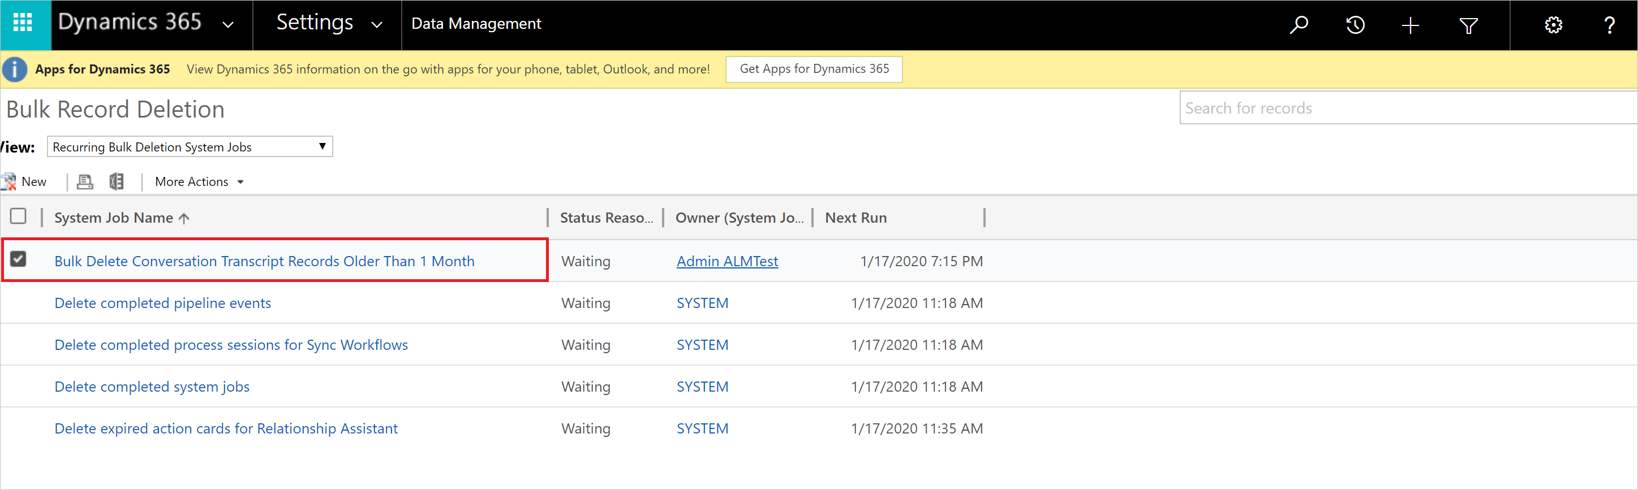
* A list of bulk delete jobs, with the first one highlighted.

1. In the **More Actions** dropdown, select **Cancel** to disable future bulk deletion using this job.

* 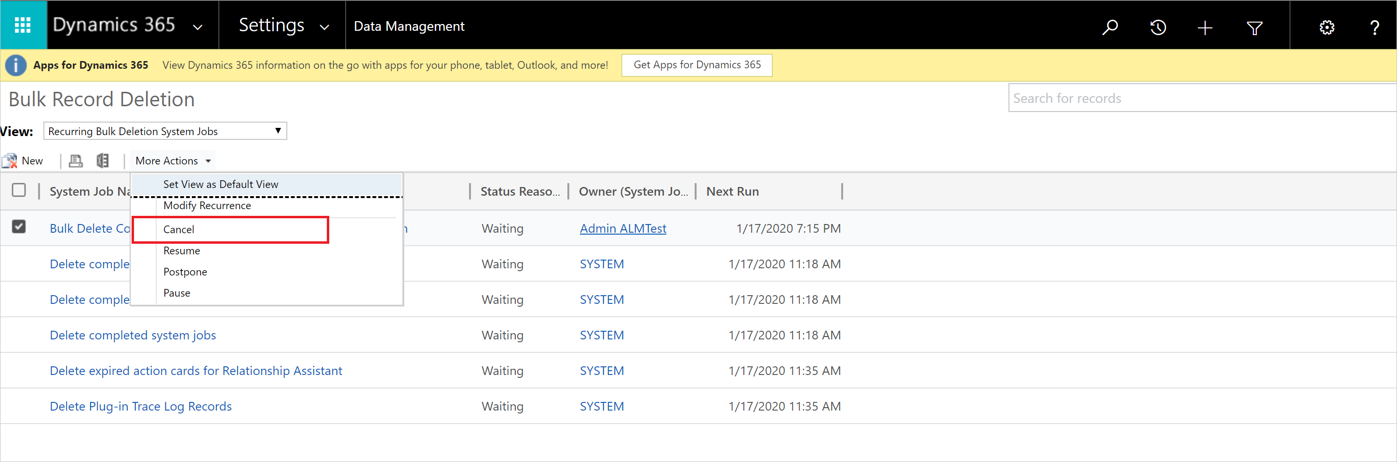
* The more actions dropdown opens to show a menu list, including Cancel.

1. Create a new bulk record delete job by selecting **New** and set the following:
   * Set **ConversationStartTime** as **Older Than X Months** to **12**.  
     This will keep the transcripts for 12 months
   * Set **SchemaType** as **equals** to **powervirtualagents**.
   * 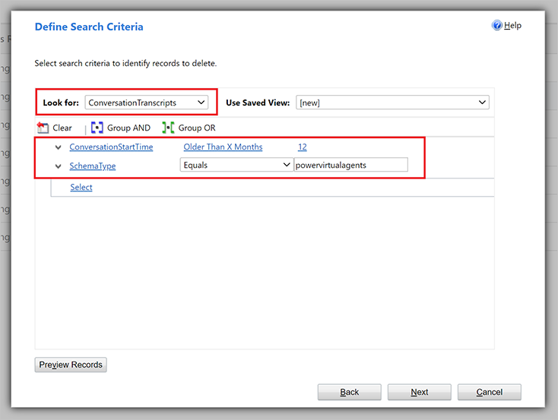
   * A popup window showing options to configure the job.
2. Enter a name and change **Run this job after every** to **1**.

* 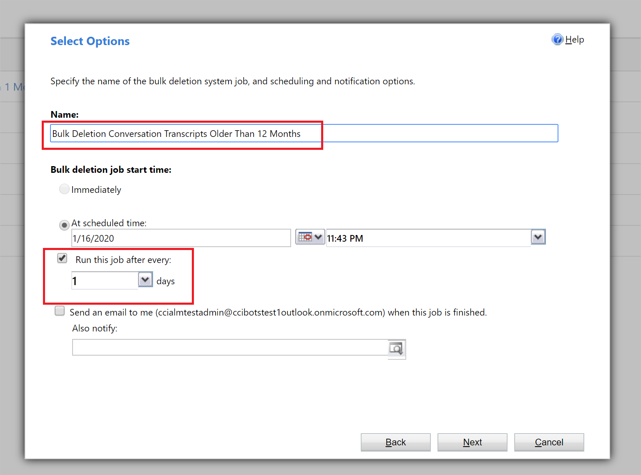
* A popup window showing options to name and run the job.
* The bulk delete job is created and will delete bot conversation transcripts that are older than 12 months.
* 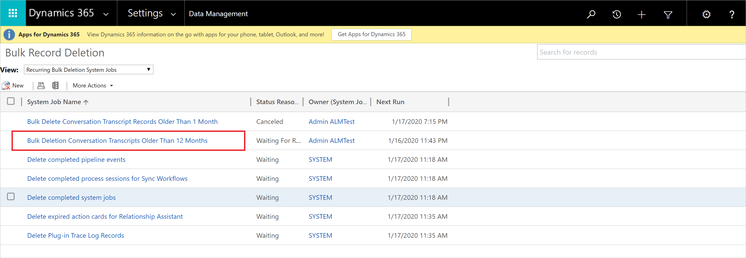
* The list of bulk delete jobs, now showing the new job just created.

# Work with conversation transcripts

When you [export Power Virtual Agents chatbot conversation transcripts from Microsoft Dataverse](analytics-sessions.md), you will be presented with many fields.

Each of these fields includes information relevant to the chatbot conversation.

This topic lists the most important fields found in Power Virtual Agents conversation transcripts, and also provides guidance on bringing analytics information into Power BI with dataflows.

## Conversation transcripts fields

The following are the most relevant to chatbots created with Power Virtual Agents:

| Field | Description | Example |
| --- | --- | --- |
| *Content* | The entire transcript in JSON format. | See the Content field section. |
| *ConversationStartTime* | The start time of the conversation (not the time the transcript record was written to the data store). | 2021-04-19T20:39:09Z |
| *Conversationtranscript* | Unique identifier for the data row in the Dataverse table. | 28eccb77-xxxx-4a63-985f-ffaaadd6f391 |
| *Metadata* | JSON that includes the Bot Id, Tenant Id, and Bot Name. | {"BotId": "198eca5f-xxxx-4ae6-8c08-835d884a8688", "AADTenantId": "72f988bf-xxxx-41af-91ab-2d7cd011db47", "BotName": "Test Bot"} |
| *Name* | The name of the custom row that is created from the conversationid, followed by botid. | 8YYe8iif49ZKkycZLe7HUO-o_198eca5f-xxxx-4ae6-8c08-835d884a8688 |
| *bot_conversationtranscript* | The bot’s ID. | 198eca5f-xxxx-4ae6-8c08-835d884a8688 |
| *Created on* | Date and time when the transcript record was created. | 2021-04-20T02:40:13Z |

### Content field

The *Content* field is a raw log of all the activities users have with the bot. Common activity types include *message* and *event*:

* *Message* activities represent content shown within a conversation. *Message* activities may contain text, speech, interactive cards, and binary or unknown attachments.
* *Event* activities communicate programmatic information from a client or channel to a bot.

For more information on activity types, see the [Bot Framework Activity schema](https://github.com/Microsoft/botframework-sdk/blob/master/specs/botframework-activity/botframework-activity.md).

The following are some of the key fields you will find within the *Content* JSON:

| **Key** | **Description** |
| --- | --- |
| ID | Unique GUID to identify the activity object. |
| valueType | Indicator of the type of value stored in the activity. This indicator dictates what information is being provided by this activity.See Common activity value types. |
| timestamp | Timestamp of when the activity was generated in Epoch format (number of seconds since midnight UTC Jan 1, 1970). |
| type | The type of activity (for example, message, event, trace). |
| replyToId | The ID of the activity that the current activity is responding to. |
| from | Contains fields id and role: |
| channelId | ID of where the activity is coming from (for example, directline, msteams, facebook). |
| textFormat | Format of the text (for example, plain, markdown). |
| attachments | Holds dynamic rich data associated with the activity(for example, AdaptiveCards, HeroCards, Carousel data) |
| text | The text for message activities. |
| value | Fields specific to the activity based on the value type, this field is where most of the useful information exists. |
| channeldata |  |
| name | Name of the event activity (for example, SetPVAContext) |

#### Common activity value types

| **Activity value type** | **Description** |
| --- | --- |
| ConversationInfo | Contains whether the conversation is from the Power Virtual Agents app’s test pane (isDesignMode) and the locale of the conversation. |
| CSATSurveyRequest | User is presented with a customer satisfaction (CSAT) survey. |
| CSATSurveyResponse | User responds to a CSAT survey. |
| DialogRedirect | User is redirected to another topic. |
| ImpliedSuccess | User has reached a question node in the topic, where one of the conditions points to the “Confirmed Success” CSAT system topic or calls the “End of Conversation” system topic. |
| IntentRecognition | A topic was triggered by the user. |
| PRRSurveyRequest | The user was asked if the topic answered their question from the “End of Conversation” topic. |
| PRRSurveyResponse | The user’s response to whether the topic answered their question from the “End of Conversation” topic. |
| SessionInfo | Contains the type (unengaged or engaged), outcome (Escalated, Resolved, Abandon), and the turn count of the session. |
| VariableAssignment | A value has been assigned to a variable. |

To convert the ID of the dialog being redirected to, a user can use the bot’s content.

## Building custom reports from conversation transcripts

There are a few approaches one can take to build custom reports form conversation transcripts based on the number of messages that need to be processed.

### Lightweight approach

[Connect Power BI to Dataverse with a Power BI dataflow](https://github.com/microsoft/PowerVirtualAgentsSamples/tree/master/CustomAnalytics). Other infrastructure isn’t required and, with every refresh, all records will be retrieved from Dataverse.

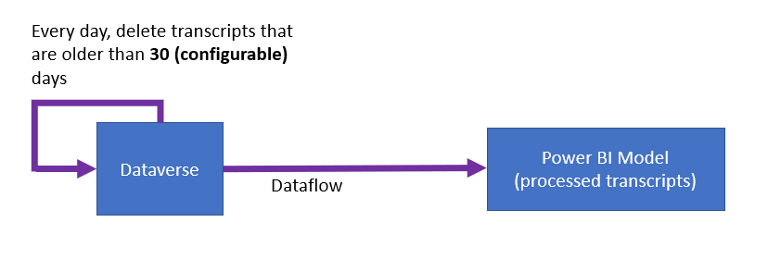

Diagram showing flow of data from Dataverse to the Power BI model.

| Pros | Cons |
| --- | --- |
| Easiest implementation. | Refresh time may increase as transcripts increase. High cost for storage within Dataverse. |

### Standard Azure Data Lake Store approach

Export Dataverse data to Azure Data Lake Store.

This method requires an Azure Storage account, but no other Azure infrastructure.

Use a Power Platform dataflow for data preparation on the transcripts and extract the data into a structured form.

Power BI refreshes data from the Dataflow and all compute infrastructure is managed by Power Platform and Power BI. During every refresh, records for a certain day will be retrieved from Dataverse.

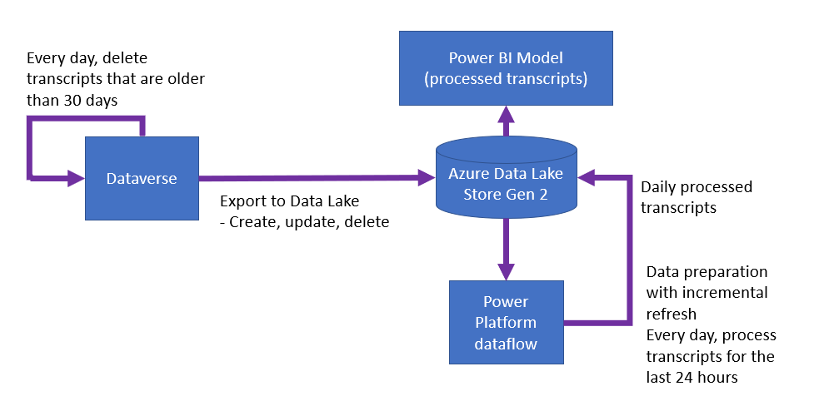

Diagram showing the data flowing from Dataverse into Azure Data Lake and then being processed by Power Platform and Power BI.

| Pros | Cons |
| --- | --- |
| Low storage cost in Azure Data Lake Store. Moderately simple implementation. No Azure Compute required. | Refresh time may increase as transcripts each day increase. |

### Azure Data Lake Store (ADLS) + Synapse approach

If data size in the Standard Azure Data Lake Store approach causes slow refreshes or other operational problems, you can use [Azure Synapse Analytics](https://azure.microsoft.com/services/synapse-analytics/) and integrate it [into Power BI](https://powerbi.microsoft.com/blog/announcing-azure-synapse-analytics-public-preview/).

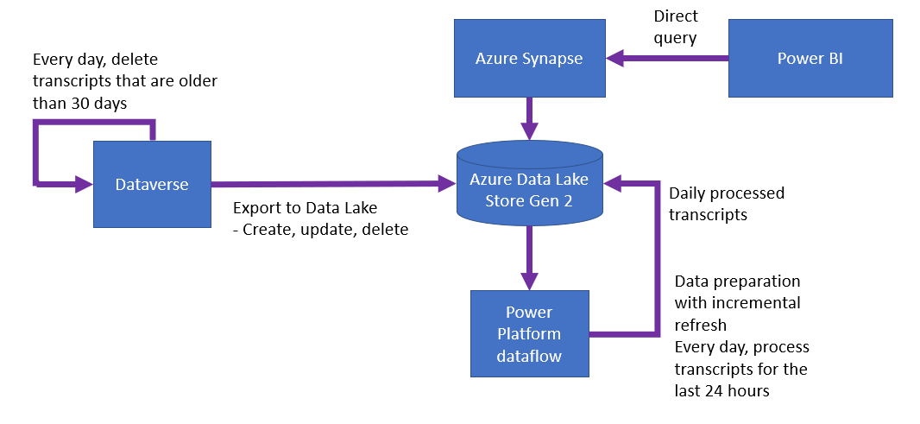

Diagram of data flowing from Dataverse into Azure Data Lake and being processed by Azure Synapse and Power Platform.

| Pros | Cons |
| --- | --- |
| Refresh time is constant. Moderately simple implementation. Low storage cost in Azure Data Lake Store. | Compute cost for Azure Synapse. |

## Tips for getting the most out of your conversation transcripts

[Variables can be used to store data relevant to your bot content](authoring-variables.md) or bot user. Parsing out the variable and its value from the conversation transcript lets you filter or slice the data by the variable

In many places the conversation transcripts refer to content by its ID. For example, the ID of the topic that is being redirected to by the current topic is only referenced by its ID. To get the name of the topic, look up the name of the topic from the bot content.

# Analyze topic usage in Power Virtual Agents

The topic details page provides a view into the performance of individual topics and how they can be improved.

You can display the topic details page by selecting the **Detail** link in one of the following charts on the [Summary](analytics-summary.md) and [Customer Satisfaction](analytics-CSAT.md) pages:

* [Escalation rate drivers (Summary page)](analytics-summary.md#escalation-rate-drivers-chart)
* [Abandon rate drivers (Summary page)](analytics-summary.md#abandon-rate-drivers-chart)
* [Resolution rate drivers (Summary page)](analytics-summary.md#resolution-rate-drivers-chart)
* [Customer satisfaction drivers (Customer Satisfaction page)](analytics-CSAT.md#customer-satisfaction-drivers-chart)

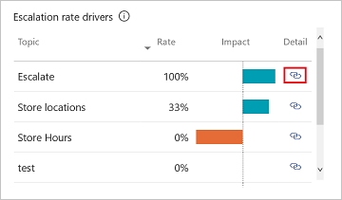

Topic details link.” border=“false

The topic details page can also be displayed by opening an individual topic from the [Topics page](authoring-create-edit-topics.md) and selecting **Analytics** at the top of the page.

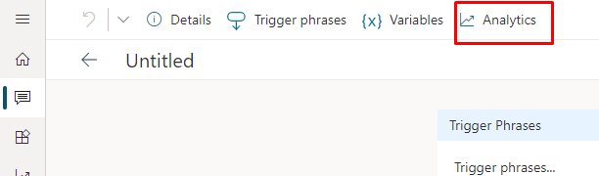

From the Topic details page, select the Analytics tab.

You can also hover over each topic in the Topics page and select the **Go to analytics** icon.

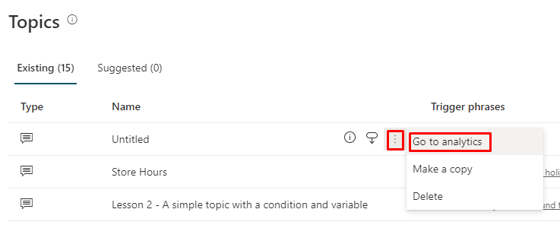

Hovering shows the Go to analytics icon.” border=“false

The topic details page includes a variety of charts with graphical views of a topic’s key performance indicators. For information about each chart, see:

* Analyze topic usage in Power Virtual Agents
  + Topic summary charts
  + Impact summary charts
  + Topic Volume by Day chart

## Topic summary charts

The Topic summary charts summarize the topic’s performance indicators for the specified time period and the percent change over the period.

| Description | Details |
| --- | --- |
| Total sessions | The total number of sessions within the specified time period. |
| Average CSAT | The average customer satisfaction (CSAT) survey score for the specified time period. |
| Resolution rate | The percentage of engaged sessions that are resolved. A resolved session is an engaged session in which the user receives an end-of-session survey and either does not respond or responds *Yes*. |
| Escalation rate | The percentage of engaged sessions that are escalated. An escalated session is an engaged session that is escalated to a human agent. |
| Abandon rate | The percentage of engaged sessions that are abandoned. An abandoned session is an engaged session that is neither resolved nor escalated after one hour from the beginning of the session. |

A blue up-and-down indicator below the value indicates the percent change in a positive direction. A red indicator indicates the percent change in a negative direction.

## Impact summary charts

The Impact summary charts summarize the impact of the topic on key performance indicators for the specified time period.

| Description | Details |
| --- | --- |
| CSAT impact | The topic’s customer satisfaction impact score. The customer satisfaction impact score is the overall average CSAT survey score including the topic minus the overall average CSAT survey score excluding the topic. |
| Resolution rate impact | The topic’s resolution-rate impact score. The resolution-rate impact score is the overall resolution rate including the topic minus the resolution rate excluding the topic. |
| Escalation rate impact | The topic’s escalation-rate impact score. The escalation-rate impact score is the overall escalation rate including the topic minus the escalation rate excluding the topic. |
| Abandon rate impact | The topic’s abandon-rate impact score. The abandon-rate impact score is the overall abandon rate including the topic minus the abandon rate excluding the topic. |

## Topic Volume by Day chart

The Topic volume by day chart provides a graphical view of the number of sessions for the topic over the specified time period.

# View billed sessions for Power Virtual Agents in Teams

When you purchase a Power Virtual Agents license, you gain capacity for the specified number of billed sessions. Power Virtual Agents pools this capacity across the entire tenant.

The consumption of the capacity isn’t reported at the tenant level, but can be seen for each individual bot.

## Find the number of billed sessions for your bot

1. In Power Virtual Agents, select **Analytics** from the side pane.
2. Go to the **Billing** tab.

You can change the date range to filter the **Total billed sessions over time** chart. You can also see the total billed sessions and trend percentage next to the chart.

## Definition of a billed session

A *billed session* is an interaction between a customer and a bot, and represents one unit of consumption.

The billed session begins when a user topic or premium functionality (as indicated in the Common scenarios section) is triggered. For more information, see [Use system and sample topics section](authoring-create-edit-topics.md#use-system-and-sample-topics)

A session ends for one of the following reasons:

* The user ends the chat session.  
  When the bot doesn’t receive a new message for more than 30 minutes, the session is considered closed.
* The session is longer than 60 minutes.  
  The first message that occurs after 60 minutes starts a new session.
* The session has more than 100 turns. A *turn* is defined as one exchange between a user and the bot.  
  The one-hundred-and-first turn starts a new session.

## Common scenarios

The following table helps illustrate which sessions are going to be billed and which sessions are free or included in select Microsoft 365 subscription. These scenarios are examples only and not all scenarios are covered.

| Scenario | Is session billed? | Topic type | Channel | Power Automate flow | Bot Framework extensibility | Bot stored in |
| --- | --- | --- | --- | --- | --- | --- |
| User logs vacation days (in Dataverse for Teams) in a conversation with the bot in Microsoft Teams. | Included with select Microsoft 365 subscriptions | Any topic type | Teams | Yes (only standard connectors) | Not used | Dataverse for Teams |
| Bot greets user on a website, customer escalates to human agent directly or doesn’t interact with the bot. | Free - not a billed session | System | Any channel | Not used | Not used | Any environment type |
| Greeting topic redirects to Bot composer or a skill topic for advanced operations. | Billed session | Any topic type | Any channel | Either used or not used | Yes | Any environment type |
| Greeting topic pulls information about the user using Power Automate flow to present a customized experience. | Billed session | Any topic type | Any channel | Yes (any connector) | Either used or not used | Any environment type |
| User interacts with the bot on your website to ask about store hours, check order status and so on. | Billed session | Non-system | Any channel | Either used or not used | Either used or not used | Dataverse |

**NOTE** Sessions that use the [embedded test chat](authoring-test-bot.md) don’t count toward the billed sessions. The Billed Session report doesn’t distinguish between the sessions included in the Power Virtual Agents for Microsoft Teams plan and those that aren’t included. You might see an inflated number of billed sessions in the report.

## Frequently asked questions

### What’s the difference between total sessions, engaged sessions, and billed sessions?

The number of **billed sessions** is used to measure capacity, and is allocated when you purchase a license.

**Total sessions** and **engaged sessions** are metrics used to determine how efficient a bot is in addressing a user’s questions.

More information: [Analyze bot performance and usage in Power Virtual Agents](analytics-summary.md)

### Where can I see the total number of billed sessions for my organization?

Currently, you can only see billed sessions for a single bot.

### If I’m on a trial subscription but have some billed sessions, do I have to pay?

If you see billed sessions, it doesn’t mean you’ll be charged. For example, the trial offer provides you with some billed sessions.

# Customize the look and feel of the bot’s default canvas

After you create and [publish a bot](publication-fundamentals-publish-channels.md), your customers can [use the bot’s Web Chat canvas to interact with it](publication-connect-bot-to-web-channels.md).

The default look and feel of the bot is defined by the bot’s canvas. You can customize the canvas in two ways, depending on the complexity of the customizations:

1. You can customize the default canvas with JavaScript-based styling in the HTML code for the website where you deploy your bot.  
   Customizing the default canvas is useful if you want to make small customizations without investing in code development.
2. You can use a custom canvas, based on the [Bot Framework Web Chat canvas](https://github.com/microsoft/BotFramework-WebChat).  
   Connecting to a custom canvas requires extensive developer knowledge and is useful for organizations that want to customize the experience completely.

You can also combine the customized canvas with configuring your bot to automatically start the conversation.

**IMPORTANT** You may install and use the sample code included in this documentation only for use with the Microsoft Power Virtual Agents product. The sample code is licensed “as is” and is excluded from any service level agreements or support services. You bear the risk of using it.

Microsoft gives no express warranties, guarantees, or conditions and excludes all implied warranties, including merchantability, fitness for a particular purpose, and non-infringement.

## Change the bot name

You can change the bot’s name.

1. Select **Manage** on the side pane, and then go to the **Details** tab.
2. Change the bot’s name.
3. Select **Save** to commit your changes.

* 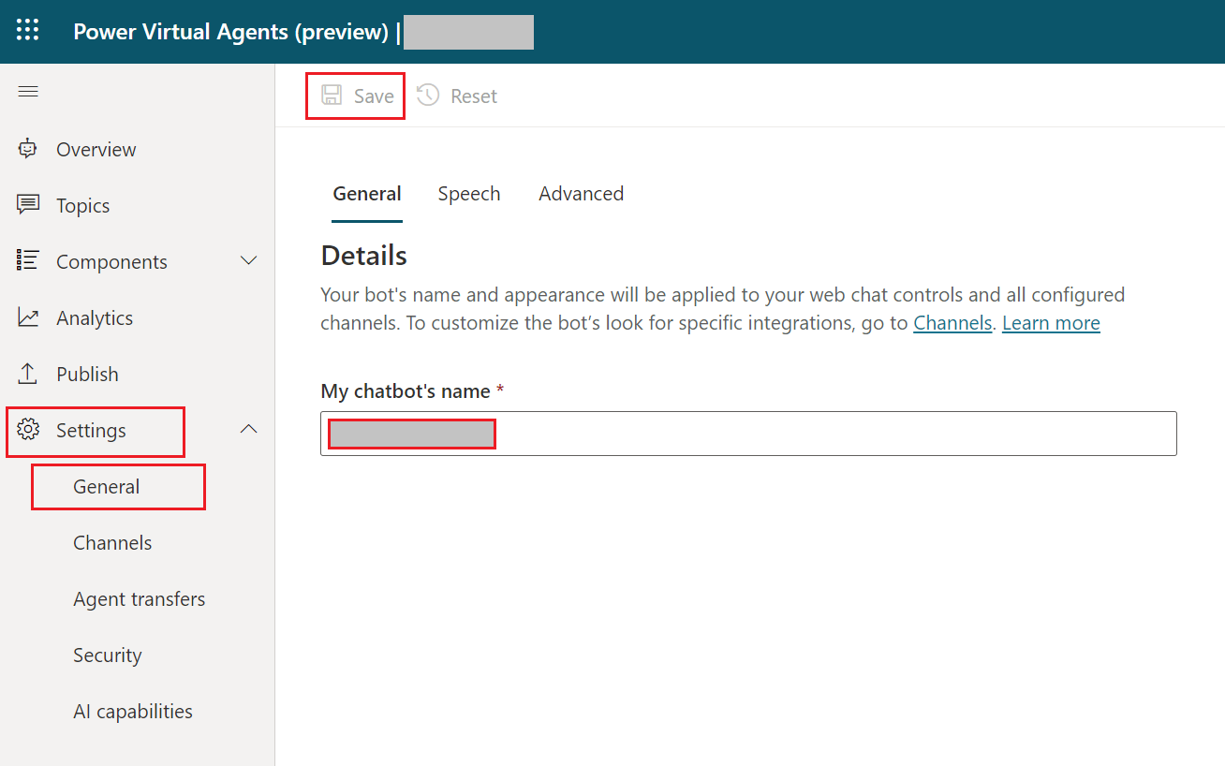
* The bot details pane lets you change the name.

**IMPORTANT** After updating your bot’s icon, it may take up to 24 hours for the new icon to appear everywhere.

## Retrieve bot ID and tenant ID details

To customize your canvas, whether it’s the default canvas or a custom one you connect to, you need to retrieve your bot details.

You can get the Bot ID and Tenant ID by going to the Mobile app under Channels.

## Customize the default canvas (simple)

You can configure how the chat canvas looks with some simple CSS and JavaScript styling options.

First, you need to configure where you’re deploying your bot canvas.

1. Create and publish a bot.
2. Copy and paste the HTML code below and save it as *index.html*.  
   You can also copy and paste the code below into the [w3schools.com HTML try it editor](https://www.w3schools.com/html/tryit.asp?filename=tryhtml_default). You will still need to add your Bot ID.

* <!DOCTYPE html>  
  <html>  
  <head>  
   <title>Contoso Sample Web Chat</title>   
   <!-- This styling is for the Web Chat demonstration purposes. It is recommended that style is moved to separate file for organization in larger projects -->  
   <style>  
   html, body {  
   height: 100%;  
   }  
    
   body {  
   margin: 0;  
   }  
    
   h1 {  
   font-size: 16px;  
   font-family: Segoe UI;  
   line-height: 20px;  
   color: whitesmoke;  
   display: table-cell;  
   padding: 13px 0px 0px 20px;  
   }  
    
   #heading {  
   background-color: black;  
   height: 50px;  
   }  
    
   .main {  
   margin: 18px;  
   border-radius: 4px;  
   }  
    
   div[role="form"]{  
   background-color: black;  
   }  
    
   #webchat {  
   position: fixed;  
   height: calc(100% - 50px);  
   width: 100%;  
   top: 50px;  
   overflow: hidden;  
   }  
    
   </style>  
    
  </head>  
  <body>  
   <div>  
   <div id="heading">  
   <!-- Change the h1 text to change the bot name -->   
   <h1>Contoso Bot Name</h1>  
   </div>  
   <div id="webchat" role="main"></div>  
   </div>   
    
   <script src="https://cdn.botframework.com/botframework-webchat/latest/webchat.js"></script>  
    
   <script>  
   const styleOptions = {  
    
   // Add styleOptions to customize Web Chat canvas  
   hideUploadButton: true  
   };  
    
   // Add your BOT ID below   
   var BOT_ID = "<ENTER YOUR BOT ID>";   
   var theURL = "https://powerva.microsoft.com/api/botmanagement/v1/directline/directlinetoken?botId=" + BOT_ID;  
    
   fetch(theURL)  
   .then(response => response.json())  
   .then(conversationInfo => {  
   window.WebChat.renderWebChat(  
   {  
   directLine: window.WebChat.createDirectLine({  
   token: conversationInfo.token,  
   }),  
   styleOptions  
   },  
   document.getElementById('webchat')  
   );  
   })  
   .catch(err => console.error("An error occurred: " + err));  
    
   </script>  
   </body>  
  </html>

1. In the *index.html* file you created, enter your Bot ID at the line var BOT_ID = "<ENTER YOUR BOT ID>".
2. Open *index.html* using a modern browser (for example, Microsoft Edge) to open the bot in the custom canvas.
3. Test the bot to ensure you are receiving responses from your bot and that it’s working correctly.  
   If you encounter problems, make sure you’ve published your bot, and that your Bot ID has been inserted in the correct place. It should be after the equals sign (=) at the line var BOT_ID, and surrounded by double quotation marks (“).

### Customize the bot icon, background color, and name

Once you get the customized canvas working with your bot, you can make changes to it.

You can use the JavaScript styleOptions options to configure a number of pre-defined styles.

See [Web Chat customization](/azure/bot-service/bot-builder-webchat-customization?view=azure-bot-service-4.0&preserve-view=true) for links to the defaultStyleOptions.js file and more information on what you can customize and how it will look.

#### Change the bot icon

1. Update the *index.html* file with the following sample code:

* const styleOptions = {  
   botAvatarInitials: 'BT',  
   accent: '#00809d',  
   botAvatarBackgroundColor: "#FFFFFF",  
   botAvatarImage: 'https://docs.microsoft.com/en-us/azure/bot-service/v4sdk/media/logo_bot.svg',  
   userAvatarImage: 'https://avatars.githubusercontent.com/u/661465'  
   };

1. Replace the bot and user avatar images with your company images.  
   If you don’t have an image URL, you can use a Base64-encoded image string instead.

#### Change the background color

1. Update the *index.html* file with following sample code:

* const styleOptions = {  
    
   backgroundColor: 'lightgray'  
    
   };

1. Change backgroundColor to any color you wish. You can use standard CSS color names, RGB values, or HEX.

#### Change the bot name

1. Update the <h1> text in the *index.html* file with the following:

* <body>  
   <div id="heading">  
   <!-- Change the h1 text to change the bot name -->  
   <h1><img src="contosobot-teams.png"> Contoso Bot Name</h1>  
   </div>

1. Change the text to whatever you want to call the bot. You can also insert an image, although you may need to style it to ensure it fits within the heading section.

## Customize and host your chat canvas (advanced)

You can connect your Power Virtual Agents bot with a custom canvas that is hosted as a standalone web app. This option is best if you need to embed a customized iFrame across multiple web pages.

**NOTE** Hosting a custom canvas requires software development. Our guidance here is intended for experienced IT professionals, such as IT admins or developers who have a good understanding of developer tools, utilities, and IDEs.

### Pick a sample to customize

We recommend starting with one of these samples custom-built to work with Power Virtual Agents:

* [Full bundle](https://github.com/microsoft/PowerVirtualAgentsSamples/tree/master/BuildYourOwnCanvasSamples/1.starter-full-bundle) is a custom canvas capable of showing all rich content from Power Virtual Agents. For example:
* 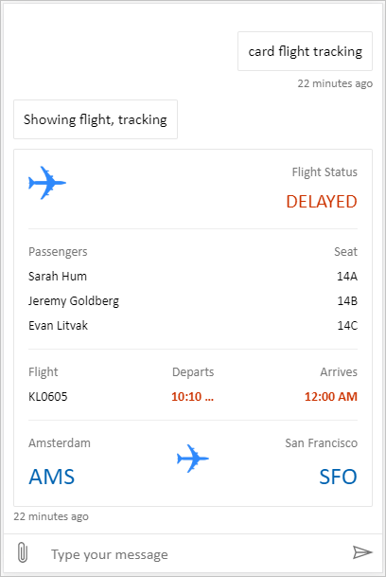
* Full bundle custom canvas.” border=“false
* [Location and file uploading](https://github.com/microsoft/PowerVirtualAgentsSamples/tree/master/BuildYourOwnCanvasSamples/2.location-and-file-uploading) is a custom canvas capable of getting a user’s location and sending it to a bot using Power Virtual Agents. For example:
* 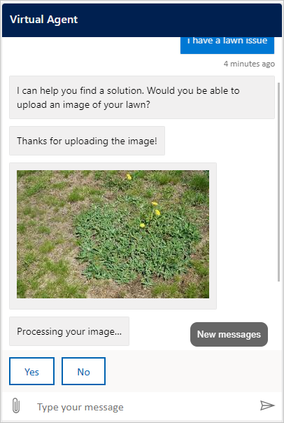
* Location and file uploading custom canvas.” border=“false

Or you can pick from [other sample web chat canvases](https://github.com/microsoft/BotFramework-WebChat/#samples-list) provided by Bot Framework.

### Customize canvas using stylesetOptions

As with customizing the default canvas, you can use styleSetOptions to customize the custom canvas. All customizable properties are listed in [defaultStyleOptions.js](https://github.com/microsoft/BotFramework-WebChat/blob/main/packages/api/src/defaultStyleOptions.ts). For more information on what you can customize and how it will look, see [Web Chat customization](/azure/bot-service/bot-builder-webchat-customization?view=azure-bot-service-4.0&preserve-view=true).

### Deploy your customized canvas

In order to host your custom canvas, deploy all files to a web app.

## See also

* [Bot Framework web chat](https://github.com/microsoft/BotFramework-WebChat)
* [Generating a direct line token](/azure/bot-service/rest-api/bot-framework-rest-direct-line-3-0-authentication?preserve-view=true&view=azure-bot-service-4.0#generate-token)

# Select voice font for speech

You can create telephony bots with a variety of voices (called voice fonts) in Power Virtual Agents. Voice fonts give your bots personality with a variety of voices and speaking styles that you can select based on the bot’s domain and context.

## Configure Speech settings

You can configure voice font settings in **Speech**.

1. In Power Virtual Agents, select the **Settings** tab on the side pane. Then select **General**.

* 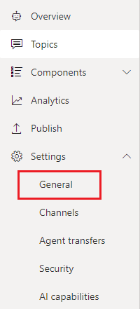
* General Settings location in pane.

1. Select **Speech**. Here you can update the **Voice font** and **Speaking style** of your bot. By default bots are set to the **Default font**.

* 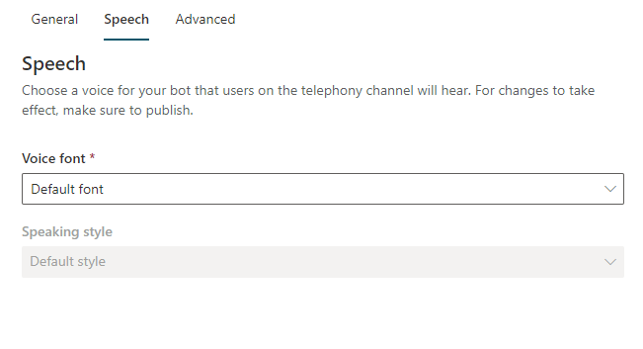
* Speech setting page.

## Speech settings

### Voice fonts

Aside from the default, there are other font options available. Select the voice font from the drop-down list that works best for your bot.

### Speaking styles

For specific voice fonts, like en-US-JennyNeural and en-US-GuyNeural, you can select a **Speaking style**. Speaking styles can be used to add more linguistic variety to your bots and tailor the speech for a specific domain.

For example, you can select **newscast** for a bot that delivers news, **chat** for a friendly chat bot, or **customerservice** for bots that handle customer service tasks. Other options add emotion to bot speech, like **excited**, or type of speech, like **whispering**.